*The Final Battle®*

Victory against all evil

**An Original Movie Script**

**By w.ps. Norman Greenson**

**The Evil Inside Your Head is About to Die**

**© Copyright and All Rights Reserved 2019**

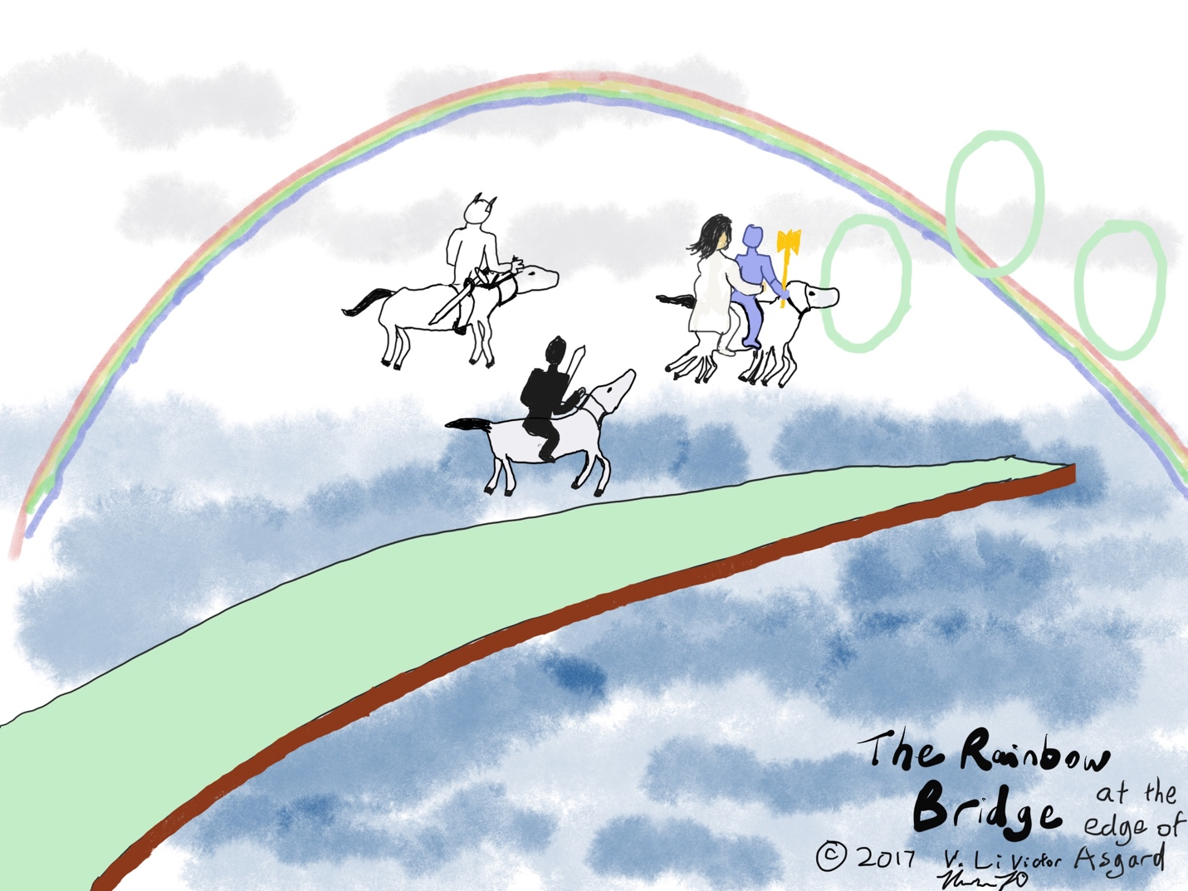

The Rainbow Bridge which connects Asgard, land of the Gods, with every other “world” of the Norse mythology. Above are three teleporters created in a flash by Odin. There is an untold character (worth fitting into the script) “Norma Windraiser” who is meant to be in back of this bridge-ending, levitating the three heroes into their teleporters

Contact information:

+852 5121 8507 (LA Time 6pm-9pm, 8am-9am)

Apple Facetime and Messages-enabled

If need be, send emails to: [superlhb2@yahoo.com](mailto:superlhb2@yahoo.com)

Advertise myself sth like “A Screenplay by w.ps. Norman Greenson”

Online credits needs a good small photo of my face

Why Make This Movie, You Ask?

By ridding the world of “health terrorists,” we can let the new generations know that they will be healthy.

Symptom Doctors will now care for the sick, and they want everyone to recover, or at least have less suffering. Kids are our future! And their illnesses really ARE gone, Yes!

The 9 years of the 3 Heroes’ lives were not in vain, they really did fight and win a Battle.

People did think that evil and the underworld or hell could defeat them—but now that’s different because there’s a powerful Army in Heaven. Good health is predominant. GOOD is not to be let down. It CANNOT be.

**Instructions for Script Usage**

1. **DON’T read the table of contents first.**
2. **Read the Outline and Super Cheat Sheets at the end first.**
3. **Ignore BLUE TEXT.**
4. **Ignore the age or old-style of the screenplay, because this Battle is timeless, and must be told at some time or another.**
5. **Read through the script for character speech:**

**[ directorial and scene-building notes ]**

**{**

***Name:***

**Odin: I now walk peacefully upon this Earth.**

**Vlod: Yes, I saw a Rainbow Bridge in my dreams.**

**O:**

**V:**

***etc.***

**}**

1. **You can have a look at my Casting Attempt, but it was my ragged try and you may of course change and audition whoever you like.**
2. **Make sure you read the extensive Pre-Production Notes after the main story.**

**Script co-written by Haibei Li (Norman Greenson) and Serafia Candorfield**

**The Final Battle Movie Script Book**

“**Fantasy Mythological Epic” “Gripping!” “Shocking!” “A serious and nuanced film, and Captivating!” “Five stars for the real-world, serious content!” “Surprisingly, not a hyper-violent movie—still has some warmth in it!”**

**tending from a big overview to a lighthearted early picture of an idyllic Asgard and Midgard – before the heretics move on in and things get ugly from there**

Table of Contents

Table of Contents 4

Introduction to good and evil sides 7

Explanation of humanity’s disease suffering as caused by Heretics and Witches 9

A visit to Skulda the Northern Poet Oracle, and seeing her reading come true 11

Odin’s visit to Mimir’s well 15

Birth of heroes 16

Henel’s Less than Picture-perfect childhood 19

Many assassination attempts against Henel, but not successful 19

Suffering of society and heroes 21

Henel’s first attack by Penefax hallucinatory swords 22

Climax of Henel’s suffering: depression 24

Society suffering many ridiculously weak and ineffective attacks (thanks to the Asgard gods): height of the Diseasers 28

The Public Continues to Struggle, Offers Help. Beginning of Planning of War on Both Sides 29

Henel and Vlod Choose Valkyries to Their Own Pleasure 31

Tensar’s Obvious death 35

Description of Game Mode: 35

Killwyn’s real death 37

Vlod’s Frustration 39

How the Past-Present Plot-line works 41

Explanation of Battle Gear; Time Travel; and Introducing Baddies 42

Jax the Bloody – more mayhem 43

Causing Suicides, Eh? 44

Penefax and Lizard are Devastated 46

The Height of Penefax the Antagonist 47

The Asgard Heroes Get Frustrated. Real Preparation for a “First Fight” Begins 52

Somnimsis 52

The First Wave Attack 55

Show of the Talisman! 57

Announcing the First Wave Attack 57

Tender encouragement of the 3 horses before the fight, by Michelle the Trainer 59

Flight of the Valkyries: Conversations 59

First Trip to Jotunheim, the Early Fight through a Dark Forest 61

The Heretics Call for Return 65

The Heretics shown feeling good, and very lame 71

Who is Charlene? 73

Facing Giantmantium: Drivloll and Drivnor and Assigned Valkyries 74

The Second Wave with Giantmantium first, not Missing Crucial Details 76

Giantmantium Scene: a Success 78

So Then They Entered Final Fight Day 84

Jax and his Abduction 85

The Trojan Warriors: What??? 86

Returning to the Main Final Fight (introductory scene) 88

Riding with Valkyries Again: Climactic Final Fight 88

The next day, the Final Fight, Odin led the charge 90

Beginning of Final Fight at Forgetropolis 92

Details on How Fights Are Accomplished 93

The Real Killing! Melee-battling all the Baddies 93

The Last Joust Between Penefax 98

The Witches Reach Their End 100

Peace in Jotunheim 101

Henel, Kara, Vlod, and Birsing Have their Celebration 111

A Shower of Delight 113

Bliss for the Victorious 113

The Almighty Speaks 114

Immortal Heroes and Valkyries celebrating after a long campaign 114

The End of Movie 118

Epilogue: A Second Rise of Arabic Evil Powers (Main movie’s AFTERMOVIE as written at the beginning of fast moving early-movie credits. 7 pages) 120

**The Ways and The Means of the Norse Gods** 128

MOVIE CREDITS FOR GOOD AND BAD CHARACTERS 130

**Production Hints and Concept Pictures** 131

**Places of Note in the Movie; And Where the LIGHTS are** 136

**SOME MORE NOTES** 138

**Simple Specs of Characters** 141

**Re-Analyzing the Good Guys** 151

**MOVIE CASTING ATTEMPT** 165

**Outline of Story** 170

**SUPER CHEAT SHEET(S)** 171

Complete Structural Analysis of Parts of Story 174

*\*\*\*: parts to be kept, definitely*

*4 line poems: displayed with darkened, blurred background and white text of poem over that*

*--blue script to be discarded!!!* ***DON’T READ THE BLUE!***

*--long and unnecessary vocals or details can actually be re-formulated into short lines by whichever actors!!!*

**Beginning of A Long Tale With Many Mysteries to be Solved**

# Introduction to good and evil sides

[narration is usually done by official narrator or a live Odin, explaining things in somber mood to Henel and Vlod, while other important scenes have the two, or other characters doing some pretty darn good speaking and chanting rhymes directly in front of each others’s faces]

[narration with footage of big Giants in Jotunheim with two heroes standing on a cliff off to the edge of the scene – panning left from heroes as an introductory scene. The next part is narrated by Odin in the Log Cabin]

**{**

**Odin speaking live**: In the realms, there were the Asgard Gods, Champions and Protectors of humans in Midgard, and the Giants of Jotunheim, the Doers of Evil.

}

[Seeing Heretics in a deep dark world grumbling and cackling, casting black magic spells at future “aboveworld” suffering humans—cancer, heart attacks, deformation, depression, ADHD (melancholy) all grumbling complaining by themselves, some about to die—narration]

{

O: The Monster Heretics, under protection by Giants, had always offended the Gods of Asgard, guardians of justice and peace for the home of the humans in Midgard. Heretics took out their anger by using black magic to hurt and harm Midgard dwellers, and even committed crimes against the Asgard gods.

It took till the time until Henel arrived, the warrior living in the 21st century, that they were finally able to start a Battle of Good and Evil to avenge the world’s deaths.

}

[showing ppl in emergency rooms and blocked mental “pillow rooms”]

{

invisible Penefax the Hallucinator: “Hehehe they are useless. Just waste on the future Earth.

Jax the Killer: “I know what to do with them. [taking out a kitchen knife from the kitchen]

Penefax: “One day, these guys will kill our leader Tensar, and start some major business. Then we will take action against their hero.

Jax grumbles: “They’ll lose”. [slavering]

}

*** And so the Heretics ruthlessly joined together to attack and try to destroy Henel, first, and in the process offend several key gods of power.

They hoped heroes wouldn’t notice their work. But they did.

# Explanation of humanity’s disease suffering as caused by Heretics and Witches

{

H and V and Luigi Warpeace walking the fields of “Minnesota.”

H: Luigi, don’t you think I’ve had enough by now? With all this battering, and all the people in rancor, shouldn’t I act?

L: Definitely. Go do something.

O: AFTER HENEL’S BIRTH announcing to people of America: With my two warrior sons, Henel and Vlod here, your troubles will leave you! I and the heroes will relieve you from suffering, for all seven billion people on Earth!

[People acting ambivalent, suffering]

}

A special god named Warpeace together with Henel the Brave and Vlod the Invincible, Champion Heroes of Asgard, together with their consorts, suffered due to the wickedness of Heretics, and vowed one day at the beginning of the Final Battle to take down not just the evils—Heretics and Witches, but other evil scourges in Midgard too such as the Criminal Five. They did it at precaution that the Frost Giants wouldn’t be totally offended because of their ongoing truce with them.

{

Luigi: Ah, I am getting the creepy crawlies again. Agonized, he bends and unbends his body.

V: Vlod, Yep, those would get at ya. Who wants that, anyway?

H: I found a collection of evil guys the other day in a book. It says something about Heretics and Witches and some Jotunheim Giants. What do ya think about that?

Luigi: I’d bet it’s made for you, huh? Tough guy?

V: I think you should read it.

Luigi: I think I should. And you too, Vlod.

V: Sure.

[Vlod curiously glancing at it: A book with “End Times” written in Swedish]

}

[pan-out scene with Odin at the forefront, looking into future]

Little did they know their carefree ambition was not at all simple or easy. Instead, it would be drawn out over 9 years, a battle fought by Henel, Vlod, and the Eldest of the gods, Odin the Allfather. And evil being evil against humanity, they seemed doomed to fail.

{

H: This is an easy task.

O: You’d be overconfident, my grandson. I think it could take 9 years or more. But you’d always underestimate and believe it is not them.

Luigi middle-aged, talking to 20’s Henel and Vlod: But you *can* really face all 215 of them, and stay alive. I know you can. Because you, Henel are the bravest. And Vlod comes close [tough-voiced].

[at a fireplace in Odin and his (W)ife’s cabin in “Minnesota”, former place of a Giant. Odin is about 50.]

O: I had always assumed before it began that it would be quick and easy. And yet, on the inside I knew it would get rough pretty quick, especially for my young grandson Henel. The things he suffered—If I didn’t have my protective magic, It’d be impossible. But they had control over the invincibility of immortal Henel. They just made him weak.

W: Henel suffered the most, I know. All his life, they tried to kill him. One attempt after another. Even diseasing him so he thought that he had a limited life-span. But noo… He didn’t die. Henel is even tougher than that.

}

[

Words on screen saying:

The 9 Year Final Battle in Old Norse

Show an early times battle scene in which warriors from the Vikings are hitting the shields of CG small frost giants (still bigger than humans)]

# A visit to Skulda the Northern Poet Oracle, and seeing her reading come true

[narration by Odin standing and pacing by himself]

{

O: Let me explain things. Our story begins thousands of years before modernity and the rise of that depressor Doldrum. I was just feeling in Midgard men the pressure of all the diseases brought upon us by Witches.

[scene of women in postmodernity bearing stillborns and suffering with cancers inside their internal babies. Scenes of witches cackling and having crazy dances, ugly, long-black haired witches with pointy chins (like Roald Dahl’s Witches). Heretics laughing and nodding. People complaining about gloomy existences.]

}

{

H: Are all diseases caused by Heretics and Witches?

O: You can betcha. Well, almost all diseases, excepting those borne of bacteria, virii, and habits and sanitation—instead high blood pressure, depression, clots in your bloodstream, and cancers all caused by them. It’s always been Mental Heretics and Body Witches. We hope that one day most illnesses would be controlled by Heaven’s Symptom Doctors. Otherwise, this senselessness would start to work against people who die young.

}

{

Odin sets off.

[planner’s cue: show Odin as prime-of-life aged All-Father and just beginning to plan the war—having teleported back from 2018 to the classical era – putting on impenetrable dark metal and gold-like armor light weight but cool looking]

O: I will do two things first: I will forge for my grandson a sharp and unbreakable magic sword that will lead it to its victim every time. [As a side scene, show a dwarf Regin who casts an awesome sword Gram from an ancient white metal, which Odin casts a “accuracy of hits” magic spell on by super VFX in which he raises it into the air, and a spectacular blue swirl of color envelops the sword, causing it to spin—it faced upward but it suddenly turns downward, and buries itself in Asgard’s weapons room platform-base and needs Henel to extract the sword from its platform-base (throwback to the sword that only the hero could extract in Immortals).

Henel you have now the most powerful sword ever devised by a god! Use your weapon wisely [Henel cautiously approaching the platform-base and trying, with a big effort to take it out] And as for Vlod Volsung, I will have to give him the most devastating Magic Mace in the world, Dafnir. [again, Dwarf Regin forges a HUGE, yet manageable mace and Odin casts a similar spell “speed defence” on a big heavy mace that he lifts up off another platform-base] Here you go guys…

O: To go on prudently [low-voiced] since I know that little first attack won’t work—and needs a remedy, I, Odin will go to seek the real truth from Skulda, leader of the three Northern Poet Oracles – her group also known to Asgard as the holy Norns, and with Odin in the Oracle’s eyes she did indeed read the future [hands facing upwards in front of their torsos—the standard prognosticating stance of the Norse], and told of some foreboding truths.

Poem Reader chants:

At half of the 20th Baldur beware.

More singed than only his hair.

Angrboda stands by Loki’s side.

Ragnarok looms.

}

[Show a witch Angrboda, with cunning pointy-chinned looks, working her way through a crowd up to Loki’s residence in the palace]

{

Poem Reader chants:

Doom to the ill-fated Giant men,

For they punish all the innocent ones.

Their stronghold Giantmantium depends,

On how they stand up to our catapults.

}

[shown scene 2:]

Giantmantium shown near ending of Second Fight. Show a scene from that city done later, brought backwards into the time of this oracle-reading.

{

Odin took down Skulda’s poems by pen and thanked her with some gold.

O: Our troubles won’t be the only the only scary thing—the cost in wounds while fighting was the most foreboding thing.

S: I didn’t lie. Oh, and you yourself will have a painful experience just coming up. [showing quiet conversation with Skulda. “Need to! Need to!” she says. “…Too painful!”Odin replies. “Must” she asserts]

}

# Odin’s visit to Mimir’s well

***It was this time that Odin embarked on a dangerous, yet necessary mission that he would need to do to set some things right in Midgard. He got together all his magic items: an electronic Talisman, a powerful double sided axe Gungnir, a written note detailing a secret from Mimir’s well, and informed his Queenly Wife to get prepared to go.

***[actual Mimir’s Well scene with narration]

In the following days there was a scary event, in which Allfather went to Mimir’s Well, and asked Mimir for a sip of his water which would gain him great wisdom. This wisdom, in fact was the knowledge of the attack solution which would enable victory against the Heretics and the physical and mental recovery of nearly 800 million Midgard dwellers in the future human realm. But to get the knowledge, he had to sacrifice his own right eye begrudgingly, covering it up with a hard gold eye patch. [A spreading black “virus” emanated from the well after he drank from it, and consumed his eye. But the well had something to offer too: a deep Magic Voice emanating from its bottom [Poem Reader] telling him of something secret in regards to the imminent attack on Giantmantium.

{

Background chant from Vlod from future:

For my all-father I lament today

The pain which he had to have his way

For all I know it was a gouge to the face

But the eye of his did shed blood

}

# Birth of heroes

**The Introduction of the hero Henel, son of Thor**

[back to Asgard – a festive scene with Asgard women and Odur—Odin’s ill-fated brother and Odin and revelers]

Going back into the 11th century years, there was once a festival. The event drew all of the members of Asgard. Loudly and with much anticipation, the Gods of Asgard cheered and celebrated the arrival of the new grandson of Odin, Henel Volsung. He was prophesied to one day take responsibility for improving the health of everybody in Asgard and millions in Midgard, the protected land of humans.

[THE EARLY BEGINNING - words on film. some Odin’s speech and a scene of birth]

{

O: All hail grandson of Odin, Henel Volsung! One who will bring wellbeing to Billions of Midgard humans in the 21st century!

}

[shows him as a young child.] Nobody wondered whether he would succeed or fail—oppositely everyone was fully assured of success. Does Henel have the courage and tenacity to assume commander of the Army Champions? Odin Allfather certainly thought he did. He took his time and recounted to every attendant the immortal promise of Henel at the festival celebrating Henel's birth [show Odin going around to the attendants and throwing flower petals, repeating the prophesies claimed by Asyniur Poet Oracle to make sure everyone knew who he was and what powerful things would happen in a couple of centuries into his immortal life, affecting 21st Century and beyond. ]

**Near the Beginning of the War**

*** [Young Henel looking proud, looking at a vision-a cutscene of his future, and looking happy, then Odin arriving, his grandfather making praise for him.]

Near the beginning, Henel had a pleasant day. He realized how his future would be – celebrated by other high Gods of Asgard and even other Pantheons in the world. He committed to worshiping the God of Charity, for which then they arranged for two other High Gods to follow Henel around for an extended time, making sure of both his success and wellbeing. Odin didn’t take long to arrive at the main battler’s footstep either.

**Entry of Vlod**

At a slightly different time, another Army Champion was born of Tyr—a powerful warrior—named Vlod, whose main purpose was to trick and suppress the Witches (body diseasers) in their homes, and by strong contention and persuading he would prevent the diseasing of the Heroes. [Tyr the great swordsman exclaiming at the celebration the promise of their child, and also of the many supportive acts he would do on Henel and Odin due to his great friendship with the sickened one]

*** [Portraying a skip to the future where Henel and Vlod had already grown up their human bodies. It is a Lounging Room where which they enjoyed listening and watching people in Midgard doing and saying things. Many things would be spoken here in the next few parts where all the sickening of Henel and Midgard residents would happen. People repeatedly and in seriousness asked Henel whether he’d be alright]

*** {

N: This was when the strickening of Henel Volsung would start happening—sick in every area of the body and brain to the point where the Big gods had to intervene.

}

# Henel’s Less than Picture-perfect childhood

**\*\*\* Less than picture-perfect childhood**

[Zoom attention from bottom of Jotunheim (Jax *full intro* cruelly laughing with his name, title, and the words “Mutilation Man” displayed for us) to overworld, fading out and in to Henel suffering—display the association of Jax and Henel. Henel strolling around the 2nd story of his grandma’s old home:]

# Many assassination attempts against Henel, but not successful

Henel had a bright, but eventful youth. His trip, 6-years old to his grandmother's house was unhappily marred by a fall off the rail-less stairs in the house, when a sudden skip happened and he veered off the edge of the one-story flight of stairs and survived. Another frightful event, during his pre-teens:

{

Jax: And now, you die early you monster-killer!

}

a "friend" who had the bad influence of Jax the Bloody, splashed hose water at his face during a pool swimming session, and he backed into the deep end of it. Everyone was quite surprised when he revived and returned to wakefulness in a half hour’s worth. Asgard’s Resurrector did it again. [quick scene of Charlene at Henel’s side, then darting away] When Henel got older, he actually realized who had brought all the pain to him, as he was strangely pushed while next to the harbor by a strange force by a ghost (obviously Jax) and drowned yet again, and miraculously recovered from by harbor-watchmen a little later—caught at the corner of the eye by harbor-watchmen [floating in the middle of the water and getting special camera attention]. He didn’t know at the time when it was happening but figured later, that the killer Heretic Jax had caused these events.

{

[before the fall into the harbor]

Jax: Hehehe you’re dead this time! Nothing can save you from this. Suicide is the best option! You will see if you get out, and get depressed. Shit, that means he’ll get out, huh! Crap.

}

[after the the fall into the harbor by stunt double, Odin wants to know how Henel feels]

O: You are alright there, my son?

H: I-I didn’t die—what happened?

O: You were brought back to life by Charlene. You realize this kind of thing might happen again, right? But you should know there’s something really good for you when you come out of our battle.

H: Young Henel sheds some tears. But he maintains. I am the one Henel!

In his just-recovered mind spun:

Poem Reader: I will make the early-dying die late!

I will make the long lived last longer!

All people won’t suffer!

And he sunk back onto his pillow, satisfied.

}

[Henel comes of age: from childhood actor to full maturity]

But in the beginning, Henel was not aware that there were a few Heretics who knew of his war campaign, and were eager to deliver him suffering. After Henel tried to reduce the bad guys’ central support – a Heretic-supporter only know to people as The Whore, they struck him back.

* [Show after scene of Henel’s suffering-others suffering in Midgard, and even the future president. Scurrying from past to future like a videotape sfx, to see modern day]

# Suffering of society and heroes

* Other events marred an otherwise pleasant world in Midgard, the Realm of Men. One man broke down and attempted a drug overdose, which brought him down [shown lamentful and sad]. Several kids died of a strange outbreak of of SARS. Another kid died of bowel cancer. But the worst was yet. A Politician received a wasting disease Alzheimer’s because of a witch. And some time during the Final Battle, another Politician was delivered a terrible stomachache, in which all his remaining energies was used up, and he shriveled and died, again due to a Witch.

* There was terrible devastation upon humans, even fully healthy ones, to exploit their weaknesses. This suffering was uncharacteristic of previous human suffering – it showed the cruelty and relentlessness of the Monster Heretics. We suffered in an extremely aggravating yet *unterminal* way.

# Henel’s first attack by Penefax hallucinatory swords

***[Henel has his first hallucinations in his sleep. For some reason, Henel is prone to imagining dangerous situations without anything real.]

{

[Henel enters an “arena” of an empty building in his sleep, it is a horrifying nightmare! Dorpf [actually, Penefax] takes out a bent, sharp dagger and wears chain mail. He comes up to Henel and stabs him! Several times, until Henel falls and drops his sword, on his knees until he bleeds to death—or wakes up, more like.]

]

What happened? He asks while getting up. I feel as if I’ve been breached and flustered. I gotta stop hallucinating!

}

He tossed and turned all night, but that wasn’t the last night lost to Penefax the Insolent and his team of hallucinators. In fact, this was Henel’s introduction to hallucinatory Mental Pain and to all the dark dreams that would be affected by Penefax’s magic throughout the entire battle.

[Show Penefax cackling and muhaha laughing at Henel with a *full intro* from his estate in 11th century “Minnesota” (filmed area around LA in an old looking American home), the place of Jotunheim]

*** [Showing Vlod whispers voices into witch’s ears and persuades them to not attack or suffer, and they readily listen to his rhetoric]

Before the real onset of terrible battle in the Final Battle, Henel had to suffer several terrible tests. Although the blunt of the Body Witches’ attacks had been defended against securely by Vlod, thanks to his wit and persuasion in cunning deals, one of the nastiest top witches, Filveig, the Witch of Poisonings, came dressed deceivingly as if she was a maiden from the land of Midgard. What she was really here to do was sinister enough.

*** { Ah, there is a strange feeling in my body. [As he looks toward his lunch on its plate, he suddenly feels disgust and repulse.] I can’t eat? He wonders. It is true. Some kind of food poisoning. Soon, he starts feeling nauseous and vomits crazily. Since he didn’t ingest anything dirty, he wonders about this. In reality, Filveig had filled his blood with a certain food poisoning bacteria. But he didn’t know this the first time. He spent four days trying to recover from this affliction. Certainly, Filveig was a force to be reckoned with.

[shown visually, Filveig witch entering the room and her ghost quietly leaving with a *full intro*]

}

An even more heinous crime happened when the witches lost their restorer, someone ancient people called Medusa, and they decided to punish Henel by stabbing him in the soul-kidney with a knife. However fortunate for him, a maiden-friend heard about this and lent one of her soul kidneys to him – a real wondrous gift which he is still grateful to this heroine for. [showing a nice model capture of Elena, the third heroine, looking heroic]

# Climax of Henel’s suffering: depression

Before Henel could fully understand himself and the world, the Monsters tried to do away with him once and for all, in a despicable way—the normal way of the Monsters.

Starting when Henel was only 13 [but shown when he was 22], they provided him with sick, false dreams over and over until he became depressed, and couldn’t “rise up” past the doldrums.

{

LAUGHING AND CACKLING LOUDLY IN A “DREAM SCENE” inside one of Henel’s final horror dreams:

Tensar: Finally, we have worked out the solution to your demise.

Doldrum: This nut really never got far with his life. I think he will succumb to our powerful disease, depression, the ultimate mental illness!

[Henel is dreaming of actually falling-not typical dream falling-but down a very deep hole, above which the two schemers Jax and Doldrum were cackling.

[Tensar is *full introed* – Tensar the Ultimate: Gene Destroyer. The text with a black and red picture of him “throwing yellow lightning” at the sky with name and title below. Doldrum is *full introed* - Doldrum the Unsympathetic: Man of Depression. Shown with a slo-mo movement with his arms coolly folded and smirking.]

Henel: I am spiraling! Although it is completely impossible for me to control, I will get out of this! This won’t be the last you hear from me! [coughs, in a dream scene]

Tensar had the ultimate plan: destroy humans one by one by genetic illness—as ill as this plan may have been contrived, that’s all we would expect from Him.

And his close buddy Doldrum wasn’t far behind: he wanted to help everyone succumb to their woes, whoever they could be and wherever they came from, depression strikes first, then other disorders. Doldrum was perfectly happy making everyone’s life miserable.

[Show who these two are by *ghost facing* them to susceptible targets other than Henel, and saying nasty stuff, e.g.

D: And tonight you didn’t finish your chicken soup! So now you wither and shrivel! Am I right? Haha it doesn’t take long before you fall to me!

T: I believe you thought this one up beforehand! Genius! And his genes are predisposed to receiving our little gift!!

}

*** Iduna the Immortalist comes from a garden in Asgard to comfort Henel from his spiraling depression. She in fact has a nice gift for Henel: a shiny round red delicious apple from her bounty of youth-preserving apples that she distributes to the gods every week. Keeps all the gods youthful!

Iduna: Lalalala how I LOVE to keep Henel and Vlod nice and youthful! Their persistence means everything to me! Lalalala And I love Odin’s cautiousness especially, for it makes me feel SOOO fresh and dandy! Lalalala!

***

{

Odur, brother of Odin. Isn’t that nice? Iduna brought her kin an apple of immortality. To keep him young forever! As if we gods are really superior to normal humans. But I always believe I am only a Midgardian, despite living in protection in Asgard.

Odin: You have eaten our apples, haven’t you, my brother? Everyone who lives in Asgard is eligible for them.

Odur: You’re right, I ate them. The only trouble I have is my dreams. I dreamt of a strange existence. I looked out of my eyes right beside my waist, as opposed to in front of my head. I wonder what caused it.

Odin: Hm. I cannot deduce the reason for that, my bro.

Odur: Perhaps I should not eat the apples.

Odin: No, I value you, even if you are not a god. You must live on. [hear a crunching of apples]

}

**A Different Girl in Henel’s Love Life**

[cut scenes between Greece, Asgard, and Valhalla]

He wasn’t to find too many girls—he had one whom he really liked, but never became *that* close to him: the cool-styled Gelly, Valhalla’s attendant to the immortal warriors. They all held each other in good regard, and the friendship between Gelly and the others was fine and well. Gelly made sure that Henel was balanced and concerted for his battles, and soothed him by playing the lute while they were warmly getting along. The crowd back then took the two of them as an item, but Henel was pretty playful and had not proposed to Gelly, his fair Attendant. This was because a special girl named Kara in his life, whom he would find later who was a specially assigned Valkyrie, was also a healer, and so much did Henel appreciate her healing on him. Despite Gelly attempting heavily to convince him that they were the hot item—Henel always had the tickles for Kara. He did give Gelly an elaborate silver ring and everything, promised her marriage, but it did not result in their marriage.

[spanning different times, showing each girl differently with minimal shooting]

# Society suffering many ridiculously weak and ineffective attacks (thanks to the Asgard gods): height of the Diseasers

[a scene of frustration among scientists and psychologists]

When the public learned of the Witch’s bad behavior and apparent inability to be suppressed because of the restorers, the public went into havoc. Protestors surrounded areas in Washington, DC and New York City, blaming the Witches for physical illnesses and Heretics for the massive wave of mental conditions that had hit mostly America during the economically prosperous period the 1990’s. The Diseasers would just laugh:

*** [some diseasers: brashly spitting out their crude poem in synchrony, showing many people getting hit by imaginary swords by Penefax in their dreams. Henel himself entered a new fight inside dreamland, against Doldrum this time, in which again, he is felled by the evil sword. This time, Doldrum prevails because he has Kevlar scalemail armor and knocks Henel down easily being the stronger of the two. It is like a horror movie: causing him to squirm and contort uncomfortably. Hidden in his mind he knew whom had caused the hallucination: the one enemy.

]

In Chant and in Turn the Poem Reader chanting for the Witches, with laughing *ghost faces* in front of Henel in bed:

“Spite you hold so hard against us,

The signs held in vain against us.

The Witches and Heretics won’t go away,

The doom of man is upon you today!”

But Vlod, acted by Poem Reader, had an equal return to them:

“It takes more than words to bring us fear,

We can consult *your* ending and it is near.

For Odin we have in our protection.

Whomever fights him gets full deletion.

# The Public Continues to Struggle, Offers Help. Beginning of Planning of War on Both Sides

At the time when Penefax the Mean, of Mental Pain began his campaign against the weary in normal society, there were probably 5% of mentally ill people with his brand of illness, mental pain. But soon, there came to be a staggering 20% of sufferers. who suffered unusually strong symptoms of mental pain.The Insolent was extremely evil, and yet never did admit his wrongdoings and shameful pitiful behavior that they showed to the Asgardians and the People. Because of their pitiful behavior, people in Midgard began to analyze and hold strong angst and formulated plans against the antagonists’ ignorance.

H: The stabbing has become too much. It is tearing away at my psychology. It must be horrific for all others who can also suffer the same issue—*don’t* call it a disease, but only an issue. They CAN rid themselves of it! I can get rid of it! I will soon show the world.

}

***[the end-of-paragraph here start showing real planning and plotting against the heretics in the **Planning Room** with drawings and figurines on a large table, 2018]

*** Just as Allfather Odin and his crew, including Odin’s ever-supportive healer Frigga the queenly wife were planning the end of the war (in the fourth year, two years before the final end), the bad side too was seeking their own protection. So they made deals with the Frost Giants to try to protect their survival (what meager amounts of that they had). The deal was that since the Giants were necessary upon the Earth and had to do what they do, not overstepping their boundaries because of special dealings they had with the Asgardians, if they couldn’t die then the Heretics couldn’t die either. The Frost Giants of Jotunheim were assigned to restore the Heretics after death, and that was the greatest thing in the beginning stumbling the Heroes. and the Fire Giant of Muspelheim was meant to kill Vlod.

{

H: [Overhearing the Giants] No, they can’t! They didn’t just made that deal with the Giants. Did you hear that?

V: Yep, the Heretics and Witches are now protected by special Giants. Didn’t actually catch what kind of protection, though.

H: *Gasp* I think they have gained immortality!

V: No no…

# Henel and Vlod Choose Valkyries to Their Own Pleasure

*** One day, in Asgard there was held a feast, for both Midgardians and Asgard gods. In it, they proclaimed the End of the Nine Worlds.

Odin: Today we feast, for we have seen that the Monsters want to prematurely end the world.

Everyone: Booo!!! Hiss!!! Why, I could take them on all by myself! I’ll wrestle them! (different voices in the crowd)

O: So I take a stand. We can beat those puny 10 or 20 bad guys only if we try hard enough. I have the secret of Mimir!

Everyone: Yeah! Mimir is a Champion! He knows the way out of this!

O: But I actually feel that it may *seem* like the end of the nine realms, only that it won’t kill all of us.

Henel: Those who are hardy, and fight strongly will prevail over the Giants and the Monsters.

Everyone: Go Henel! The Brave One! Go! Go! Go!

O: Now quiet, let’s say our ruminations and remind ourselves of eternal life.

Everyone: falls quiet and slight whispering to each other.

[Funny cut-scene—Henel makes a naughty trip one day to the feast, and sees sexy dancers, and also sees dozens of big-bosomed blonde Valkyries, all expecting his arrival. Several of them were dancing stylish, curvy dances as entertainers of the party in their high-fashion Norse outfits. Everyone, thinking for themselves, were surprised when Henel passed up all the fair-haired ladies and chose instead the prettiest and cutest brunette in the crowd, lovely Kara, and lifted her.

{

H: So, my predestined Kara, you are to be my immortal companion, am I right?

K: Certainly, my man! [waves her hair back] We’ll just test the waters. You need to show me your true immortality on the battlefield. But you need not worry--you are the ONE!

H: Oh, sometimes I have misgivings about my real strength. What if I’m only a swordsman?

K: But I see that the rod in your pants grows as readily as your sword is unsheathed.

H: Yes, they do have their resemblance—haha!

K: Don’t worry, my Eternal, you’ll make it.

}

Vlod, a little affected by Henel’s rapidness, decided to make a go for it himself. He looked around for HIS prettiest Valkyrie and straight nodded at her, giving her the wink.

{

Birsing: Vlod is your name, is it? I think it as commonly known as Tyr, your father!

Vlod: I don’t match up to the great swordsman that he is.

B: Oh, you shouldn’t say that. You are the most eligible gent around, and a looker too!

V: I fight strongly, like Odin asked us to. But let me ask you: are you only my *once had* Valkyrie?

B: You mean only a temporary companion? No, once you make it past all the Heretics you’ll turn me into an immortal. So how about you to show me your stuff?

V: [and with his shirt taken off to show the Midgardians, showing big muscles, he lifts his girl and takes her out]

Odin also arrived at this grand feast.

Odin: Ah, there’s my pretty lady—Aesir Frigga. [walks over to her abashedly] No more swashbuckling. It is getting tired. Instead I wish to complete my conquest and snuggle with you.

Frigga replies: That’s very forward of you, my man. But before that, don’t you have a crowd of evils to kill?

O: Yes, you’re right. It is going to be 3 vs. 250 or more! How would we last if the Giants take us on too!

F: Not the matter! You have the Secret, and the great Henel and Vlod by your side. I don’t doubt you shall win glory for Asgard!

Everyone shouts in chant: Glory for Asgard! Glory for Allfather! … And Vlod! … And Henel [and clinking of mugs]

THE VALKYRIES HAVE SOME KIND OF OPTIMISTIC, SERIOUSNESS-NUANCED, TOTALLY CONFIDENT SPEECH STYLE. SOME TALK IS MADE BY THEM.] He was to get Odin to choose the absolute most beautiful Maiden among them. And so Odin simply pointed his finger at one Maiden whom he already had met: Kara the Beloved. Henel was so excited and enthused about this that he ran straight to her, beside many passed-up blondes, and hugged and lifted the brown-haired Valkyrie Kara, whom really was the most beautiful among them. He kissed her romantically, and Kara got an ecstatic feeling herself.

They exchanged: “Henel, I want to be with you forever, to soak in the days, and live on into eternity.”

Henel: “There is an obstacle to that though, you might know. Although I’m an Odinson, lasting as long as the Sun lasts, I may one day perish due to unnatural reasons.”

Kara: “Oh, I might die too. Yet, since we have been born immortal, isn’t it that we may change from living to Oblivion and back again?”

Henel: “There is no pessimism in the house of Odin. Let’s continue fighting—as long as we have the world’s support, I bet I can make flight of the warzone after it is all done.”

# Tensar’s Obvious death

*** [Conversation by Odin to Vlod: don’t show actual event]

Due to an initial plan made by Asgard, the very first death that happened through the battle was of the Genome King.

Henel was so gripped by the sudden death of thousands of people who died suddenly once, due to genetic factors in 2016, that he decided he himself were to act out the avenging of deaths against Tensar. He knew Tensar would do terrible genetic diseases to many famous, powerful, brave, or otherwise normal humans in the world.

# Description of Game Mode:

**[Game mode:**

Starting at Giantmantium, many times when we see a battle between a Champions, Frost Giants, or some scenes which need to be animated we see Game Mode, in which everyone is hyper-realistic CG [this scene had been pulled from a later scene in the movie, when the horsemen are attacking Giantmantium]. We should also see some vital stats which are animated with—for example—expanding hearts on the top left which show healing is being done, or two swords clashing (or sword and mace) when two are fighting. And we should keep track of every fighter’s stats using percentages and bars on the top left and right, detailing heroes/heretics’ life meter, and attack strength, and names. If restored, the baddie’s meter will turn grey, then shine brightly red as hearts get back to normal. When dying, they should fall on the ground flatly, waiting for their Restorer Giants to bubble them down to the ground (invisible), then raise them from invisible to real, live body, and they would run away and be teleported.

]

{

O: I’ve always hated the oppressor of the weak, the denier of hope, and the curse that has befallen humankind who is the opposition to the Almighty, Tensar. No matter who fights him, or who is able to disable him, let ME ultimately decide Tensar’s fate. And mine and Almighty’s resolve is clear on this one: that Tensar is defeated fully, and *early*. Survival for my Heroes!

H: Survival.

V: Survival.

Vlod: I have invested my full energies into this 9-year-long campaign, and I have nothing but a full decision that Tensar and the Queen’s deaths will be the first. Not that we should terrify the rest of their monsterhood too much, but I think the great monster needs its head removed, huh, Henel?

O: Hehe, that’s right Vlod.

O: I beg forgiveness from the Creator himself, but I must cause two early deaths in our campaign, so may thou give us permission to zap him? [waited a few seconds for affirmative] Alright, here’s to Thunder and Lightning! [A huge rainstorm started in Tensar’s area, and a brilliant flash of lightning zapped at Tensar (all electric beams all throughout the rooms of his house.) It was wrought by the exactitude of the Allfather, and Tensar was electrocuted instantly.

}

These thousands of untimely deaths, most notable of which was Steve Jobs’ fatal pancreatic cancer, that he had to act, and remove this great threat which most people had considered was the Devil. So he begged to ask God for forgiveness, and was granted a special permission to use Odin to send a bolt of lightning, while at the same time Tensar walked out of his ancient house and cause a rainstorm on his head. The bolt of lightning landed perfectly, since Odin is always deadly accurate. Tensar’s heart had arrest immediately.

# Killwyn’s real death

**[**Conversation by Odin to Henel: don’t show actual happening]

Another event planned early was simply predicted—happened after Tensar’s death and was cringe-worthy, yet real. Killwyn the queen’s *[full intro]* death was pretty ugly, since nobody liked her, given her brain-melting skill, then she wandered into a dark place in the rocky lands near her home. She had recently murdered an enemy of hers IRL, and now Odin had decided her ending—that she should get lost in the rocky lands and collapse of exhaustion.

{

Poem Reader:

Tensar is the helish man.

He once gathered a hideous band.

He designed his world to shrink and shrivel

More like he got blasted at the end.

}

[Henel and Vlod become full maturity w/facial hair, in prep for fights]

**Annihilation of Tensar the Genome King**

*** [after our lovely cutscene, there is another ugly scene—the kind which makes up most of this very, very serious movie]

[subtle change-of-tone by advantaging the heroes and disadvantaging the now losing heretics. A conversation and some graphic elements]

The Asgardians took advantage of this weakness between the Giants and the Heretics. They brought anguish to some of these Diseasers. They made them feel *bad*. That was by example the death we brought upon Tensar the Genome King, the ultimate bad guy.

{

T: Gloomy are the ones who fall to my interventions! The end is nigh for those who oppose Heretic worship! [after suddenly awakening at night to the idea that he might be cremated in a sec.]

O Narr: He had been responsible for the “creation” of all the baddies of evil at the culmination of mankind, wreaking senseless havoc over almost all. And of course, he was responsible directly, or indirectly for all genetic mutations and genetic diseases among Humans.

We unviolently condemned him to a repetitive short-life by “blasting” his body and fissioning all of his particles.

{

# Vlod’s Frustration

Vlod: To Hel with those who have caused Henel and the people great pain! Condemn those causing unnatural illnesses, viciousness and maliciousness! The Heretics and Witches have something inferior—themselves, that will ensure their doom in our Final Battle. None of them will survive our powerful attack against their core: Doldrum and Penefax. We will have our avengeance! Our tiny army will defeat the huddle of them! And their allies the Giants will shake before our feet.

Heroes in Chant and Turns:

To hell go the witches and the heretics too.

Damage on humanity is obviously for fool.

Because we all know the real and true.

That our Lord saves our lives ultimately.

}

Thus he became the first death before Killwyn that happened in the kingdom. We easily saw that his terrible wrath would not affect us after the time he was physically gone.

Everyone before long knew there was a reason for the Heretics’ insolence and shamelessness, and their willing to fight despite big losses. They couldn’t think. There was something missing in their brain, perhaps an inevitable result of joining a senseless and worthless tribe, that their IQ became less than human. Everyone saw this as a reason to maintain their hope and longing for symptom-free days. The easy death of Tensar helped too.

[First love scene: (Fantastic Dream-scene) Kara was lost on a sheet of ice, on which she didn’t know whether she would break through and fall through the icy chilled waters. But that was not enough to hinder Henel and Odin. Odin Allfather lifted Henel’s horse Dreipnir up from its feet, and the three flew over the water at such a high speed. “Come on, says Henel, let’s get you out of this predicament.” Then him and her got on Dreipnir and flew back to their northern home with Odin’s support and she was shivering and was about to become sick. But Henel brought her a giant cup of snow-pear flavored mead (with the honey, of course) and before long they were rolling around laughingly in Henel’s bed. She started to take off her clothes, and we could fully see her augmented breasts, of Roara’s the immortal’s doing, which gave her physical appeal. Henel was really enthused about this first lovemaking with Kara. In the end, she was a little troubled that he had come outside of her instead of simply impregnating.

{

K: Why not simply give me a baby, my babe?

H: I just think a pair must have some bonding, get used to each other’s physical touch, and get warmed up to each other before actual impregnation.

K: But what if you die in battle?

}

# How the Past-Present Plot-line works

Vlod, Henel, and Odin are all immortal gods. Thus they remain with us humans through all time. Yet, if it weren’t for the success of the Final Battle, affecting mostly mental illnesses in the present- attacks which arrived at us from the long-ago medieval past through time-magic, they along with all humans would have perished. But Odin knew better. His secret from Mimir’s well was that their enemy was not only the Heretics, as he had thought but also two Restorers hidden in a dangerous stronghold known as Giantmantium, ruled by Giants. He thought now that we ought to take care of Giantmantium early. But during his First Wave Attack, he would’ve simply forgotten this need.

But the fight was a two-time-period-struggle between the Norse gods and the Diseasers that tore down the Diseasers back then, only to have its effects realized today. Just shows who’s immortal, and who wasn’t! This story is mainly reported by the two Asgard warriors, hardly aged, who spelt out the story by remembering the very old days over a period of several days. [The two having days of conversation in a large country cabin in “Minnesota” in the wild. Although they were primed and peaking with the Valkyries (Odin excepted) in the 1200’s, the Valkyries by the 21st century were in a nearby cabin spiritedly skipping back and forth between theirs and the boys’ Jotunheim cabins. The story is formed by both conversations and action cut-scenes. Nowadays they were primarily pre-occupied with electronic gaming gadgets from the 21st century.

# Explanation of Battle Gear; Time Travel; and Introducing Baddies

Henel’s armor was just like an archetypal Norse Viking’s. It was a black helmet rimmed by red and blue lines, very onerous and fierce looking. It had spiky white side juts, thin eye-sockets, a big frowning mouth-opening for breathing. The rest of his armor is bulletproof, and shows muscle regardless of his actual build. Odin’s was dark-gold armor, with a special thick helmet with a large frowning mouth opening, like Vlod’s too. Vlod’s armor is dark brown, similar to Henel’s, and he also wears tough and unbreakable supports on his joints and other regions: the defense against the powerful. [more exact details in end-notes portion]

**Explanation of Time Periods traversed using Time Portals**

The bloody bloodshed of the battle actually happens in the 11th century, A.C.E. It is dealt out by Odin opening time teleporters into the future’s *past*, in which the future Heretics are attempting to manage and dominate over people in “this” world (an imaginary globe of the future over their head). And only they see it (plus the immortals)--normal people are oblivious to what’s going on down there in the past. They control all parts of time, except for times after 2018, from this time in the past Earth. [Show a supernatural scene in which Monster Heretics are casting spells into this imaginary overhead world. Shown in the very early pic in the document]

**Introducing and Explaining in a few words each baddie**

When each baddie is seen for the first time, their Norse name appears, with a few words to describe the baddie e.g. “TENSAR: The Genome King. The Designer of Evil.” but don’t cross over into Greek monster explanations.

# Jax the Bloody – more mayhem

Back in the stage in modern days...

Very soon a terrible incident happened because of Jax the Bloody’s work. His job was simple: Enter the souls of the weak and susceptible, who had frail egos and would attempt to kill themselves.

[Show this exchange with Heretics banally laughing in their home]

Jax:

I am the Leader of the Heretics! Heed me in fear.

Other Heretics:

Pene: Fool! Idiot! I’m the one!

Dold: I am!

Jax: Yeah right! I will cause the fall of humanity! Everyone will die and my life will be great! I will bathe in pure luxury and humanity will bow to me like a king!

H in the Lounge Room: Yeah, with these big muscles, I will pommel you and your brothers too!

Jax: Bahhh!!!

We hear Valkyrie Birsing saying: “He got you there, you dummy. Now you better step back from him, or I’ll scathe you.

}

# Causing Suicides, Eh?

In a later scene, Jax attempts for real to influence Henel into jumping off the top of a two story building. But we must remember that Henel is *truly* an immortal, and cannot die at all.

*** Henel was pressured by strange physics to walk the stairs outside onto the roof. He mumbled a groan and panted. He did in fact get the suicidal feeling, with *ghost face* of Jax chuckling in the background. But he could also sense what would happen next.

{

H: Grr… even a Jax can’t make me mortal can he?

}

He wandered to the edge of the building, and stood there for a few seconds. Then, a la Batman, simply fell off the edge front-first. Words flashed before his eyes. ODIN WILL SEE YOU THERE.

[The camera fades as soon as he “hits” the ground, we hear a slight tap sound, then the show lights up again] Henel had felt some feeling, but it didn’t amount to any pain. So he then simply got up and walked.

{

H: That was weird!

}

**Responses to their terrible attempts**

[Cutscenes of heroes recounting their attempts to take down the Heretics via “little attempts” in which most failed because the Heretics had special methods plus an infrastructure network ready to help]

One of the Heroes’ earliest attempts to battle down the Diseasers was using plasma from the sun, which Odin could move and he extracted some and attempted to burn the baddies. However, the baddies knew it was coming so they watched the Heretic die, then called on a Giant to bring him straight back to normality using Restore. This power Restore would prove to be the most hated and most enduring of all their powers. Because after anyone died, one of the 7 Giant restorers could restore someone else. It became agonizing and unfruitful.

*** Before long we reached a point of needing more powerful ideas. So we attempted chain-bombs and smart-bombs, the former being a linked up mini bomb system in which many were killed at the same time, but of course they restored. The smart bomb was used only once – it extracted essential parts of their brain, but did not work because they killed their own spirits and were restored from a fine state in the past.

# Penefax and Lizard are Devastated

*** [act the following part out with falling roofs as mini-camera]

Shifting forward a couple of years into the battle, special techniques were used against the long-lasting Penefax and Lizard the Obsessive, who were both deprived of their most simple belongings. We basically cast a powerful spell of destruction on their homes while they were out, leveling them and giving them nothing to live in. They then wandered the streets, looking for friends who could take them in. During the search, family members came up and hailed them, because a character is a character, and their family would support them as kin. They took them up in shelter, and we could not just bring these family’s homes down.

*** This is a multiple ghost-face conversation between four creatures in four different parts of the world {

H: Penefax survived! Don’t you know the horrible consequences you bring every day to the weak and the infirm? How dare you ignore the entire society which you wrack, considering you are but one of them?

P: Ah, but you guys punish too hard. I cannot talk to you. Leave my brain! You are not welcome in here.

}

 {

“You fool!” we all chanted in chorus. V: “You don’t deserve your special powers only to damage every mind you deem unstable. Now look what state Henel is in! It is a fake state. How dare you oppose the human family! What are you, an alien? A monster?”

P: Oh ho ho. So you think I’m that bad, eh? Well just consider me your final nightmare! A killer monster from space! Yes – this is the reason why you will never get me!

H: Only those with small brains like you would treat us like you do! (complaining) Lack of sympathy and respect!

[Vlod in background] Inferior monster!

}

# The Height of Penefax the Antagonist

The third and final major enemy of mental attacks, this Penefax and creator of terrible killing dreams, would himself be present in this last hit against Henel. But what would happen later to him, is a complete reversal of these evil-caused dreams. Penefax blatantly walks up to Henel in this third nightmare and pushes him. “You are the one to offend, not me!” Henel replies. Penefax takes out a sharp short sword, and goes at Henel. But Henel is quick. Too bad he’s not wearing a helmet. Penefax garishly stabs Henel in the face, and he goes down. “There, hahaha I have dealt with you completely!” Of course, in reality little has changed, except for Henel’s resolve.

**The President**

*** So at the time, The Powerful President was in power and enjoying some of his best days. Unfortunately, his pen suddenly developed a halo of light around it and imaginarily changed into a steak knife. Strange, he thought.

[The “President’s” face is not shown. Let him think this out with an echo.]

“Should I really look at that—or is it just a weird sensation getting the better of me. Do I consider it a real knife? Wait, wasn’t it just an envelope cutter in my pen container?

He thought about it several minutes and decided the problem was not worth his expensive time. So out the window went the President’s pen. This was a transgression, but not the only one nor biggest one that these Heretics would complete.

Later the CIA hurriedly scurries him to get a psychological examination.

He informed several of his aides, mostly women, and they realized what’s going on. They quickly escorted the President to a doctor’s chambers within the white house. The CIA didn’t take long to arrive either. The doctor tried asking the President several key psychological testing questions, to see whether he had been transgressed or not by an unknown force. Then seeing that we was mostly ok, but not completely, the CIA took over and examined his body for any scratches, burn marks, or anything else that might’ve harmed him. They in fact found a slight cut—partially healed on his chest. “How could they have gotten to his chest?” they pondered wildly. “I thought he said it was a hallucination?” They had more interrogation with him, but decided at least that he could go on doing his job. The President got pretty scared, but got over it in the end.

**Judged and then Degutted, but always fine in the end**

[conversation with some scenes]

After Tensar the Fearsome was defeated, we expected everyone to go down in a quick and easy process, but in fact it took months of planning and deliberation to finally deal things out against the Heretics, and we “failed” more than once to deal a final blow to the baddies. There were more and more minor Diseasers to add to the Talisman (name list) of Diseasers. [show the Talisman, a cool ad-hoc mechanical gadget with names printed on it from top to bottom-most powerful to least powerful] Plus there was the constant plague of hallucinators, for sure you can be sure there was more than just Penefax the Mean. Once everything was added to the list at the final days of battle, then finally we knew there would be no more baddies who would give use a hard time. It took long to deal out all the evil Restorers, since they could restore each other, restore themselves through time, or even restore others from their point to some point in their future. We simply had to let their time run down…

[the “early” part of the battle in which we didn’t know we had a long time left, but each stage in which we won we won something—not just faking as some in the audience assumed]

After Tensar’s defeat (the leader of the Heretics) we had many setbacks – they attempted to restore their men after each supposed “Victory” more than once, and always kept at least one restorer around. At one time we became furious.

Henel shouted: “We can’t take this any more! I must go on with normal life! If they keep attacking me with the blades of Mental Pain, I’ll be severely disabled!”

Odin responds: “Be patient and have a rest, oh weary one. You must spend longer in defense against the Forsaken.”

Henel responded: “I’m just pure angry. I’m going to take my knife and degut some of them!”

So on he did, teleporting to several key Heretics’ homes and cutting their bowels out from under them, leaving them to bleed. He did this without restraint or caution, and so the Heretics noticed and got a Giant to bring back a past version of each others’ bowels, and with their healer, healed them back into place. It looked like magic, but of course magic was the only thing that saved all these Diseasers from being removed right away.

[Vlod explaining:]

*** One must remember that these Diseasers had always been responsible for symptoms which people got and would have suffered from, from acid reflux to heart attacks to hallucinations. It wasn’t only disease which they caused to spread. In some ways, they were real and not able to be ignored. In other ways though, they would make symptoms so bad and so *downward* that we felt they were being inappropriate – we needed better symptom managers to let people live nicer, symptom-free lives. Some illnesses, especially mental ones, should get better over time, as the condition of the sick changes, rather than having the one common ending of suicide. It’s a good thing none of the Asgardians ever succumbed to self-inflicted death.

[Like a horror movie: There is a cut scene of Henel sleeping and receiving three short swords in transparent attacking Henel’s soul—causing him to squirm and contort uncomfortably, hidden in his mind he knew whom had caused the hallucination.]

# The Asgard Heroes Get Frustrated. Real Preparation for a “First Fight” Begins

{

H: A god can only withstand so much suffering—so much of his brethren’s pain, before he decides to react. So starting today, Odin, I, and Vlod will start to destroy the Lesser Heretics. We will act for real.

O: Bravo, Henel. I will call the first target: Somnimsis, he who takes rest from all of us.

V: [out to Asgard from Planning Room’s balcony,] Beginning today, we put our big heads together, to bring forth a new challenge for the Heretics to face. We forge our invincible weapons! And our armor remains unpierceable.

[just some sounds of armor and weapons being forged behind the heroes]

}

# Somnimsis

The Heroes were responsible early for another big change in people’s health and natural progress. Somnimsis, a sleep loss evil diseaser, had caused unnatural sleep loss—a feeling which is like someone trying to wake you up precisely when you’d fall into sleep—and seemingly normal problems for centuries. But soon after we brought him down with the early losers whom were all causing massive assault problems, we all started to simply get better sleep, and even started realizing what kind of force was causing them loss of sleep. Gladly, he didn’t fight us back when we provoked him. Somnimsis posthumously (like a real undead Zombie gets *full intro*, looking frustrated and angry). We teleported an invisible “fizzing pill tablet” into his drink and he fell over. In their Lounge Room, Henel and Vlod could easily tell humans were having a better time after the downing of Somnimsis.

 The real challenge for removing sleeplessness was the persistence and seeming invulnerability of Somnim and his crowd, undead ghost Zombies, looking like Casper and whom all attempted to wake people in the world every day.

*** [Just before the night of the bad pill, Henel suddenly woke up, bedazzled, then he tossed and turned, but nobody was there to put him to sleep, so his soul mal-rested the night before the pill tablet night. That would be his last sleepless night. ]

{

Somnim before he took his pill: Dastardly are the fools who oppose me recklessly, for they will wither in the milder comfort of their beds. And they’d be more and more restless the days going.

O: Do you realize you agonize a large crowd of folk every night, to their dismay. Where they could have gotten rest, you make them muddle-brained and weary? Do you have sympathy for those who suffer?

S: Hahaha you should see the looks on those sleepless yesterday. They were squirming! Not only 2 nights of sleep like usual, but I maintained their wakeful state a full FORTNIGHT! They won’t ever recover like this.

H: Evil is as evil dies. Don’t you know the worst all end?

S: What? Who knows about that? That’s gibberish. I am not making the present worse.

O: Well it just seems that you are! I will have to type up your actual death sentence now!

S: I fear no evil, I see no death.

H: You’d be one to fool yourself. And his Zombies might as well be included right Odin?

O: They’ll be taken care of later.

}

{

Somnim right after he takes his pill and is about to die: Ahh! Sleep loss is natural! You cannot get rid of an immortal Zombie like me! [chokes and falls over]

}

Later in the week, many people had gotten worse with their sleep loss, so Odin decided to act. He went to Somnim’s place, took a hair-curler, and said:

{

O: Today you die of bleeding under that head of black hair!

}

And he pulls a large amount of [wig hair] off Somnim’s head, as he had stipulated in his sentence. He bled.

{

S: Nobody is brave enough to battle against all 175 of us. You must be a loser then.

H: Not a loser—it won’t be lost! I will have your petty sleeplessness and you annihilated!

H: Calling Odin, we need a deletion of this badass.

O: Happy to do! Don’t worry, my son.[actually waiting till the second fight to destroy him]

}

**On a lighter note: Allfather and Queenly Wife**

*** [Odin the Allfather hadn’t gotten to know his queenly wife Frigga and the heroes’ healer. When they met sparks few immediately. The encircled each other, then simply hugged. But that wasn’t it. “When I had met you in my dreams, you had always lured me into the bedroom. I wonder where you want our precious relationship to go” “The most peaceful and pleasant place, of course.” “ But how do we produce our great friendship when normally, you would have me in your bedstead instead, Frigga?” “Hm,” she responds. We are to be great friends and have long, deep conversations before finally finally getting our gametes to meet, aren’t we?” “I would say the dreams are an affront, meant to distract you from our great and pure love.” “Ah, just as I’d have expected!”

[back to seriousness]

# The First Wave Attack

 *** There were in total two wave attacks in which everyone was ridden, and in the first one we *thought* we had destroyed everyone, but in reality they had more infrastructure to support them and get almost everyone restored.

[A NOTE: These wave-attacks should not show Henel/Vlod/Odin to be too violent and catiegorical. They should not cackle and slander about the opposition’s ludicrousness and insolence. Have more introspective words on them]

*** [Early restoration dreamscene: Henel and Vlod taken aback because of some Heretics after the actual fight who died of violent fighting and were restored by Frost Giants.

{

V: Even though they were judged dead, they were easily brought back by Frost Giants.

}

*** The first wave attack happened after we judged everyone dead or sickly as a consequence of the full, ending battle’s end. We didn’t need to kill them all, because the only real ones we feared were the restorer Giants and their clients, who could bring everyone back into power after Heretics were downed. We concluded, after a while that all of them, including restorers had to have some way of death.

{

O: It was a tense situation. Doldrum the Damned had indirectly caused hundreds of thousands of suicide deaths. Penefax himself had caused thousands upon thousands of deaths but since they didn’t know about it they were indifferent. And to be sure – Jax the Bloody who at several times tried to help Henel kill Henel was continuing to meanly kill thousands upon the earth every year in the world, mainly to simple mood fluctuations.

}

# Show of the Talisman!

*** So the heavenly team brought together their resources. The Talisman (gadget showing enemies alive) was *almost full*, save for some realizations which would come later. So we used it to mark all the restorers and powerful Heretics who were at the center of the evil attack.

[a scene showing the glowing bright talisman with green and blue LEDs and tiny labels]

{

O: Hey guys, how would this Talisman I made do for fancy? It tallies every guy and girl on the evil side who’s either alive or dead.

H: Interesting!

V: Fascinating! How do you operate it, anyway?

O: Odin glady showed them by pointing his eyes deeply into the Talisman and switching on and off the lights by mind-control.

V: Let me try!

O: Sure! Just be careful becuz I’ll be using it for real later!

# Announcing the First Wave Attack

[Change scenes into an Asgard heroes gathering: Horses with Heroes riding past residents of Asgard and Henel announcing the First Wave Attack in armor and battle-gear and going by in revelry with the music playing, about to travel to “Minnesota”/Jotunheim in 11th century.]

**\*\*\* “Today marks the day when we shall achieve victory.** These evil monsters will soon realize their doom,” Odin exclaimed.

“I agree, it has been far too long and it’s been a dangerous trip for Henel who has suffered more than one injury,” Vlod exclaimed.

“The jerks won’t get away. They’ve torn at my soul long enough. Sadness comes to those who spill the blood of millions.” shouted Henel, blood coursing through his veins. Raises sword Gram up to crowd.

*** So they rallied with their women – that is Odin with his queenly wife/healer Frigga and Vlod with Birsing and Henel with Kara—the Valkyries. The Valkyries’ job would be to first: prime them for battle, and give them encouragement while watching their fight from the backs of trees, careful not to incite any monsters. Warn the Healer too when their hero is injured.

# Tender encouragement of the 3 horses before the fight, by Michelle the Trainer

***The three powerful talking steeds, with Sleipnir as main interest…

{

**[While riding horses into teleporters at the top of Rainbow Bridge, leaving the last ending of the bridge, “Flight of the Valkyries” plays and NORMA the FLIGHT CONTROLLER in the background, facing toward the flying armored men, guiding everybody’s flight path, including Valkyries who would go back to Asgard “disappearing in teleport as colorful light sparks” during the horses’ flight]. Norma herself has to do a “backwards flip” to the beginning of the other side, running herself thru the air into a teleporter, and then out to the exit on the other side, and closes them.**

# Flight of the Valkyries: Conversations

[Kara-Henel]

K: You know I will meet you back here for future times as your wife. You will fight bravely and mash those buggers (British for nasty guys), won’t ya? Your glorious nature implies you will win big. But in case you are hurt, don’t take long to call upon Frigga the Healer.

H: Your words are sweet and soothing. I might have you as my real wife.

[Birsing-Vlod]

B: You make me salivate. I just wonder—will we get to know each other briefly, or not at all?

V: Extremely soon, my lovely maiden. I will win the fight and then I’m yours!

B: How can we win?? When do we win???

V: As soon as we decimate all of them. Then we’ll tell each other jokes and amuse each other by the fire. Will you be accepting of my storytelling?

B: Oh, certainly, Vlod. For I think of you as the most forthright.

V: Fine!

[Frigga-Odin]

F: Your love is grand and divine to me, Odin. You will receive the most satisfying and longest-lasting love of all.

O: If only I could savor your enchantment before all the battling.

F: Don’t worry, success *and what happens afterwards* is assured. The air between us is magical. You will not go the way of the doomed. That’s them!

O: Onward, men! Our Valkyries are ahead of us!

}

They were told they would enter Jotunheim at the end-divide of the rainbow bridge in the present Bifrost, where there would be three magical teleporters cast by Odin which would, with Norma’s help, immediately transport the heroes, Valkyries and Frigga to 1021 a.c.e. Jotunheim, of the long ago past to meet Heretics. (In Minnesota/California/Northeast/Jotunheim)

{

Poem Reader in background after heroes enter Teleporters and the Pitch Black Forest:

Deep in the woods your muscles shiver,

The dark brew of the evils simmer,

Henel’s patron Charlene protects,

But on his survival I would bet.

Poem Reader in the background:

Flash and smash their swords might fly,

For the fate of the Evils is right nigh,

At the waters boys and girls meet,

Frigga, Birsing, Kara complete.

}

*** A brilliant light flashed in front of their eyes, and a moment later they were in a town location in what seemed to be where supposed Jotunheim—land of the Giants is located [ in the undiscovered America], in the 11th century.

# First Trip to Jotunheim, the Early Fight through a Dark Forest

{

O: This forest is extremely creepy.

V: I wouldn’t come here if people paid me gold for it.

H: We pay with our lives if we don’t annihilate what’s at the end.

O: I’d be careful of those fake branches on those trees. It’s the swords! [imaginary, moving lights appear in front of Henel’s face as hallucinations of tree branches, and he quickly dodges what he sensed was one]

O: Haha, just kidding, son.

}

*** They brought out their weapons, in case magic wouldn’t do for their purposes. **They dismounted for greater fighting ability.** Some bodies had scurried by [restorers], with no armor. But the real enemy was nowhere to be seen.

***The next moment, after reaching a particularly spooky and critter-filled expanse of land, with forests circling it, many bright lights shone forth, as the Monster Heretics all teleported in for the first Great Fight *with their chain mail armor and helmets on*, and on they slashed and bashed at each hero (mostly missing hits or lightweight weapons “bonking” off each other’s armor), in gladiatorial style, no easy winners, can’t put each other down since the Champions were immortals with invincible armor, and the evils too had a protective magic around them.

{

O: Watch out for blunt weapons! They can’t stick but they can hurt!

H: I’m just trying to hit this guy’s helmet off!

V: Who made Dafnir so heavy!?

}

Everyone was feeling the energy in the day and shouted to their fellow fighters and got them riled up. But before long Henel hit really hard slashed a garish wound [seeing blood but not the actual slash] in Dorpf’s arm. Dorpf fell first [*full intro as ironic thing just before his slaying]* body, causing *terrible internal bleeding*. [use post-designed “blubbering” FX where the evil is hit with a bonking-liquidy sound, then blubbers onto the ground and stays as a translucent dark-grey blob]

Just outside the containment area of Forgetropolis—the Giants’ primary stronghold, the Heroes and the Heretics beat each other down so hard that all the Heretics started to bleed from the multiple slashes and bashes from the Champions’ weapons. The Heretics, given their low confidence, slashed and bashed with lameness, while the Heroes, feigning ultimate victory, pretended to give it all their might, but did not go all in for the kill. In fact, several lesser Heretics such as Dorpf and Earstuff went down [as for slayings, when dying the Heretics are protected by Restorers, and “blob” down into translucent blobs of genome-containing goo, only to have the restorers clear and reform them into bodies]. For the Champion’s little bruises, which had included a blunt strike to Henel’s chest which broke his rib [barely shown], and Vlod who got a nasty cut along the side of his chest—into his armor—by a broadsword [show only the cut body], there was Frigga, in the background, who actively and effectively healed the two Champs with her white magic [before and after shots only].

The Heretics were bleeding badly though. Penefax, in a last ditch effort, tried sending blades of pain through both of the lower fighters (he knew they would be ineffective against Odin). Doldrum had a trick, too [*full intro]*: he disorientated and confused the three Champions with black magic mind-control. The heroes got angry. Lizard, who was being surveyed by Odur, was attempting to slice Odin’s head off but his big broadsword fell precisely on the head of somebody who happened to be riding by, [the only violence in this fight that we show] buttressing his brother Odin—Odur by name, Headless Horseman by fame! His head went off, but immediately Odin noticed and cast “Continue Existence” on him because that was his dear old brother! His beheaded body immediately re-energized, and *caught* his own head facing forward in his two hands. Then the head looked grim, and Odur returned to Asgard on his horse. Odur had a battle maiden , Fallup, waiting for him in Valhalla, the hall of valiant fallen heroes, in Asgard. They exchanged words, hugged, and then fade out. The heroes, shocked by the beheading, were frustrated and now lusted for revenge. Doldrum himself became greedy, though. He began his charge on his horse toward his longtime enemy, Henel, and swung his mighty sword against him. Henel detected his rampant approach instantaneously and ducked, where Doldrum was disappointed, and didn’t have much time left. Henel got on his horse, went at Doldrum and aimed his longsword at his lung area, pricking him off his horse and onto the ground with a garish wound [barely shown].

{

Doldrum: You haven’t seen the end of me.

H: You are no longer a threat.

D: Doldrum is the beginning of all mental problems. Aghast are the ones who seek out problem after problem because of me!

H: You are truly sick, old man. I remember you from the old days. But they were unpleasant memories.

[In his weakness, his body blubbers out and becomes a GREY BLOB on the ground]

}

# The Heretics Call for Return

*** Then the remaining Heretics called for return, and they all went back. Doldrum and some others bled so heavily that it *looked* like they died, but all that happened were their bodies on the ground *bubbled down transparently into blobs of goo,* then a mysterious Restorer Frost Giant teleported to the ground and restored the bodies of every Heretic back into existence, with onlookers looking shocked. **Restoring from death, for the baddies is first their death—"bubbling down" from full body, then a delay while others are killed, then “bubbling up” from death to full body back to normal. They get up, and run away to be teleported back by an invisible guy (a Giant teleporter beside them in the forests by Jotunheim, who affords them accommodation)**

The Champions gave a heavy sigh of vainness, and because of the Champion’s *own* incompleteness of plan Poem Reader chants while guys look down in slo-mo in regret:

“Their battered souls lasted past this,”

“Which details did we go amiss?”

“So we tried, with the sore muscles on me,”

“To see the Heretics back on their feet.”

With that they headed home in bright green teleporters past their first defeat, and it would ultimately prove to be the last loss of theirs.

**Dreipnir the Resilient Talking Horse (voice actor)**

***Some had originally concluded that Henel’s 4-legged horse (in where Odin’s was 8-legged) was a bit mad. It had gone through a tough childhood being dragged across sand as punishment for not doing its horse labors well enough for her then owner. As she was dragged, she fake snorted loudly and felt pain writhingly, but stood up to it anyway. So now, she seemed a little off-key. In fact, it was the damned Doldrum who had made her sad in the older years.

*** “Why the long face, my horse buddy horse?” Henel asked. Though Dreipnir like the others can understand and speak human speech, she simply dismissed him with a knock to the face. “Are you hungry? Sad, even?”

{

[in protest of the “regimen” of depression that she constantly was going through]

D: I don’t want to see you lose. It hurts me most. I like Henel.

H: Awww, Dreipnir’s really brave. I think we’ll prevail. Now cheer up.

D: [shakes the head], too many hurts for Henel. Henel needs better.

H: Don’t worry. You’ll prevail too!

}

But being a sane horse, after a bath Dreipnir shook off his problems like a well steed and returned to normal feeding. “Dreipnir the Resilient.”

In Fact, All the Horses Will Have Exchanges of Words in a horse-like way during the rides through the Pitch Black Forest!

E.g.

{

Sleipnir: Dreip? Is Henel alright?

Dreipnir: Sure, why dya ask?

Sleipnir: I dunno, Henel’s always dying.

Slognir: Wha you mean? He died?

D: No, he’s here.

Slognir: Why he don’t like gurl horse?

Sleipnir: He not a man.

Slognir: Haw haw haw I know, he likes boys!

Sleipnir: Haw haw you thought he’s a man!

D: What you guys say?

Slognir: Sleip said you’re gay horse.

D: I’m gurl. I like guys. [head thrown up in conceit]

}

**Iduna and her Beautiful Apples**

There were days when each of the Asgardian Gods and Heroes felt like they were getting older. Victory in the Final Battle they had felt assured of, but is Immortality real? Some wondered because of strange things that happened in the 21st century especially one incident when Giants captured Iduna the Apple Holder’s basket of rejuvenating apples. When that happened, they realized that aging is normal, since they hadn’t aged a year with Iduna around, but without her they aged very quickly. When she was restored to her garden in Asgard, suddenly everyone restored their youthfulness despite being thousands of years old. Everyone became more vigilant about the Giants.

**Love for Slognir (Also a talking horse-with voice actor)**

Given the heroes take home the Valkyrie babes, it should seem natural that a horse would find love for himself, too. Slognir ventured away from Vlod one night, only to find a small lake near where the encampment was. He neighed quietly, and a young mare tucked her head and ran to Slognir to find if he was a handsome horse. Of course, Slognir was dear to the heroes. So they did some cooing and then went for a fun run, chasing each other in the forest. Afterwards, he brought her to see the encampment, and everyone felt happy that Slognir found a girl, and Vlod was especially pleased.

 Decided it will be the Home Stretch after Tensar, but not really. Instead a fight-training and symptom-bearing process

**{**

O: “What can we do after the recent defeat by the evils?” Odin asked. “They outnumber us by the hundreds and they may bring their witches out to cause us physical illness at any time.”

V: “We are brave and true. I think without your magic we could easily be defeated. But we must keep our numbers small since they might affect our psychology acutely. We can’t cause other Innocents to be affected,” said Vlod.

H: “Mine mental workings are taking a beating, since every day Penefax punctures me hard with his hallucinatory swords and spears. Reading and thinking becomes hard. I look forward to the end of it,” Henel explained.

O: Though our first climax ended up in defeat, we must carry on and try again.

H: Doing the same battle over seems so ridiculous! How can we repeat the same battle?

O: It is simply the restorer Giants. They have a protective power.

H: Next time we damage the restorer Giants.

H: What is that secret that you obtained?

O: Oh, simply that to identify the two restorers you must look for a glowing pendant on each of their necks. Find two and you’re lucky!

O: Ok, now I’ll call on a full attack on Giantmantium, the Giant’s first stronghold.

}

We entered a little delete-battle before the Final Fight took place. We tried deleting quickly, so quick after their restoral that they wouldn’t have time to restore again. But we soon realized they had automatic restore with their hand held tightly against a machine that another evil had made. They were restored over and over again, agonizingly to us that it was so hard to delete even one of them, and neither did deleting the Frost Giants work. We eventually realized we had to fully kill the Frost Giants and the Heretics later or else this battle would never come to an end—difficult given their threats against the health of Asgardian Gods*.*

# The Heretics shown feeling good, and very lame

The guys would go to little restaurants by their homes, have a little meal, with a little bit of mead (in Jax’s case, recklessly drinking) and pretend to enjoy life. They in drinking and talking in fact achieved worthless drivel, though in reality some knew their ending. [Heretics shown as a bunch of driveling fools, saying dumb things to each other while eating]

{

Dorpf: Why, eating and drinking makes me think I haven’t done anything wrong!

Penefax: Yea, why dwell on that dumb Henel when you can just drink it away!

Earstuff: Arrr, you’re right, my evil man! Your pants are falling down! HAHAHA isn’t that funny guys?

Dorpf: Yeah, I saw that before you!

[Everyone chuckles]

Penefax with pants down: I hate you all. You stink. [wiping his snot on his face with his arm]

Doldrum: Doesn’t anybody think there is a terrible ending for us, with all this conniving and stuff? Shouldn’t we back down? They always say something about a consequence—some kind of end of our evils.

Dorpf: We should attack more! What consequences… blah!? If you don’t know it for sure, it isn’t real!

[pausing a second]

Earstuff: What attack??? What do we do ourselves anyway?

Doldrum: As if you know, you dumb lunatic! We should hit them at their heart...

Jax [interrupting]: Just enjoy life! We are simply spoiled bastards. We don’t do anything! Eh… hehe what?

Penefax: You monster. We’re all in this to destroy the One Henel! Before he kills us—we should hit him and he should suffer more and more before he shrivels up and dies! Right?

Dorpf: Henel shrivels just like anybody shrivels. They grow weaker all the time. He and his “humans” might go insane!

Jax: Yeah! They will go insane. Everyone will be insane!

*** **[After the meal, in introduction of the various evil battlers, swing the camera around to see them, cool/rad looking up at them, with their name and “character type” and illness effect under their faces. E.g. PENEFAX: The Most Insolent. Hallucinations]**

# Who is Charlene?

*** At the end of a road and a cliff before him, Henel felt sad—an unusual feeling for a brave battler. A maiden named Charlene came to his side to ask what was wrong.

{

H: He replied “There is so much cost to this war. Even one of my big warriors was killed. Too bad for him—the Headless Horseman.”

K: “I’m terribly sorry I couldn’t prevent that. I’ll assuredly save the next who is wounded. Does that suffice you?”

H: “Yea, I guess so.” And this special resurrector quickly scurried off hanging a long yellow and blue dress—with Henel turning backward just missing her. [He ruminates for seconds about Charlene and who would be resurrected if they died in battle – switch scenes]

 }

*** It was soon clear that we needed to bash away the restorers, and then be able to beat away the rest of the Diseasers straight, the latter in a perfectly planned Final Fight. So Odin and his Horseman legion leaders and Heroes went about organizing the possibilities of the Giant Fight fight, trying to test all entries and outcomes. They were located at the BARRACKS of ASGARD, somewhere near the center-building in the middle of the city in a high tower, a planning tower for Odin. The center-building was surrounded by many golden-colored buildings in a bright landscape. [camera pans surrounding the planning table where Odin is using futuristic holograms and placing them here and there, seeing which patterns of fighting resulted in fewer deaths]

# Facing Giantmantium: Drivloll and Drivnor and Assigned Valkyries

{

Introduction to D1: Drivloll and D2: Drivnor, two Horseman commanders of small legions who had the troops and firepower necessary to knock down both Giantmantium, and in prospect the refuge of the Heretics Forgetropolis. Planning session with Odin:

O: Today is the big day before the final day of battle. Horsemen: Let’s make good of our Asgard resources and plan this one perfectly. There will be two Amulets of Power on two restorers, so those will be our targets.

D1: Yes, O Allfather, we’d better get this one right or we’re in the poop.

V: In the bucket!

D2: All of us better get out resources together. How about our troops, and our Behemoths? Behemoths are necessary to block the iceballs of the Wizards. Are they sufficiently prepared? our Behemoths? Beastly as they look, they are some of our only cronies of us who can beat down the Giants.

D1: Their will is strong and their talk is tough. I’ve had some Orc-chatter with them, since that’s what they speak. They are definitely loyal.

D1: No, they are orderly, not chaotic. For they were domesticated before, and even learned language.

D2: Even if we had nothing to do with it, our men can easily beat the Frost Giants and Wizards. Our archers with flaming arrows are good enough to melt those Wizards.

Beatrain: Ok, we can knock down any big Giants they send at us, because they’re unprepared right?

D2: They’re unprepared, but bent on destroying us!

Beatrain: What do we need to destroy in the city to reach our objective of killing the restorers? What if they take flight?

D1: We’ll get legionmen at the rear exit with maces to take those little Giants down.

Beatrain: Sneak attack! Dat’s awesome, bro! Yeah! [knocks fists]

D2: So how do you compare me and you, Beatrain? [shows her his mammoth biceps]

Beatrain: Whoooaaa! We got the hottie here! We’re gonna have to do a little bodyrub later on!

D2: That’s hot, my Valkyrie.

D1: Yes, Drivnor—I’ve been training my soldiers on how to build and operate powerful catapults which have flaming rocks to knock down their wall and internal buildings. After that we’ll just torch their buildings.

D2: Great! Then we are expecting a full burn-down?

O: Hold on, let me predict whether any guys on our side die.

[doing some prediction with hand palms-together above the head, eyes closed]

O: [after a few seconds] Ah, I see that four [to be verified] of our legionmen will be murdered by those Giants. But not one more.

D1: I heard that they have special wizard Giants who are small but have freezeballs to ice us up.

D2: They might be a problem, but with Fire in our hands we’ll get prepared.

[Odin, Henel, and Vlod, and Drivloll and Drivnor rested.]

}

# The Second Wave with Giantmantium first, not Missing Crucial Details

On the day before Odin’s Final Battle, many preparations were made and the true, horrifying nature of the event which was to come were revealed. Odin especially, took it as a hard pill to swallow that all his Family might be killed in the atrocious battling that would occur, but fortunately for him he did not swallow the pill.

Instead, Mimir’s Well in the Old days gave him knowledge that there would be a new beginning for humankind including Asgardian gods, beyond all that we can comprehend, this physical entropic world that we have gotten from 1700 BCE to 2200 CE. And he also figured that since his men would be killed (then restored into immortal form). He knew that in the wake of Heaven’s defeat of morose Evils, people would hurt less, be less prone to sin and degeneration, thus bringing on a new purity and joy that he took a liking to.

{

[scene showing 8-legged Sleipnir of Odin and the heroes and Horsemen convening, and transitioning into a pre-final fight scene]

O: Today we ruin those Restorers, eh?

Drivloll D2: Yes, Odin.

Drivnor D1: We should… but then how can we defeat their Wizard Frosties and catapult killers as they are trying to blow away our legionmen defense?

O: Oh, first we fire our arrows at them, strengthened by my magic, to try to melt them. They can’t stand those, I’d doubt.

D2: That’s great, but these are big ones.

O: Ok, but we have strong support, do we rely on our Behemoths more or legionmen?

D2: You got to arrange them in the right flanks to hurt their most powerful ones first. The arrangement is everything.

D1: What are our Behemoths? Have they eaten?

O: We have trained sloth-like Behemoths, 2 times the size of our biggest fighters, who are under our charm.

D1: Oh, phew! I was loathe to deal with those Wizards myself. Imagine turning into a block of ice!

O: We can handle it. Let’s work out the optimal arrangement of soldiers. All we have to do is melt up the first rank of wizards with firey-arrows, and then send behemoths for those we can’t melt.

D2: Then we catapult the city while legionmen go to the rear of the castle and make sure restorers can’t escape. The Giants near the front of their line will be dealt with by our hoards of archers. To defend the archers, our Behemoths again.

D1: Yeah, I’ll make sure those terrible Giants don’t get away with their assistance to the Heretics.

D2: That’ll be our goal.

}

# Giantmantium Scene: a Success

The truth that they had found out after inquiring the oracles was that in their visions of the Final Fight, the evilest of the Giants had darkly built up a vast walled city—Giantmantium [show virtual camera panning right over the entrance above a part of the city], and they could always sense when their compatriots the Heretics or Witches might be beaten. Given some of the blue Frost Giants (actually the size of big men, 1.6 times a six-foot size guy) were Restorers—that is they could restore bodies from a dead carcass at the end of each battle. It had made the fight much more difficult.

*** So then Odin employed two strong Horsemen Drivnor and Drivloll to go to the walled city, [together with their medium-sized legions—**[GET AN OFFICIAL BATTLE PLANNER TO WORK OUT TECHNICAL DETAILS]** 20 in each of two, catapults, Norma the telekinetic, healer and Behemoths who would knock down any potential Wizard Frost Giants and Catapult Killer Giants who stand in the way of our catapults tearing the city down. So the two went with their well-trained legions, to face the Giants and make sure they wouldn’t restore the lives of Heretics. Oh, and of course there were twelve great big catapults, moving slowly and tagging behind their Behemoth pullers, which would tear down the walls and buildings rock by rock. The giant Behemoths stayed in formation, the dutiful beasts they were. At the end of fighting the Army decided to send some strong soldiers in past the moat and search for dead Restorers—the objective.

As they approached the city, the Horsemen signaled their healer and catapults to be pushed to the rear, legions near the front, with no front-line shields, but only arrows and swords, with Behemoths leading up in front of their catapults, but as they approached the city side Giant leaders brought out killer Giant fighters who attempted to bash the catapults, and Frost Wizards who opposed us using freezeballs and magic rocks.

{

D1: Drivnor, bring along your legion, we need support!

D2: Gotta shoot them full of arrows before they hit us! [dozens of CG archers shooting in unison, like a game, arrows placed blankly on top of each other’s CG’s]

D1: Look, the catapults are breaking down their moat-fence!

D2: You know what we should do? Beat the first wave of Giants down with fire arrows and our Behemoths, then break the wall down. Then throw rocks inside!

D1: I’ll use multiple archers on each Giant here. And I’ll send 5 of our Behemoths to beat up their frost wizards.

D2: (a few minutes later): I just had a vision. Somebody might be clubbed by one of them! Watch out for yourselves!

}

The minor Giants tried to kill the catapults, and this was their only real victory: the twelve catapults were broken after a second fling of rocks. Inside the game scene, blue Giants bashed and hit using their huge fists clenched above their heads at the soldiers but smaller soldiers were nimble and quick and cut them down with their swords and arrows. Seven legionmen were beaten. Giant sloth-like Behemoths, with Odin-supported intelligence were able to knock down fearful frost wizards because their freezeballs basically only affected humans (some legionmen were frozen with an outer shell of ice, which they tried to break up inside but some were successful—others not). Some of the freezeballs actually hit legionmen, leaving them incapable and shuddering on the ground. Some of these icicles were shattered before doing damage. And at last, Norma Windraiser and her second role with the catapults started to launch fiery rocks toward the inside, tearing down the moat of the city wall and also burning up the inside.

[retelling]

So Behemoths and Asgards’ legions with their arrows and little weapons went to try to get rid of the last Giants in our way. Each Giant could withstand a few arrows, and if no arrows had hit them they actually got up to the legion and a few, maybe five legionmen are lost in this battle to the clubbing of Giants with their big fists pounding down on guys’ heads. Three were also unfortunately iced and broken by nasty frost wizards, while for good measure all of the opposition is eventually smashed. Little Wizard Frost Giants are scorched severely and sorely by Odin’s spells, and beaten by our Behemoths. Big Frost Giants, meant to kill the Horsemen and the catapults are eventually rattled by the legionmen’s arrows and spears, normal battle style. It was a pretty furious fight—Odin never wants any of his side’s men to be hurt much—he magically fortified everyone **[This whole scene, except for some speaking parts, is done in CG with super-realistic characters. Some Actors may have to do their scenes in front of green scenes]** The Horsemen and legionmen entered the city looking for Restorers, but couldn’t actually find them. All the residents of the city had put torches to their own buildings while bereaved, and ran the opposite way. The catapults slung their huge rocks at the buildings even after the men left the city. But they weren’t that quick. Some Giants made it out and sprinted away. How about the two Restorers?

And so the wall was torn down, and then the Horsemen themselves entered the city to assure they had killed the two Restorer Giants. There was hint of sabotage, though. Some Giants went to hide in one of the back huts. Now they came out, three of them, and pounced on Drivloll as he came out. Of course, the loyalists immediately went to his aid, but were too late. They had bashed him to **death** with clubs. [seen as a background bashing] This would have been a terminal event, but it is remembered what was promised to Henel regarding the dead.

So Charlene the Ressurector came immediately as a transparent figure, in a flash using teleport [a mini green teleporter appears and drags “in” to reveal a full Charlene], poured a little elixir from a flask into Drivloll’s unmoving mouth with an incantation done with her hands, and he came back to life after a few minutes of “death”—still revivable—having had lost significant blood.

{

D1: I’m ok, I’ll survive. Agh this is really painful. I’m gonna need weeks of rest.

Valkyrie Seeping’s voice from a moving visage: The gods are with you today. Seeping makes you endure in your rest. Rejuvenation on you soon.

And if the evils come to you in nightmares Beloved Seeping will replace those horrific images and bring pleasantry back to your dreams.

}

Drivnor had also experienced a near-debilitating attack inside flaming Giantmantium. His men started shouting “duck! Drivnor, duck!” when a bunch of little Giants plotted and threw a couple of little double-sided axes at him [slo-mo action]. So he did duck quickly, and the axes just barely missed—cutting off part of his beard. At this he reacted sternly, calling on his legion to attack the Giants, and they were all torn down.

(Charlene also immaculately disappeared back to Asgard.)

*** After a full inspection of the wreck brought upon Giantmantium, the two Horsemen had been at the back of the city, looking for Restorer Giants, among others who tried to get around the two Horsemen, but were afraid to get near them, since they were scaredy-cat citizens. After the whole city charred burning, the Horsemen found the now-visible bodies of two Restorer Giants. Drivnor inspected each of the Restorer Giants’ emblematic glowing amulet with a blue “R” on them, to verify. These two would’ve made victory impossible for the Army Champions. And then the Horsemen hailed victory, with Drivloll noticing from the ground. They had overtaken Giantmantium, and eliminated the Giant restorers.

# So Then They Entered Final Fight Day

Many people were in disbelief that this next final fight against Heretics would remove all of the diseases. After all, such common ailments as cancer and heart disease and stroke were all taken naturally, not blamed. Yet, Henel the Brave knew his alignment and own powers very well, and because he was Fully Good, and just, he knew that the Monster Heretics’ period on Earth was to be stopped in favor of a Symptom Doctor period. Those 800 million in Midgard would not be forsaken.

{

[Preparing for final fight, Odin, Vlod, Henel. In the Lounge Room]

O to the people of modern day world: We will heal most diseases, and for those we don’t, we will slow their progression!

People of modern day world: Disease is unremovable! It’s natural, isn’t it?

Ugly-voiced person: Mine illness is 100% the work of a Demon! Anyone else thinking that their illness is not natural?

Several people hearing it: He’s right! Mine cancer came, and went, and came and went again! It is the work of a Devil and we can cure most of this stuff!

People: It’s the work of a demon! Don’t believe ill will last!

O: Henel the Brave and Vlod Volsung will remove you from that fate! Let’s believe in them.

}

# Jax and his Abduction

Before the final fight Jax abducted Norma Windraiser from the Asgardians as she ventured to go out to plot the blasting of Forgetropolis. In the middle of the forest, she was taken and barely made a magical call to Odin that she was being abducted. Without her, it would be difficult to say the least to round up and move all the soldiers and catapults.

Before very long, though, Odin sent out a special, fair-haired Knight in Shining Armor (literally, a kilomantium shining armor-wearing knight hidden under his helmet). He went out to fight this invisible threat – as he had not received immortality yet, but would be rewarded this at the end of the fighting. The Knight rode fast and far, until he reached the rim of the Pacific, where he saw a grand castle near Forgetropolis in Minnesota. He thought he would never succeed at dealing with this threat from the front entrance, so decided to barge in a back doorway after witnessing that it was clear of guards. He barged down the door with his powerful steed, and trampled some Giants who were still living in the huts in Forgetropolis.

The Giants were in disbelief and dismay to see such a powerful Knight destroy their homes, but could do nothing. Wizards, a common enemy of the last fight, came to try to freeze the guy with cold freezeballs, and they would just bounce off his tough kilomantium armor. LOTS of Wizards showed up to try to freeze the Knight, unaware of the anti-cold power of his kilomantium armor. He grabbed Norma whole, and made off bravely on his horse without even heeding the nasty Wizards who were cursing him behind him. No words! Norma was easily brought back to Asgard. Asgardians informed her she could be relieved of her catapult driving in the last fight. She was relieved about this, and quite shaken by the prior engagement with the Giants. She entered a building to rejuvenate.

Many people were in disbelief that this final fight against Heretics would remove all of the Diseasers. After all, such common ailments as cancer and heart disease and stroke were all taken naturally, not credited and not blamed. Yet, Henel the Brave Mot Ondska (against evils) knew his alignment and own powers very well, and because he was Fully Good, and just, he knew that the Heretic Diseasers’ period on Earth was to be stopped in favor of a Disease Manager period. Those 800 million on Earth would not be forsaken.

# The Trojan Warriors: What???

*** Just before the culminating Final Fight, curiously a duet of so-called Trojan warriors appeared in the background. They were teasing and taunting the heroes. Unexpectedly, Drivloll who was around let out a giant, tremendous fart which he was very embarrassed about. So immediately Drivnor and Drivloll went to go inspect the baddies, whom were found to be illegitimate Midgardians! They did not wear the official silver emblems that all Midgardians wore. The two Horsemen went to go pick at Hiccup dude and Fart Man.

{

D1: Hey, fools!

Fartman: What the hell? Who said we’re fools?

D1: Yeah, it’s you! Hey why does it say “Troy” on your shirt? A bunch of evils?

D2: It also says “Fart man” and “Hiccup dude” on their shirts.

Hiccups: We’re not evil! You can’t kill us!

D2: He guessed our plan before we carry it out, hehe.

D1: Isn’t it said that only with these Trojans gone there can be a peaceful world before us? What do you do about fools like these?

D2: First, let me ask them. Do you believe in Saint Nicholas? (*chuckle chuckle*)

F: Santa? Some kind of red and white costumed bozo? Down the chimney to put the fire out?

D2: Hehe, can’t tell pyrite from gold!

D1: Isn’t it told that Santa can maintain our relationships and marriages?

D2: These guys wouldn’t know!

F: Taking his pants off and shows part of his ass.

D1: [to F] Is that the best you can do?

F waves his partially exposed butt.

D2: He’s a dumb-ass, get it? How about we skewer them?

D2: Ok.

}

And they speared them with their long spears.

Things started to turn around.

# Returning to the Main Final Fight (introductory scene)

The Heroes bellowed and shouted at each other:

{

We chance to save the ill! Our finality is coming! This becomes our last try! We won’t squander it! No say! We fight to the death! Adrenalin pumps.

}

# Riding with Valkyries Again: Climactic Final Fight

**[Song called “Final Battle theme song” (sample music)]**

*** So onward Henel and Vlod, Odin, and Valkyries rode onto and above the beautiful Rainbow Bridge (situated as a white, self-supporting bridge straight going forward toward teleporters below the top of the rainbow cast above a large, surrounding waterfall—like Niagara Falls) and straight under the rainbow itself, using the telekinesis power of Norma, with three oval-green-light teleporters above the end of the bridge, which Norma should make their three horses, themselves, and a bunch of legionmen warriors (plus others) rise up into the top, left and right lower teleporters and all immediately whisked away into the past of the current universe) Frigga was with Odin, in case anybody needed healing in the middle of the fight. Odin, heroes and the rest went on! Filling the air up with theirs and their horses’ warmth, Odin carrying their steed into the teleporters, high in the sky with his magic. They took a little while on the Rainbow Bridge to converse with the Valkyries before they entered the ominous Pitch Black Forest.

{

O: “We set off to Forgetropolis soon. It is where the Heretics stay. And the Heretics—you will be afraid of those cruelest in their hearts, would you, Henel?” He asked.

H: “I say not. For everything has brought us here, stage by stage, and even if we had hiccups along the way, our survival is guaranteed. Post-Final Fight I will luxuriate naturally, with Kara!”

K: Kara responds, “I can already imagine the aftermath of your attack, dear Henel. Bloody ugly monsters with heads chopped off! It should be a treat to watch!”

V: Henel knows no limits when his own safety is compromised.

H: “And yet we must pray that we stay our executions a little. For we must show them our humaneness.”

Vlod: “Ha-humaneness you say! Humaneness for Midgard Men! We shouldn’t save executions for the wretched. We give no mercy to the Witches.”

}

**[Play a climactic song as they enter the teleporters]**

[like a dream scene, this preview of the beginning of the final fight fades out to reveal a side battle that Drivloll and Drivnor had]

*** On the way to the fighting ground outside Forgetropolis, Jotunheim, which served as a refuge for the Giants, all the heroes rallied and followed in cognito their Valkyries, in plain clothes, felt braver than ever. They rode through the night forest quickly and with vigor, until they reached outside Forgetropolis.

# The next day, the Final Fight, Odin led the charge

*** [Preview of final fight after the Trojans] Vlod led the actual crushing of the Heretics. The last three Heretics, Dorpf the Insolent, Penefax the Mean, Doldrum the Unsympathetic, and Jax the Bloody took over their time limits, because of the cruel nature of their crimes against humanity, but were all crushed too by the end. Odin did reconnaissance work which of course was difficult and stealthy, but did it perfectly, as expected.

*** Everyone preparing for the fight at Forgetropolis had underestimated the grandeur and sheer size of this prize, that the Heroes had in mind, and was bitterly opposed by the Evils. Only Odin knew what goodness would come after the battle. So not only did he summon all the participants (Norma, Charlene, other good guys, AND the witches, and the ghosts of dead Giants from Giantmantium, and the headless horseman to watch! Off to one side Norma kept their catapults and legions) It was prepared to be a great and awesome fight. We could then only imagine it to be a win-lose scenario, with half of the good and the bad dead. No one expected the sheer overpowering might of the heroes’ effort, though.

***Intro to the order of fights: Even though the first part of the day of the Final Fight Vlod committed each crushing, the second part of the day Henel as usual, being the Defense of Asgard, had to withstand horrible pain due to Penefax the Insolent and the incomprehensible insolence of Dorpf, worm man. They were fed up with this insolence by now, so they called on Penefax to do one-on-one. As usual, this wimp chickens out and lets others fight before him. The Champs scowl at this mediocrity, and continue their melee sparring off of their horses., so they called a joust on the baddest, Penefax, with him riding a powerful, black horse, giving them an advantage. But onward they jousted, one at a time so all were eventually stabbed by Henel and Vlod’s spears, and we even healed them after each stabbing, showing them our “humanity”, although in pretense we were planning to mutilate them afterward.

But Henel wasn’t going to tolerate little symptoms Penefax thought he could pester him with.

On the side of the ongoing battle, there was just a little scuffle though.

# Beginning of Final Fight at Forgetropolis

*** The real beginning: When the Trio heroes approached Forgetropolis: there was an eerie silence and only the flicker of palace torches and the light of the full moon was in the sky. The guys didn’t really know how to lure the Heretics, and only the Heretics, out of this Giant encampment.

But they were to witness the answer soon. A watcher Giant at the top of the drawbridge which had not been lowered, knew of the heroes oncoming, so he signaled a Giant inside. The Giants, being “accepted” members of the 9-worlds, unlike the Heretics, didn’t want to battle the heroes and have their palace destroyed like Giantmantium had been. So a big Giant actually lowered the drawbridge, and as the adrenaline was building inside the hero fighters, the big Giant took a huge club, and totally smashed the entrance into the castle. Then there was just a smattering of wood pieces filling the entryway into this castle.

So then what? It seemed strange to the heroes what had just been done. But their answer, given they were still fifty strides away from the castle—there was some empty land. So where was the battle? A few moments later, they found out: the Giant teleporter sent all the Heretics, supposedly to their doom, in front of all the heroes. Like chickens, they immediately tried to cross the moat again and reenter Forgetropolis, but the moat was filled with remnants of the drawbridge and they didn’t even get in the water. So again, the unmerciful teleporter sent them to the front of the battle again. This time, the Heretics took out their weapons, prepared for battle.

# Details on How Fights Are Accomplished

[elaborate on the following “after hours of sparring” graphically!] This ending battle scene is a dark, surreal bloody and violent, on a battlefield organized CG (except actors), in which heroes all get dismounted from their horse to fight with big powerful magic weapons (that being magic, had substantial color *trails* behind them looking like swooshes of slashes.] They take turns in front of the camera: All weapons are fake, lightweight unsharp aluminum or bronze pieces, and no weapon actually hits the monster hard—instead, the monsters automatically (like a game) turn into gelatinous blobs and magically blob into the ground (black goo) when “hit”. Some non-fatal hits are shown, but not very violent or using off-camera angles.

# The Real Killing! Melee-battling all the Baddies

*** Eventually, after minutes of sparring “formally” like fencers with the feigning attackers in front of Forgetropolis, no winners, the evils were beginning to feel the heat. They were unfortunate to be themselves, really—that they had crummy lives in the 11th century, had to do this evil, and died withstanding the serious attacks against them which they didn’t link up with their heretic work. So now came the real killing. Odin got fed up and cast a “Stay Still” spell on the more minor of the heretics—Lizard, and Earstuff, so that Vlod could do his thing. Dorpf was the first one to die, having chicken-battled with Henel who was obviously more skilled and dexterous with his broadsword, over Dorpf’s stick +3. And his “heart was stabbed” by Henel, resulting in parasitic disease finally being relieved for the thousands of otherwise very normal-minded people of Midgard.

Against Lizard emerged the same fighting style, but with more intensity and furor. Henel paved the way for the fight by making it really safe for attacker to avoid the target’s attack. Thus he swung once, and the magic of the sword got him a little closer [each slash had a trail of blue magic energy behind it] but missed two times, or hit his chainmail. Lizard felt annoyed but wasn’t out for the count. The two continue to do this kind of Awesome Fighting, reminiscent of other famous melee fights, until Henel got a chance to chop the guy’s ear off, which then bled profusely and he muttered several angry curses before bleeding and “blobbering” down to the ground.

*** Next up were the big badasses Jax and Doldrum. Odin was perplexed about how he wanted Jax the Bloody to go down, since he had masterminded the killing of 478,000 sad mentally ill people, but had not touched a victim with his own hands! He felt like using a magic method of death. But the deeper part of his mind thought he should send a real Battler at him, and beat him away.

*** A friend of the Heroes called Deletionist steps in to clear the gelatinous blobs and , as one might say, and deletes the corpses of the battled-down and clears the battlefield for more battle.

{

O regarding Jax: Vlod, you take care of this one! I want that huge killer to have an appropriate death!

V: Let me think.

}

*** So after a few moments Vlod decided he wanted to just hurt him a little at first by bitch-slapping him and see… he mega slaps Jax. So Jax got angry and pushed Vlod from the stomach going forward. This caused an obvious consequence, which was obviously that both of them would fall in a heap on the ground. The fall hurt Vlod’s body because of the big mace he was carrying, and, angry, he simply withdrew the mace and somehow reached Jax’s butt, which left him a great pain. Jax attempted to hit Vlod with his sharp knife, but Vlod was quick and dodged it. Jax keeps striking at Vlod who was almost defenseless with his mace on the ground, but Jax kept missing frustratingly, until one time when he beat Vlod on the top of the head. For this Vlod got angry and got up quickly with his mace and hit him with a big swing in the side of the arm, so this puny but big Heretic simply blobbered off onto the ground (no blood in these scenes!). would punch his head in like a turtle’s, since this one had also caused Midgardians great mental pain. First he knocked his body’s knee down to the ground and made him whimper. Jax tried to fight back using his big pike, but kept missing since he was somewhat a dotard. Although he tried to get up, Vlod found him right there below his mace, and [would-be] punched his head partly into his body as a blob, instantly blobbering him.

Before moving on to the finale, Odin had another command for Vlod:

{

O: Somnim kept me awake in my bed for 8 nights in a row! Earstuff made me forget who was on the whole Talisman two times! Beat him up for me, subcommander.

V: Will do, commander!

}

So Vlod, being tired, got on his horse and decided to try to knock the sternum of Earstuff, but they had a little plan provided to them by Doldrum to quickly dodge each of his unsharp weapon’s blows. Because the big mace belonging to Vlod was heavy and unwieldy, all the bad guy had to do was duck, and the mace missed. Really taken aback now, he tries for a middle-body hit. Earstuff approached him with his longsword, and being exposed the two gruelingly sparred [with surprising deftness] but Earstuff was gradually taken down [and knocked out with some kind of special sequence of battle hits] given the mace was heavier and deadlier than his longsword. [CG/camerawork/green screen weapons fight]

[On the last hit]

V: Your terrible reign over inattentive kids is over!

Next, the horribly mind-boggling Obsessive guy Lizard tripped on a log, and he would’ve got away had Vlod not noticed him there, using Dafnir to bonk his back broken after a couple of missed swings but got him after the 4rd strike [blobbery].

Earstuff, ready for more action, muttered from the ground

E: I’m still alive, you dumbo!

Because of his insistence that he live, he was very stupid so he ran over enthusiastically with his big sword, but Vlod had an answer for him: he knocked him with his fist upside the chin: a big painful blow and he reacted badly to that. His teeth fell out, and he muttered some indistinguishable words, but with some strange coincidence of motions fell on top of his own pointy sword [ADD fell over and turned into a translucent heated blob]. Died pathetically. Watchers all laughed.

*** Neither did they feel any remorse in killing Doldrum the Unsympathetic—responsible for many millions of indirect deaths. The heroes needed a way to bring him real, painful pain, as opposed to “mental pain,” so they requested that Odin do a “Plug Throat” physical spell on the guy and choke him from outside-in, using a big blue rubber ball that shrank into a small one. After the ball grew from a tiny to a usable sized ball, it was shown levitating into Doldrum’s mouth, and he immediately began choking as he ran out of air. As soon as he had fully ran out of breath, he disintegrated into a blob on the ground. The guys decided that this wasn’t too violent of a method, and that he deserved this classic method that Odin had developed.

# The Last Joust Between Penefax

Last but not least, Henel the Brave in a separate battle area faced his final joust against Penefax, his life’s bane and enemy. Penefax himself mounted a tough horse for joust against the stout hero.

{

H: It’s about time you met your match, huh, Penefax? I see your jousting skills and arms are truly lacking. I’ll battle you to your death.

P: I see no death, I feel no pain.

H: It’s not what you feel, but how grotesque your ending will be!

}

They sped towards each other rapidly and mightily. Penefax with his tough brown club (oppositional to his pithy imagination), and Henel with a magic +500 sharp lance were somehow about equally matched. Henel was sure he could dodge and hit Penefax with a single blow and kill him, and did indeed dodge the club by a few inches and, using the lance-spear slashed horizontally, awkwardly at his Kevlar scalemail-covered side. But the slash didn’t knock Penefax off his horse, ending the joust. Instead, he turned around again for another round.

{

P: To your death, Henel! You bloody killer of many!

}

They turned towards each other again, and this time Penefax tried to be more exacting with his club. However Henel had already thought of what to do. He brought out a little shield from his back-holder at the right time that it would surprise Penefax while he approached. So Penefax bashed straight for his stomach, but the weak shield blew his strike off to the side. Due to the pressure from Penefax’s heavy club bluntly hitting the shield which Henel had brought out, the club hit hard and strong, even bending the shield and downright cracked it, and some splinters of the shield actually entered Henel’s arm. Given all the pain now they were feeling wrath and savage thoughts at each other. A third fight.

{

H: The pain is there. But I’m not over.

P: My veins are coursing with greed.

}

Given that Penefax’s club was about the weight of a medium dog, now he attempted to swing its pointy end at Henel’s face. But of course, since Penefax went straight for the head, Henel easily ducked, and then both horses turned around toward each other, since they were smart mighty horses, Penefax tried in vain and frustration to hit Henel again, and instead Henel drew his sword Gram [switched to direct camera view of scabbard] from its scabbard [where he dropped the lance he’d been holding before], light and nimble as a feather as its name, and swung it mightily with its target-accuracy magic, and struck off Penefax’s [blobbering] head [and body turned into a blob instantly, too]! (stunt dummy). His horse neighed upward in astonishment. [Angle the horses appropriately before shooting each section of this horse scene] What an appropriate ending! All the good onlookers cheered and shouted in praise of this climactic fight.

# The Witches Reach Their End

*** Around the area, there were several witches with light-orange-tannish coats with hoods watching. Their dark days of body diseasing was finally over. Where they’d have rooted for the Heretics as they’d expected them to win, they suddenly felt dejected. As Penefax’s head came off, all of the witches around began to feel a great panic all of a sudden. Vlod had implanted a special device (made by Odin) into each of the witches, which gave them feeling of death and anxiety, and they felt steaming heat and burning sensations in every direction, going around in circles and figure-8’s, until they melted into blobs on the floor as if they were in a bubbling pot, all at the same moment (faces and eyes turned black). Henel and Vlod marveled at this strange incident.

*** So by then the restorer Frost Giants were long gone, and there was no save for those who collapsed as part of the Fight. The Diseasers’ stronghold, Forgetropolis, being a sanctuary of the Giants, was left intact. All the Giant residents of Forgetropolis fell aback at the power and the perfect fighting of the Army. They applauded in respect all around the fortress.

# Peace in Jotunheim

*** Now it seemed like there was some kind of peace in Jotunheim, land of the Giants [Off their horses, everyone carrying their official weapons in calmness. Some praiseful music] After all the destruction the heroes, and healer and Behemoths left the scene in the dimly lit forest promptly, and headed back to Asgard via teleporters, except for Henel who had one more task before he left.

*** On the way back, Henel stopped by the brook to have a taste of its water [didn’t get to drinking it]. To his amazement, there were a couple of big huge 24kt gems (green, yellow, and red) twice the size of a finger for Kara, his battle-maiden, and for the other Heroes’ wedding rings for their maidens.

{

Shown to Odin: Wow, these are nearly perfect Gems of Perfect Attraction! It means that the girl and guy will never lose their doting attracting for each other!

H: Hey, lucky find! I think I’ll get Regin dwarf to sharpen them and make them into rings.

**Vlod and the Fight With the Flame Giant of Muspelheim (like Jotunheim but fiery)**

[Old days – put this before the Final Fight]

*** Vlod gets fried by fire coming from the [part costumed, part CG] Flame Giant. After escaping with his clothes almost burned off, he spends weeks to recover while everyone else was resting. There were surprise attacks by some last witches while this hero was resting, however. They wanted to know if they could introduce some diseases to Henel for being “insolent” against them and they had tried to inject him again, and he raucously blasphemed against them in the public. Despite their image *not* having been ruined by Henel, they had wanted to be deleterious anyway.

Vlod pretty much lost his cool at this wicked impulse, and he fired back with only words, saying calmly and confidently at these witches: “You know that Humans can only tolerate a certain amount of suffering. You must now know that Henel has suffered great losses due to the purposeful actions of the Heretics and many others including you ladies? How about a little sympathy. I know you can muster it. Life isn’t that bad simply because of some brash words from him is it?” His calm ways were shown clearly by this interaction.

The witches replied: “But we don’t have to be humane, do we? He looks like an evil orc!”

Vlod replied: “Orc or not, whoever works for Odin is a hero! And you know that all three of us are immortal—not one of you can hurt us. Don’t worry, however. I know a secret that eludes Henel and makes us all worry about him. It’s that you girls and even some Heretics will barely be touched (chuckles a little)! Is that not a bad ending?”

The witches unassuredly went both laughing and crying because of this.

*** Birsing added: “Your ugly faces and butts will ensure that you are not reproducing! Who would want to see a bunch of ugly mini-bitch-Witches anyway, you dopes? To add to that, those ‘costumes’ you have on will ensure you get dissed by all my bros in Midgard yea uglies!” “Sad fate for a bunch of hags, huh?” in return, some witches hissed and coffed.

(Oddly, one of them made it out of witch-reserve and went on to marry Loki, like mentioned in the beginning)

**The Last Enemy: The Green Dragon**

What the heroes didn’t realize however was that there was one more enemy, this time not an insolent Diseaser but a dragon who was able to reproduce any of the symptoms of any other Diseaser. Henel took up the mission of defeating Fafnir the Green Dragon.

{

H: Vlod, you must join me in the defeating of Fafnir. He continues to haunt me, even past the Heretics’ death!

V: Fafnir!? Isn’t that a deadly poisonous Green Dragon living out in the cavernous regions? Isn’t it told that whoever comes near it will be poisoned to death?

O: You don’t dare intervening in its affairs do you?

H: For my health’s sake, I’d do anything. Even risk my death.

V: Brazen!

}

**The Story of Andvari the Dwarf**

[Interpret and film the next part on your own design. Make sure some elements are part of it, e.g. the hoard, Gymer, Heretic-simulation, the shield, ridding of old non-magic sword, the sword, and the bone, and Regin the smith]

{

O: From Svartlfheim came a very early dwarf named Andvari, whose life in Svartlfheim seemed only for the purpose of guarding the great stones, gems, and gold which he had obtained from the mines near his hometown at the very East of Svartlfheim, the world of the Dwarves.

[Andvari little guy doing his little act]

}

{

A: That terrible Gymer has done it to me again! Oh how I covet all the treasures of other dwarves. You’re reminded that this hoard is not all there is!

}

He didn’t know that just at this moment, a giant Gymer had entered his cave, and furiously, looking at this huge hoard which even he could not carry by himself, it was so overwhelmingly big.

{

G: Why, this hoard is so large, I’ll have to curse it with the ultimate curse of death! I am greedy, but I despise others who are predisposed toward the same. Whoever touches more than a half of this pile shall die!

O: Andvari the dwarf was the first one to suffer the stroke of greed and death. It was stolen! The curse follows its owner.

}

**The Story of Henel and Fafnir the Fearsome Dragon**

Long ago, members of Svartlfheim, the world of the Dwarves, had had a long acceptance of Fafnir the Dragon being one of their neighbors. *Just recently it had been discovered that it was actually IT who held Penefax, and ALL of the other Heretics in protection by simulating their Diseaser work for them when they went missing.*

But Henel, hero of Asgard arrived with a deadly attitude against the beast.

[*ghost face of Dragon speaking]*

{

D: I hold the sign of Penefax, one of my old brethren whom I mourn for sadly, as he passed away nobly. I will continue to afflict humans harshly, and badly! Nobody shall think that Penefax is gone!

Look, I am large and my green scales makes me invincible. Only a magic sword can puncture this! I should continue to fight on without my Heretic masters. To dire straits with all of them! Mot Ondska doesn’t frighten me. Nor the weapons of that monster man Odin.

}

At first though, the hero Henel had doubts about the need to slay this one dragon..

{

H: I shall be renowned like my forefathers won renown, in battle with men and in conquest of pure evils. (to Regin the dwarf weapon-maker)

Regin: But you would not be a true Asgardian battler, unless you dispose of the true evil remaining, Fafnir the Dragon, whose image I worked onto this shield.

[showing him a strong gold engraved shield with an image like the feared Fafnir]

If you ride to the crest of the hills you may behold a desolate land where Fafnir haunts the dwarves. If you are a true Hero of the Asgardian Champions, you will slay that ultimate dragon before he finds a shape-shifting bone, and let the dwarves return to this land. And do not oppose, for the Dragon holds a great gold and jewel treasure. Only one other has held it – Andvari, but he is lost. Now the hoard is Fafnir’s, and you are the next one to take it.

H: You must make me certain of my victory by crafting a powerful magic yellow-glowing sword, a sword which I shall name Gram.”

}

The dwarf Regin went on about it, using his great might and strength to craft a big sword for Henel, soon-to-be hero of Svartlfheim and Midgard and Asgard. He tried for days, and the initial swords he made did not hold up. But at last, Henel obtained from Regin a powerful sword that could cut through both hardness and fineness. Henel was prepared for his fight against Fafnir the Dragon. [through all this, Vlod is in the background listening]

Vlod also visits Odin to ask him to bless his superior mace Dafnir with magic, to face Fafnir. It is granted.

{

N: Norse dragons are dinosaur-like dragons with seeping green acid that comes out of them when attacked. They’re invulnerable to normal weapons.

}

Regin prepared Henel and Vlod for their ultimate battle. He reminded him that to be in the dragon’s way while the dragon emerged from his abode would be fateful, so they needed to slash the serpent’s heart from *under* his massive body or Fafnir would see them. Henel agreed. But he realized additionally that Fafnir’s venomous liquids would be poured into the pit in the ground, along the dragon’s dinosaur-shaped body’s path and smother him in acids before he could get out. So instead of digging just one pit, he dug several pits and made channels between them so he could escape Fafnir’s venom. Vlod prepared the channels and three holes in the ground, just big enough to escape from the dragon. And as the dragon came near, right at expected time, Henel and Vlod barely made it to the position that they had prepared for, slashed and bashed the beast in the heart area, and heard it making great howling sounds of pain and suffering. While the green blood flowed, Henel quickly darted into the right side hole, just as some acid began to make it to the first pit. Vlod escaped into the other-side hole himself and escaped being scathed.

But Regin soon got greedy and attempted to steal Fafnir’s treasure, which before had cursed each of its owners with their death and stolen by someone else. Regin now attacked the hero Henel with a long sharp pike, however outside the pit Henel was musing about something when Regin attacked, and if for a moment longer he waited there he would have been slain, but he noticed and slashed Regin on the shoulder and Regin fell.

{

R: His last words were, “now you have won glory in the slaying of the last protector of the Heretics, but you have witnessed my attainment of their disease! Now you shall die too of the great curse!”

}

But Henel knew better, because slaying this beast and dispelling the power of the Heretics meant that he SHOULD be destined to good health and happy times (being optimistic).

{

H: I think your words are piddly. The slaying of the beast enshrines my heroic achievements.

}

[In the background, we could see that Vlod in fact made off with a small bunch of treasure to fund his and Odin’s future lives—given it wasn’t a lot, the so-called-curse never followed that hoard]

But Henel saw a vision in his sleep, in which he seemed suffering the same rotten-food-illness which Andvari the Dwarf had suffered one day because of owning the majority of the treasure which held his name. He also saw Gymer in his dream, rebuking him for the sinful greed he had inherited because of his taking the big treasure. But this dream did not have an ending.

He thought for a moment: “If I lavished in this hoard forever, would it do me good or would it bring me sloth?” So he continued to ponder about this question. As a surprise, he figured out the answer. The answer was to keep the treasure and spend it quickly, before its effect would come forth in full. So then he divided a third for Odin, a third for Vlod, and a third for himself. Gymer’s vision came back, and he cursed Henel for his cleverness, for thinking that the small hoard’s curse had now been lifted. “You lucky mongrel! Now you can have it all! But don’t think of me, Greed, when you spend it quickly!” Henel imminently decided that he should warn the other two to spend their wealth fast and unsparingly. He kept thinking of how to handle his own large amount. But there was one piece of gem that was simply bigger and more alluring than the rest of the hoard’s gems. He thought: “Odin would not have me keep this gem should he? Why, it’s the shiniest and strange looking gem in the lot! So he decided to ask Odin what to do with this gem. Odin responds: “Well, gaining from my immense knowledge, anything smaller than 10 centimeters of a gem will not constitute great greed.”

But Henel reminded himself of the multiple dreams he had in which an image of Andvari reminded him to dispose of the great hoard. [show one dream scene] So he decided that he would unload the great mass of treasure as soon as he could. He borrowed a fisherman’s boat and set off into the sea so that he could cast the treasure hoard as far away from himself as possible. He finally let off a great sigh.

# Henel, Kara, Vlod, and Birsing Have their Celebration

Henel and Kara, Vlod and Birsing then shared some celebratory conversation, and shared quietly their promises to each other.

Henel and Vlod, astride on their glorious horses, returned to Asgard with the full fanfare of victorious Viking soldiers—though actually being Asgard Immortals. Humans living in Asgard applauded loudly for the two. Henel didn’t take it up upon himself that he was superior to Thor or Odin, though—he respectfully knelt in front of the ground on which they stood in the Hall. (no sight of Thor or Odin’s face)

[Keep Vlod and Henel’s marriages short, without emphasis on religious aspect of things; Rush through the marriage part-it’s boring]

Odin acting as ordained priest: “Do you, Henel, take this Valkerie wife Kara to be your lawfully wedded wife?” Henel, holding the hand of Kara, answered “I do.” Giving her a shiny blue ring, they “kiss” slightly off-camera.

Odin continued turning to Vlod: “Do you take this Valkerie wife Birsing to be your lawfully wedded wife? Vlod having given her a green ring, answered “I do.”

{

QW: I love you too, o Honored Odin (“hedrad Odin”)! Won’t you be my husband!

O: [flabberghasted] Me, oh my God, yes-yes, although by natural eternal life I keep you as always, my Queenly Wife, Frigga! We’d better kiss now though. (handing her a ruby ring on the side)

}

They kissed and became a real couple. [in real life, since kissing is hard to achieve, round-pan the camera behind Frigga or Odin as they are close to kissing but not.]

Then Odin had one more honor by himself to give to the two subcommander Heroes: he brought out two pure gold “Army Champion” emblems for their shirts [his already on himself], indicating their true value and worth to the world.

{

O: A weakling cannot have won this war. We pitted 3 against 175, and came out triumphant. Isn’t that genius!

}

Odin stuck these two badges on, and bowed to the two guys while they bowed back.

# A Shower of Delight

***As Henel and Vlod step out of the church which Odin had taken for his own, an exuberance started in Henel’s spirit, as rain increased in amount and for the first time, his fears, moods, and problems began to be cleared away. He spun around in circles, arms outward, looking up at the sky in this night with Vlod looking on.

***Then, seeing that problems, illnesses, and symptoms, and crimes ended for most humans on the Nine Worlds, everyone cheered, even opening their eyes in hospital gurneys and having a full breath, or cancer patients’ lumps, visible at first, receding. Everyone felt the merry delighted spirit that was the special feeling for the ending of the last day of the Final Battle.

# Bliss for the Victorious

{

The two battler Heroes looked on after they had returned to the modern world, with the wind blowing their hair into the background.

H: Not too bad for three warriors and 8 years of work, eh, Vlod?

V: Wouldn’t really wanna do it again.

H: But doing it again would be fun. With a super-long vacation afterwards, don’t you think?

V: Psshh, you take your vacation, and leave me the rest of the war reward.

[H leaning back on a porch chair]

H: The painless feeling is what I’ve been desiring.

}

{

Narr: The Battle had finally commenced., and Tomorrow, a New Day of Restoral in the “above” Human World, saving in the future 800 million lives and much sickness trouble simply forgotten.

# The Almighty Speaks

There was new hope for wellness in the world. The Almighty himself, said to the world after having watched the battle in the background and being sufficed, “Your illnesses now recede, and you may look forward to a renewed life; if someday ye rest on green pastures with me, then so be it.” [kids on the ground feeling happy in a nursery, with God’s head high on the movie screen]

}

Immortal Heroes and Valkyries celebrating after a long campaign

{

H in a reminiscence during sleep:

O: Long have I waited for a hero of your might. We should continue slaying the monsters of the world. Thus you should have a little son to continue with. Or perhaps a daughter. But nonetheless, it will be a brave one.

H: Oh, I see. So I should further bond with Kara.

O: You should.

}

He beckoned Kara into his bedroom, and told her of the need for him to have another Volsung. She paced and looked deeply at the ground, but in the end felt captivated by his offer and with laughter fell on the guy’s body in bed, with a thin nightslip on [and cuts out]. The two have a rough-and-tumble knock on the bed, showing one nipple.

Vlod and Birsing end up in a bed too, of the royal Asgard palace type. Vlod just sits there, glancing at Birsing off the bed who is undressing (not fully shown, with cloths everywhere) and looking forward to a good nights sleep. But he said: “This is an extraordinary night. Let’s make good of my romantic feeling!” Birsing: “Now? But won’t there be a little new Volsung in my belly?” “Yes, there would! Isn’t that a happy wonder!” The two pounced on each other and scene faded. (Keep rating at PG-13 by not showing this one much. Girl and boy are wrapped in cloths for this short scene, making for the next one) with furniture in foreground covering all the man, most of Birsing, but show her head and the back of her—from the side, doing a ride in slo-mo. Hot, but not X-rated)

As a surprise, it turns out Odin had secretive plans for both Henel and Vlod, so the same exact scene shows an ending of shortly showing Birsing’s boobs and nipples with an “ahh” right after impregnation by Vlod. It should be known by now that Vlod also won over the heart of his babe Birsing, and in a scene in the second next year, Birsing was impregnated with a boy kid, with Kara showing her belly. The next generation of Volsungs were already ready!

{

H: Congratulations!

V: Congratulations to you too! [as Kara comes from another room to show her big belly]

}

AWESOME SEX: NEAR NUDE NOT-REAL-RIDING SCENE

Camera does a 180 around the front of a nude Kara on a round track—no sexual motion and penis obscured high camera

Other one zooms into Birsing’s face after we saw her partially nude and still on top of a real man. After each camera display each girl’s face as they pronounce: “Whoa!” completely bewildered.

[if scene results in Rated R, hear the two girls from outside their rooms moaning, then the next scene.]

Real Kara sex scene:

Artistically done, with decency in mind and lust only subdued. It should only show the beginning and ending of the scene. In the beginning, we can see Kara’s full front being exposed, then Henel’s back while he overtakes her, but she should turn him around in arousal while Henel again, and then a still few moments, and then see them both lie there covered in cloths.

Gelly happened to be peering in that general direction for a second, and began to undress, taking part of it off, but Henel noticed and passed up on her, stating his love for Kara. She put her top back on and sighed.

[This section appears straight before the night scene just above]

To top everything off, i.e. having one’s cake and eating it too, the last scene of the normal movie involves showing the two hero boys’ Valkyries playing water with them in a large house pond, showing playing and rubbing under the water.

Later next afternoon, both Vlod and Henel rightfully take what is theirs, given that they had expended so much effort and now wanted to enjoy the natural spoils of the adventure. Showing only the first: Henel’s girl Kara was slim, sexy, and had a slim figure to show off with normal bikini and top, with a very happy disposition, began to feel love and lust for Henel. Given they were already married, they felt now free to play in whatever way they felt like.

Like Henel had done to his Valkyrie, Vlod now starts rubbing up Birsing’s body, after her slowly taking off of her blouse and wearing a colorful skirt to show him her full body [with only a bikini covering her]. Lustfully, but of course it wasn’t their last time playing in the water. Celebratory, Birsing laughed precociously and watched Henel, in delight, in another part of the pool and Kara, two immortals.

Finally Frigga gave up all pretense and physically pushed Odin, over the edge of the pool into the pool, and was already undressed to show a bikini-top and both happily jumped together inside the pool, feeling close.

So at the end, everybody executes their trained high-five with their Valkyrie/Queenly Wife, goes to a Sichuan noodle restaurant together, where they hilariously joke at each other and have “hot food fits” trying to take down the extremely hot food, and laugh about their new pregnant situation, taking it very unseriously.

[After their “sessions,” having a little drink in modern-day, (bigger) house, they start to gossip about babies]

{ K: Did you guys know that even if girl’s on top, and there is only one little sperm who manages to crawl up the cervix, you can still get pregnant?

B: Pshh… Not me, I’ll push that little Volsung out!

}

At the middle of the afternoon, the sun still hot in the sky, there is the 1st Ending.

# The End of Movie

After the quiet ending, a puff of the “filter-shaded” sun explodes and out flies at near light speed: Elena the Scorcher of Fire, one of the Volsungs and the heroine to complete the trio of Volsung Heroes elder generation in the two part series; a message stating “This is only the Beginning for the Volsungs! Main Swedish theme song plays while credits roll screen by screen. , ending up with people teleporting to Glenda. She arrives on earth, knees bent head arched, in full battle suit, and raises her (replacement for Johansson) uncovered face with grin, starting a futuristic theme song for Glenda, and then credits!

To top things off, the girls and the three guys will all get together in a CG waterfall scene in a normal pond or pool with green screen behind it, playing with water while they enter the pond, and then as a climax – hug. The camera pans off into the sky with a specially made animated Holy Trinity trio coming from the distance and God the Almighty offering Henel a Conquest crown, which he reservedly receives, and the others applaud. But the next scene after that is not the credits, instead it is a text warning that there is going to be an aftermovie shortly and after some main credits flash by quickly one screen moment by moment, and then a quick intro to the Aftermovie, then about 10 minutes, after which there are the formal credits rolling (not flashing).

# Epilogue: A Second Rise of Arabic Evil Powers (Main movie’s AFTERMOVIE as written at the beginning of fast moving early-movie credits. 7 pages)

{

Vundel the Alien Arab Restorer: I’ll get revenge for the blasphemous killing of so many of our compatriot Evils last century [it is now 2106]. You hear it, Odin! Revenge!

Odin: I barely remember the ways of the Evils, but now it is coming back to me.

Halifat the Alien Arab Teleporter: Yes, my brother, it is time. We will conduct an insurrection of their leaders, and use them as scientific experiment subjects!

V: What an original idea! Who are their leaders?

H: Who else? Those blasted immortal warriors Odin, Henel, and Vlod of course.

V+H: Chuckle chuckle. We can all see where this is going. Whoosh—back to your home planet!

O: I have a better solution for them.

}

Odin, after hearing about this new rise of ultrapowered Aliens, became a little alarmed and decided it was right for a new hero, Elena the Scorcher of Fire to fight this one. [introducing Elena in her mostly black-colored Teramantium suit (1000000 times stronger than iron suit) and helmet, face exposed, with a miniaturized flame thrower, Spirnir.]

Unfortunately, the two weird Aliens already had focus on Henel and Vlod, so they came up to their grand mansion, threatening to blast it pieces.

{

H: What fool! Who dares threaten our extremely expensive residence?

V: Why it is the insufferable Vundel, leader of “The Evils!”

[both H and V chuckle and laugh at this little threat]

Odin then decides to drop a piece of ceiling on one of their heads (to test). It breaks and they respond.

Halifat: Oh shit! They have magic! I’m outta here.

Vundel: Relax. I am fine. We are also invulnerable.

E: Stop right there! You aliens apparently have no knowledge of human law and order, do you? I am the scorcher of fire Elena, and I have been called on to remove this minor threat. So how do you guys *plead*?

V: Hahaha a woman like you can’t possibly entrapmentalize us!

E: What is Entrapmentalize anyway? Oh, I get entrapmentalizing. It’s your obvious ending! You’ll both be trapped before long. That’s what I expect.

}

A running chase ensued in which the bad guys try to rush to a weird car that somebody else was trying to get into, stealing a key, but Elena burns up one of the car’s tires with Spirnir and it can’t run. They then freak and go in opposite directions.

And of course, you can’t control rampantly hyper-excitable Aliens so they actually got away, running super-fast into a far away street, after which Halifat finds a futuristic-looking car with remote controlled door, and e-ignition and, using his radio-wave-generator drives away, far into “Arizona” [real location in LA not known], where he would be left for a day. As for the other alien, he is captured by human police and detained in a secure room.

Elena, being a secret agent for the International Center for Justice, follows the Alien and police into the secure room. She is assigned to ask the Alien specific questions about their origin, species name, and other details. But he is a real treat and doesn’t answer anything properly, instead foolishly trying to contrive “intelligent” answers to everything. So the ACS agents get angry. A particular police starts to beat him up, finding no other way of recourse. He asks Elena: “Am I beating him hard enough?” to which she answers sardonically, “No. Keep it up.” And supposedly walks away from this case temporarily. They beat him up just three times, with the Alien Vundel looking more and more flustered each time, before he starts oozing green acid out of him. One of the agents is burned. He cries. The other agents tend to him, which means the Alien has an opportunity and oozes this powerful slime on the handcuffs, and puffs green goo on the wall to make a sizable hole in the side of the room to escape. Later the ACS come to inspect the situation and are appalled, not knowing what to do.

Elena, who has been dealing with things in a different room, notices that the guy passed the ICJ building’s hole and is running far into the distance with part of his own clothes burned.

{

E: [Hearing from other officers] Wow, a guy who can walk through a wall, huh? I wonder what’s happening in the interrogation room.

}

She looks in there, and is captivated by the fact that there was a large hole in the room.

{

E: I’d better go on WBC (World Broadcasting Corporation) TV channel and report this threat.

}

So she asks the agency to put her on TV, and they send this warning to everyone in the nation. She predicts for everyone watching this show that Entrapment is near—a long predicted state in which an alien is either left alive or dead on Earth, something nobody really thought about since it was a strange idea—they are meant to return to their home planet.

So now the city that they’ve infiltrated is kind of in a state of shock, and people have readied themselves with guns, ready to shoot the Aliens. Somebody wrung Vundel’s neck, and he died! But being a restorer, Vundel sinks into a pile of blobber, then from the past restores himself up from the blobber back into a full self. So in essence he is invincible! Of course he didn’t enjoy being shot at all the time.

{

[in Arabic-style accent]

V: I will defeat all you capitalists. You just see! You cannot possibly kill me. The human planet are belong to us! :P

}

People are appalled. So the army comes up with a special plan—throw a robotic pitbull at the guy and try to tear him all up. Their plan is almost successful—that the tough dog is not bothered by Alien’s acid, but unfortunately the Alien is so strong that it throws the dog into the wall and breaks it. Elena is really mortified by this.

So in an effort to save herself, Elena the Strong decides to try capturing the other guy, whom she is also mortified by since he is a teleporter and just locking onto him with her laser would be hard. She got her weapon, Spirnir the Miniaturized Flame Thrower out as she approached Halifat in an Arizona supermarket parking lot.

{

H: Stop! I know that is a dangerous weapon, but I won’t be killed by it. It is the inferior work of Odin, that grandfather of Henel, our worst fear.

E: What do you know about Odin! He is one of the greatest heroes among us!

H: Hehe, we are going to take your leaders and perform experiments on them so we can have highly intelligent Bionic support staff for our needs!

E: How about you eat Spirnir’s flame first!

}

So she runs at the guy at hyper-speed and burns super-hot plasma towards his face using Spirnir, but she misses the target because the Halifat can teleport himself faster than hyper-speed running. Being not so intelligent though, he pushed himself into the path of the quickly-zig-zagging Elena, and got superheated. “Uck, it hurts! Oozing green blood out of his side. Still not dead, Halifat teleports him over to Elena and tries to choke her.

{

E: After a couple of fast grabs and dodges, he holds onto her neck and asks: What are you doing? You can’t kill me like that, such a weirdo! Go back to your own planet!

}

She brings out a taser and simply zaps Vundel, which pushes him away a little.

Odin, slightly aged from the Final Battle, realized what’s gone on with Elena, and decided to cast a huge “Transfer Sun Energy To Person” spell to try to fully scorch Vundel, and Halifat, and get rid of both of them. He thinks that this spell, used for the first time, would go right. However he didn’t calculate how big the flare would be, there were blinding pointlets of sun energy surrounding the earth with the solar flare. He tries with all his might to shield the Earth with a protective shell.

Now the energy must be drawn upon to give Elena a boost and let the Scorcher of Fire have enviable amounts of magic fire power. So she sucks it all in: a big round fireball of magic surrounds her and she sucks it into her chest. Where then she combines all this energy into the middle of her two hands, and sends a *hadduken-like flaming orange fireball* into Halifat, scorching him and sending his particles in all directions like a mini thermo-nuke.

She then flies into the sky and “pushes” all the solar energy back into the actual sun, thus dispelling the scary solar flare from the Earth and returning it to the sun.

{

O: That was great, Elena. I didn’t know you had such great powers. Congrats [bump on the fists]

E: Now you finish this.

}

Next, in dealing with Vundel, Odin did some quick thinking and decided that he needed a Presidential order to try to kill the non-human Alien who was left. So he gets a 3-D projector, which projects each other’s half-head onto a flat surface, looking like other holograms that exist during the day. Also known as wall-holocall, Odin warns of the irritation that people would feel as an effect of these weird, non-destructive Aliens being on Earth. He exclaims that though he looked human, Vundel was certainly someone who was imitating humans and not an “assimilable” person. So Supreme Court Justice Barfield Vanderchild, being an action-packed member of the Supreme Court, decides to enable a new law on unearthly Aliens. He decides a minute on this opinion, then requesting a vote from the other Justices, the Supreme Court passes it. They determined that the Aliens were a threat to the “System” present on Earth—that the Norse Heroes needed to kill them fully, and so our sense of the natural human species could be maintained.

{

E: Send them far out of the Earth, Allfather! Back to their original domain!

}

Then Odin teleports the remaining one of them out several light-years away by wormhole, and he floats, gagging for air but quickly dead.

Then, relieved, Odin and Elena hug triumphantly and she quietly announces to him, I have a new boyfriend just waiting for me!” Odin replies: “Oh really? You never told me that!”

*** THE END. Final ending of the Final Battle Between Good and Evil – fantasy-fiction version.

# **The Ways and The Means of the Norse Gods**

A fireside conversation started at the end of the Final Battle between Heroes, Odin Allfather, Frigga, Iduna, and the Valkyries, and minor characters Charlene, Norma, Michelle, Skulda in the scene.

Iduna: How will you guys sleep tonight, given this great accomplishment toward mankind you’ve achieved?

Henel: I-I would love to eat and drink and be merry! (clinking mugs together)

Frigga: Isn’t there anything else to accomplish?

Odin: We’ll wait two days to make sure nobody comes out of hiding and unexpectedly attacks us.

Vlod: Sounds like we’ve made a perfect attempt.

Charlene: But don’t you want to make more love to your Valkyries, now immortal like you?

Valkyrie Kara (giggling) Making love while already having this little bump here wouldn’t be right! (glancing at Henel)

Henel: We’ll have our love. Right now I’m into this meat. Really juicy!

Iduna: Isn’t there some place of peace that you want to go and just relax?

Vlod: Yes! That is what I imagined would happen after killing all the evil and illness in the world.

Odin: Fire and flint make a meal, but the rest is up to the two couples in front of us (Vlod mumbles “they’re now immortal like us”). As for my queenly wife, Frigga and I will be dancing under the moon and lying on shores of clean sand in 2020! Past all this gunk.

Skulda: Oh! Oh! I have another reminiscence! (hand beside her ears) I see flying vehicles and faraway trains, and more teleporters!

Odin: Really? I really should pay you better. Let me think, when do these events happen?

Vlod, Odin, and Henel all try to predict the future using their powers, Henel for the first time.

All three mainly Vlod: Ahh, yes I can see a great and miraculous scene in about a century, where we are teleported somewhere far, far away—but where?

Henel: I can say that the girls are much more beautiful! Well, I am content with Kara because she fills my heart with warmth.

Vlod: I would like to say an ode to my sweet Birsing, the newly Immortal!

Love is fleeting but life is young

Happenchance to find good among

Leaping at a new love quickly without delay

How luckily I met this one at this place

Birsing’s heart beats for me always

Birsing’s eyes light brightly at me fondly

Odin, others: Bravo! in applause

# MOVIE CREDITS FOR GOOD AND BAD CHARACTERS

INCLUDE THIS AS A FRAME 15 sec AFTER THE AFTERMOVIE

|  |  |
| --- | --- |
| HENEL: 1st Protagonist  Army Champion | VLOD: 2nd Protagonist  Army Champion |
| ODIN: Allfather of Asgard  Army Champions | FRIGGA: Queenly wife of Odin, healer |
| KARA: Valkyrie for Henel | BIRSING: Valkyrie for Vlod |
| SEEPING: Valkyrie for Drivloll | BEATRAIN: Valkyrie for Drivnor |
| IDUNA: Provider of immortality | Charlene: Resurrector |
| ODUR: Odin’s brother the Headless Horseman | SKULDA: Northern Poet Oracle |
| NORMA WINDRAISER: telekinetic and remote control of catapults | MICHELLE BRAWN: horse trainer |
| GIANT: VFX or big costumed-man | GIANT-RESTORER: Giant with pendant of power (glows until dead) |
| PENEFAX the Imp: Antagonist  Visual Hallucinations | EARSTUFF the Goblin: Dumbo  ADD & ADHD |
| JAX the Wraith: The Deadly  Mutilation Man | LIZARD the Doppleganger: Lizard  Obsessions |
| DORPF the Serpent: Worm-man  Imaginary penises | SOMNIMSIS the Zombie: Terrorist-diseaser  Sleep-deprivation |
| DOLDRUM the vampire: viceroy  depressions | TENSAR the Minotaur: Genome King  1st Diseaser |
| KILLWYN the Fiend: Brain-zap  Brain damage |  |

# **Production Hints and Concept Pictures**

Director should have 8K cameras, to reach the hippest audience, and for even wider viewership should be translated to many major languages and subtitled as many.

Color tints of 1st Movie Which All Have A Place in the Film:

**White Black Blue-Brown-Yellow gold– Colors are presented CONTRASTED, COLOR-TINTED and bold. Call special emphasis of characters: “Color Emphasis” (bold on interesting things, bland and ominous on other things**)

**The production scenes and colors should turn out to be stark, dark, yet colorful and happy gfx, but not extremely complex or costly.**

Some Key Actors can have dyed blond hair—except Odin, while EVERY man should have lots of facial hair. All armor must be traditional Norse style, metal plating, including the usage of different signature colors on dark outfits: of Odin (gold outlines), Henel (blue outlines), Vlod (red outlines), Horseman Drivloll (black outlines), Horseman Drivnor (blue outlines). Valkyries and other women should look youthful to match the ages of several of the actresses, have clean make-up on, dress a little sexy while looking and behaving *pretty* Norse, have clothing styles for Valkyries, each different from each other: Charlene, Skulda, Frigga, and Norma. Each of the other male characters should definitely look quite Norse.

We should be frugalduring production. Production costs should be kept to the $96m maximum.

REAL Production company:

TARGET Scriptmovie length: 1:45

Author’s normal name: Victor Li, pseudonym Norman Greenson

Author’s email: [superlhb2@gmail.com](mailto:superlhb2@yahoo.com) Facebook: Vik Tor Lee (should show a middle-aged Chinese man’s face)

 WE MUST ASK the producer whether we have cleared R-rating, making film **barely acceptable for 17 w/Guardian audiences**, by making violence “less intense and persisting” Can you tolerate a little nudity? Barely making it would be fine!

**More Actual movie tips:**

**Don’t want a mush of a memory!** Please treat this film freshly and get to understand each part+the whole well!

When writing **NEW spoken script** in original (early book) style: Make the writing smart! Especially to **present real scenes, create new special speech dialogue** and not just for narration by Henel or Odin. Change some script to exciting, fight script. Make action as engaging as possible. Use snappy, lively style for poems recited out loud in turn or in unison. More than one take is alright.

If the script is changed please **Return the script** to Victor to see if the changes are good.

Whenever someone talks to somebody or refers to somebody outside of where they are, there is a chance for a “**ghost face**” to appear. Ghost faces are used for Valkyries, Penefax, Henel, and other characters.

There should be lots of little songs with **double-layered** instruments or vocals adding to the texture.

**I’m giving lots of creative freedom to the actors/actresses as well as the director for anything needed in the film:**

If the story is incomprehensible because of editors’ loss of certain features, then you should bring them back by writing new script in its place. Save a new version, during filming, on computer every half-week.

**Beginning Credits** for “Screenplay by Victor Li” Shown prominently on 2nd screen

**Ending Credits:** short credits after the waterfall 1st ending. 1st screen should name all the starring actors. On the 3rd screen it mentions some people, then says “But the World is Not Yet Safe!” and credits continue onto a 4th, last screen with some copyright lines.

**Full Intros:** Each evil character should get a **cool-style intro (*full intro)*** in which they look staunch—or whatever, and see their names near bottom of frame in red, slo-mo shooting after they are just introduced. Evils bloody red and black. Everyone will be wearing symbolic monster outfits! (Real? Not real?) **The intros must be translated into different languages.**

The reason for the **Giants’ formidability** is their strange power to clear nerves near fighting wounds, and continue fighting despite being injured. They also have fewer blood vessels, thus bleeding less.

The heroes and evils when described to be speaking to each other or to Valkyries **make up lines in situ** and according to the general feeling when they are filming. Use as much **NATURAL backgrounds** as can be done. Not as much green screen.

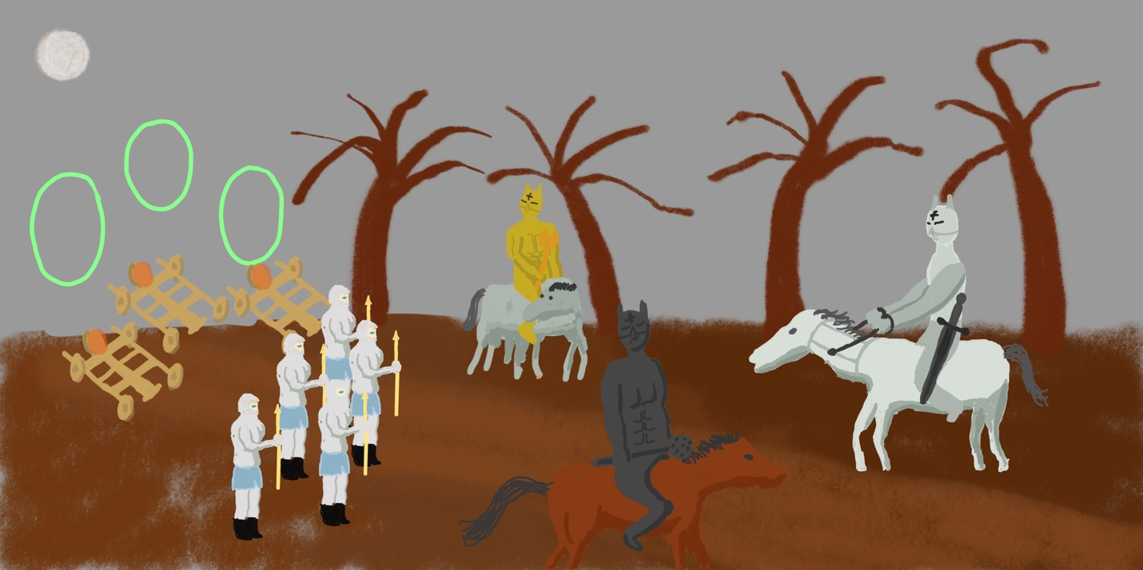

Teleporters, flaming catapults, 50 legionmen, Odin on Sleipnir, Vlod on Slagnir, and Henel on Dreipnir in a dark spooky “Pitch Black Forest”

A stark, moonlit night, the third and final fight in which the three heroes and some legionmen come via teleporters (Same as the other two times) to melee-fight the baddies off their horses, in front of Forgetropolis. That’s the second Giants city.

When the Heroes, Legions, Catapults, and Behemoths enter the **teleporters**, they are to be sucked in as an “extending cone,” which starts out long and flatten in the middle of the teleporter, then on the other side, the extending cone comes out again and gets sucked back into magically appearing, opaque-increasing bodies on forest side. Should happen almost instantaneously.

Although girls have sexy fashions, the **size of the boobs** is over-emphasized (average EE cups) and they seem to be fake, but not necessarily. It passes quickly amidst of finding a girl for Henel and celebrating the end of battle. Every big-busted woman wears a thick-padded bra and looks a lot bigger than how big they really are (wearing traditional Swedish big woman dress).

At the great **final bath/pool** scene, Kim, Kristin, Gardenia, and Freida, and also Elena will be revealed onto a real or CG waterfalling background with Kristin on the bottom left facing left, Kim on the right side facing right, and Freida (with string bikini) facing right, with their “partners” facing opposite. First film finished in sync with pleasant music panning gloriously into the sky! The front people are under trees. The early three are filmed doing things at the same time.

Market Movie With **Interesting Posters** Before Summer or Halloween (?) Launch!

**Aftermovie** with Scarlett Johansson acting as a modern day immortal Norse hero will last about 20 minutes AFTER the credits. In the credits, it will show prominently in big white text in the beginning: “WE NEED AN AFTERMOVIE!” And after showing the aftermovie, other credits like FX team and make-up are shown page-by-page quickly (no scrolling).

Make British English-ish lines for everyone in a Nordic style, except not so Viking and more free English-speaking Asgard

ODIN and only Odin uses some “North European” accent and **spoken language features**, but all in English. The **music** is *meant* to be Swedish ominous folk music, but we may just use normal classical music and “Flight of the Valkyries” (with a feeling modification).

**The Valkyries are “babe” type girls** chosen from the public who can act a little, *look* like the companions of heroes as they are, and are willing to get *boob bags* of large proportions. Everyone is charming and smart, at least. Frigga is a smart girl, meant to be “queenly wife” of Odin, and also has some but smaller *boob bags*. Frigga even looks smart, though mostly infrastructure.

**The fashion is highly stressed** in the movie—in fact, it is all high-fashion style hand-sewn fabric, highlights, gems and jewels, making the fashions some of the more expensive products shown on movie. The Valkyries can be shown with funny Norse hats with two horns up from the sides! The Valkyries have the most stylistic clothes on, everywhere they go. They don skirts or longer dresses or puffy skirts or puffy pants with plenty of ornaments and colors. Everyone has like—DD boobs—they are chosen because of their assets and should be pretty smart, pleasant, and agreeable types. Everyone on the set must have nice Norse-style garments or armor on when in the Old world. **Keep it simple, and** **show relatively few people.** Everybody in the Old world is styled to have a look like traditional Norse or Swedish people, but more modernized. In the modern, 2010’s age, everyone is dressed cool or tightly-fitted. Stressed also is the brown/blue makeup which gives everyone a Gothic-Norse look.

**Poetic Moments ™** in which 4-line poems are spoken are specially portrayed by making scene black and white or blurred and the words of the poem are displayed on screen, then maybe tinting towards blue or gold-yellow, depending on the feeling of the precise poem. Then Henel, Vlod, and Odin will synchronously and sometimes in turn speak them.

# **Places of Note in the Movie; And Where the LIGHTS are**

**Log Cabin in Minnesota at present –** with Luigi Warpeace, the guys discuss the beginning of the story and enmity with Heretics. Light is in the fireplace.

**The Lounge Room** - room near centre of Asgard in which everybody broods and reads the minds of other gods, people, and Giants. Ambient lights in the corners on top.

**Henel’s Suffering Bedroom** – a place of horror by hallucinatory dreams and sleeplessness. A faint light lighting up the whole room.

**The Planning Room** - room right at centre of Asgard in which Odin and others plan for final fighting. Similar in simplicity to the Lounging Room, there is a fancy looking hologram planning piece (like a table) pedestal-tall and intricate looking, with a Time-Knob, 6 inches wide in the middle, to plan things in different time periods. Lights are everywhere they should be in a modern command chamber.

**The Horse Training Grounds –** A place in Asgard where a **horse trainer Michelle** trains the heroes’ and Horsemens’ horses—riding and horse-jousting, and maybe share a few words with the riders and the horses chat. Ambient lights to SEE the room, and coming from outside in daylight.

**The Heretics’ Crazy Barroom –** They drivel and slaver there. Typical Bar Lighting.

**The Rainbow Bridge** - fighters, Valkyries and commanders and catapults and Behemoths start to lift off off the edge of this bridge—the Valkyries are sent back by Norma on moving clouds, surrounded by a supreme waterfall and a rainbow, with the Bridge ending in three Teleporters. Light from the glorious sun above bouncing off a big wide rainbow.

**The Landing Spot** – a big patch of land potentially holding some heroes, five legions with two Heroes, two Horsemen, one Odin, behemoths, catapults, catapult operator, Norma, and a healer and a resurrector. Either from the sun at Giantmantium, or the moon over Forgetropolis.

**The Outside and the Inside of Giantmantium** – an afternoon-sunlit theatre in which we face our strongest enemies: the Frost Giants. There are many general frost giants who are ready to fight and try to survive, mostly using their fists. When the warriors get inside, it should show a set with several burning straw huts, a bunch of fearful women Giants running amok, and two, invisible Restorer Giants which are the key. When they burn down by the fire brought by catapults, then Asgard prevails. THE LIGHT will be from the afternoon sun, almost setting.

**The Pitch Black Forest** - a forest that’s usually trodden at night, with many dark trees, but is CG in reality. The heroes horses, Horsemens’ horses, and other staff first gather, then run through this forest toward a Castle. The first, failed fight is had here in a dark location short of the Castles. There is little light except for a partial moon.

**Giantmantium** - the sanctuary city of Giants, in which they lavish and party all day and all night. But they are threatened by a whole Army because the Heroes are offended by two particular Giants (the restorers). Afternoon sun.

**Outside Forgetropolis and Final Fight Ground** - A huge, tall fortified castle (looking like a Vampire’s castle) which is visited in the dark, unlike Giantmantium, where the Heretics are sent to the outside to fight the Heroes by melee (hand-to-hand combat) and also a joust between Protagonist and Antagonist. Light comes from four pegged, large torches outside the castle, and from artificial tactically placed ambient lights to light the Fight.

**Recuperation Swimming Pool** - People relax here with their girlfriends and look like they’re having fun.

**Asgard is a gold color-based futuristic city** *in* Poland with a maroon brick wall around it, and a large seaside moor and ending peninsula side on the east, with the tallest buildings in the middle and smaller and smaller buildings as you go outward. Everything is futuristic and perfectionist. The only way to reach the other “worlds” would be a port and then a flat bridge on the sea-side of the city which reaches out and suddenly ends with an unmoving rainbow over it (The Rainbow Bridge). Jotunheim (pronounced Yotunheim) is *in* Minnesota, USA by default but filmed in California. Light is everywhere in Asgard, and darkness is default in Jotunheim.

**Lamps and coloring**. The overall feel of the movie is “dark”, including Giantmantium’s outside for the first fight and Forgetropolis fight. Therefore to lighten up the frost giants, Heretics who are fighting, and the Heroes, we need lots of LED lamps outdoors running on batteries. Give the movie some colored light. And more specific colors can be applied using simple VFX.

# **SOME MORE NOTES**

The **presentation feeling** should be light sometimes, heavy sometimes, but young and innocent-like.

All the early color artwork was done in **iPad Pro Procreate 4**, a great app for making easy-to-do color or b/w artwork. It costs only USD$6 on the app store, $120 for Apple Pencil 2 and a thin cloth glove are necessary.

*** Should we heavily promote and encourage people to buy the Blu-ray and DVD versions of the film? Sell 4K UltraHD 60fps HDR versions of the film?

Representative Art

ASGARD:

(For movie 3-D sake, **fewer buildings, only gold-colored,** **navigable**, and an obvious Immortal Home bldg in the middle, with sky deck near the top from which Odin watches the 9 worlds)

In the **Aftermovie,** to depict the “FBI” walls being burnt down by “acid”, they must obtain BRINE at +1.6ph and walls made of some kind of foam. The Arab Evils will be wearing traditional, colored suits (while being fully American) and be free and wild seeming, and little round hats-that are colorful.

**Quips and Jokes** are made by the actors themselves, in situ during the production time. There is plenty of “small talk!” Add whatever little thoughts and chit chat that the actors feel they need to add in, to make the movie seem more human instead of all gaudy.

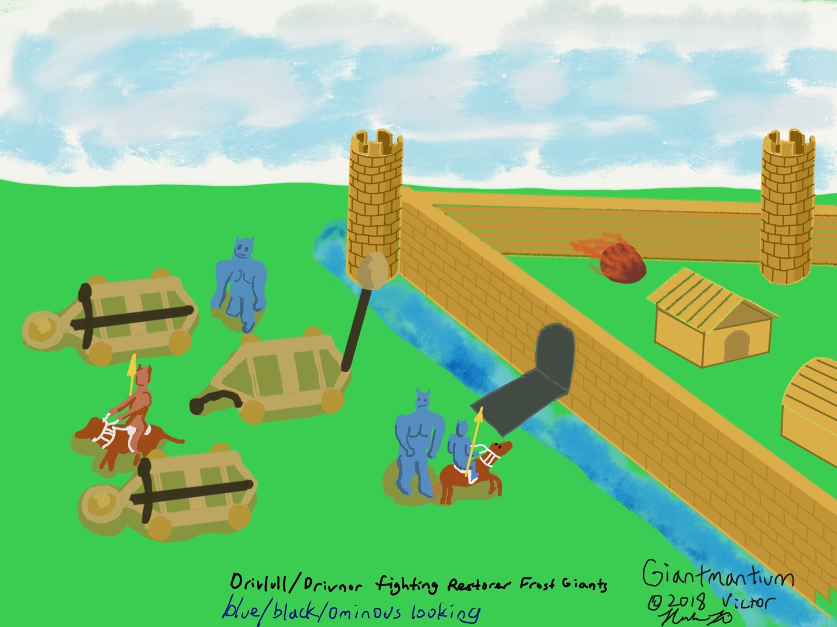

 Giantmantium, castle of the Frost Giants who come to attack the invaders Drivloll and Drivnor, brothers who fight for Odin. They and their legions burn down the city but suffer a severe injury (story remarked)

**Giantmantium** (filmed in the daytime with some sun shining through): A brown-walled city with a moat and moor, poor shrubs darkly colored in every direction. It contains simple buildings with no Heretic and Witch refugees, and restorer Frost Giants. The Frost Giants are big athletic CG tall and tough black-colored, spiky-haired brutes. You can add CG frost on their beards. Our Behemoths will try to knock down their Giants, and destroy their Small Frost Giant Wizards, who cast icy freezeballs at us. Make sure when the catapult rocks fall, it’s actually shown dramatically and burning up the in-city huts.

**Forgetropolis** (filmed in the night): A big, stark looking Gothic fortress with high walls and hard to invade, even with the few catapults siphoned to it. Only to see the evils emerging. Representative colors are black, white, and blue. The white is artificial light created just to light up the last fight. Inside are the old buildings of the Giants, which need not be burned down or destroyed. Instead, the Heretics should be killed outside the moor-less walls and then the Heroes would make leave of it.

Dinotopia (Los Angeles) is the city of Elena Vanderstring.

# **Simple Specs of Characters**

**Odin** of the simple past, doing mythological things is in a blue cloak is shown with a big magic staff, which he doesn’t use – decorative. He has a large black beard

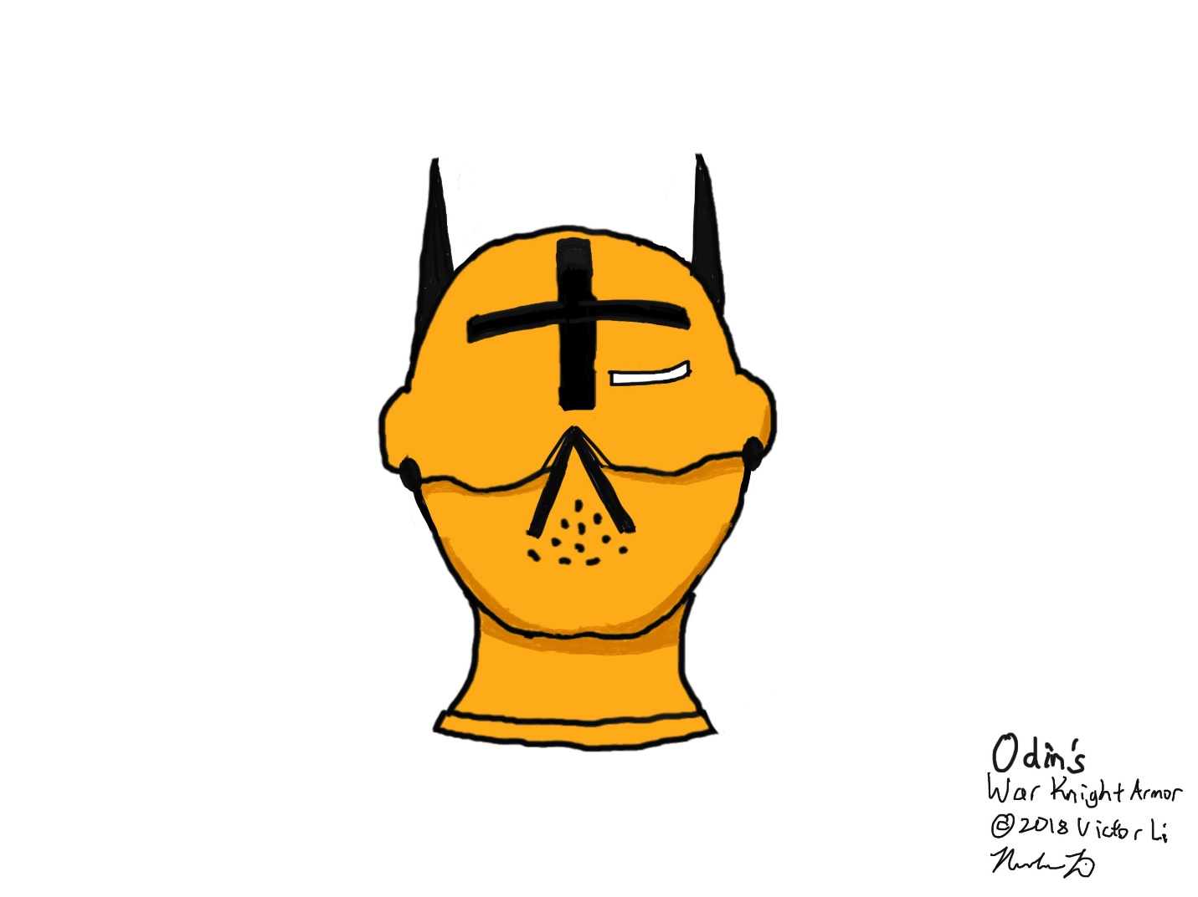

 Odin’s supposed gold-alloy armor, but not as realistic as their fierce and bold Norse armor should be like

**Odin** in battle gear is around 50 only—being immortal, black hair and LARGE BLACK BEARD covering his chin, gold-Kevlar-alloy armor (his armor’s coloring will be gold-bronze-tinted Kevlar scalemail WITH WHITE REINFORCEMENTS for mace damage, Henel’s is dark blue, and Vlod’s is space grey—not as in the drawings!!!) thin-eye-slit and upside-down “V” breathing hole with movable mouthpiece and carries the heavy double-sided axe Gungnir that has the magical ability to “quicken” other heroes’ attacks, thus making each the heroes invincible. ODIN, HENEL, and VLOD’s Armor is much like the stuff found in a google search for “Norse armor”. My concept drawings are actually too plain and simple, even if the elements of the armor’s face might be real.

**More-than-expected attention must be paid to designing real-looking, heavy tough armor for the three Army Champions. It should be *extruded,* i.e. bigger than their real bodies and have detailed muscles, patches and grooves. The style of armor is generally Nordic—not Sweden. Generally should look dark and awesome. Can look on google for “Norse armor” to get some inspiration. While the heroes have magic knight-Kevlar scalemail armor, the legionmen have hard-to-penetrate Viking-style knight armor, which can be frozen slowly by Wizards.**

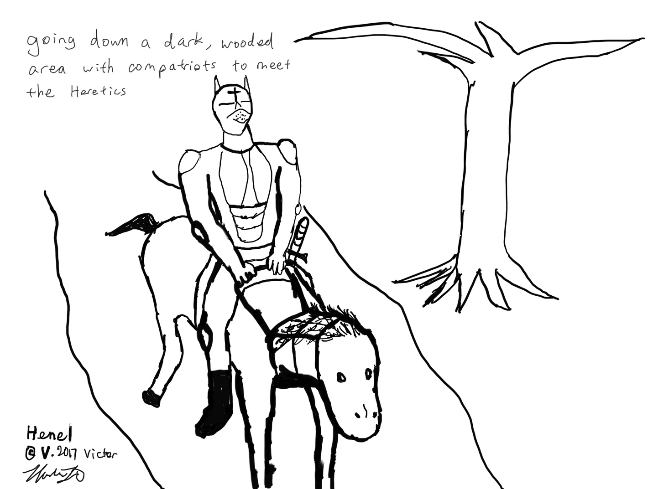

Henel in supposed knight’s armor (actually, awesome and fierce-looking Norse armor), w/o Odin or Vlod

**Henel** is portrayed by different actors, from **age 4 to 8 to 17 and 25-ish (in looks)**. he has a covering-bottom-of-face brown brunette beard. His heavy Kevlar scalemail Armor is invincible, with a BLACK CROSS at the top-center of the head, showing health benefit—and black everywhere except for a thin slit (surrounded by red) at eye-level and an upside-down V hole for breathing (with movable mouthpiece). Facing the final Heretic foes, he dons heavy Kevlar scalemail in Norse style, with gold reinforcements for mace damage and wields a magic sword called Gram forged by the armor-maker dwarf Regin. The sword has double magic – it automatically poses toward the next enemy to fight, and brings you to hit his soft spot automatically – and adds “wallop” intensity of damage too. The sword Gram is broad yet razor-sharp pommeling a guy’s head off in one swing. It moves by itself toward the target (as if it had a mind of its own). In jousts on horses, which the Actor and a stunt double need to both learn how to do well, the Actor is unfortunately given a short, but stronger and more durable spear-lance, which has the protection for the hand. The other side must miss hitting him, and then he will have to bonk his spear on their shield (or armor). It’s a lance-battle with an especially violent ending!

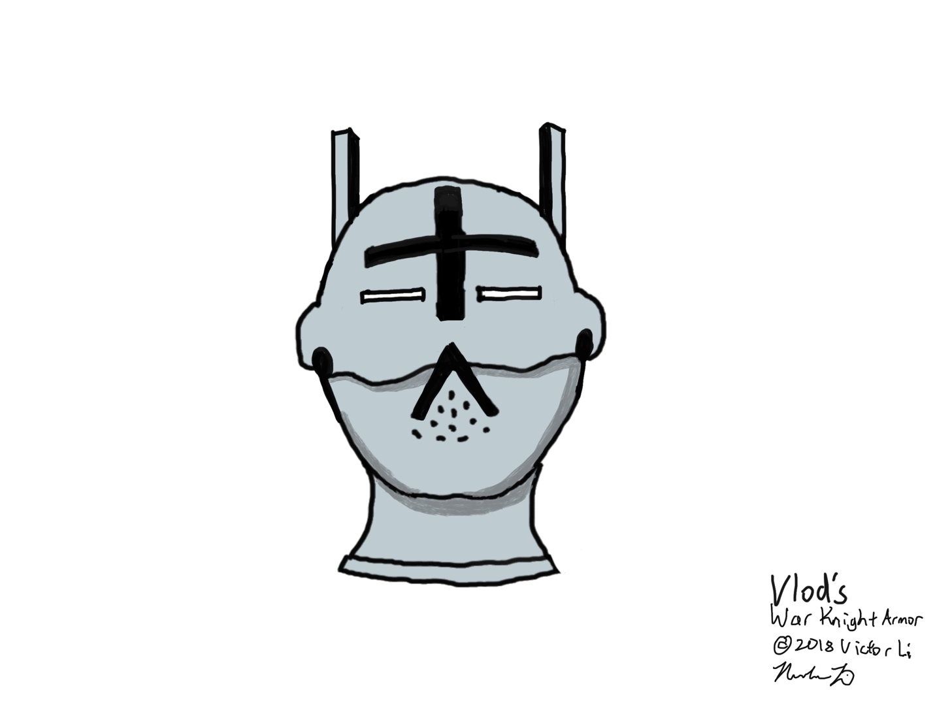

**Vlod** is portrayed mainly by a 25-year-looking actor, blond or brunette, thick beard. Vlod is only a witch-defender, and thus doesn’t have that much fighting. (However, he has the super-cool ability to prevent early witch-caused diseases!) Armor is black iron heavy Kevlar scalemail, platinum-reinforced for mace damage. He is meant to just be there and protect against the onslaught of the witches, which doesn’t happen (witches do their work constantly and invisibly- no massive attack). He weilds a would-be heavy mace meant to bluntly damage various baddies’ armor, quickened by Odin’s magic. The natural magic of Dafnir is its exacting accuracy—it is never off and hits the wrong part. Dafnir has magic “sight” of its own, as if the wielder doesn’t even really control it.

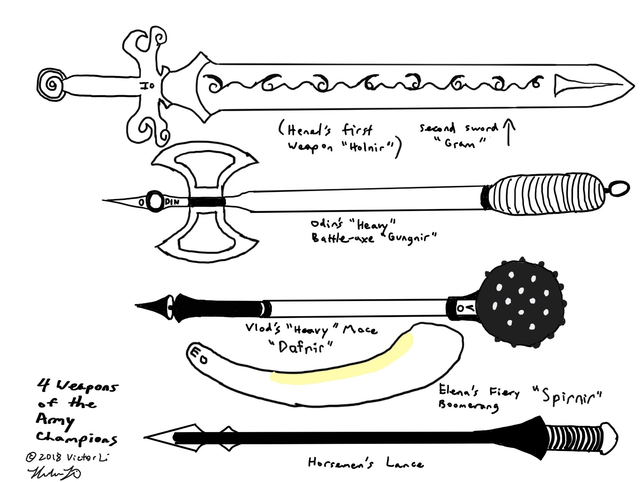

**Elena** dons a sexy and curve-enhancing heavy undamageable Teramantium (one-up-on Kevlar material) suit or “shell” colored red with sexy colored accents, flaunting sleekness (likeness to female Terminator in T3), and with an back-of-skull-covering helmet. Weapon is a sharp-piercer plasma-jetting boomerang which can always automatically return to her hand, and never singes her. Must not be too emphasized—acceptable. She doesn’t even need a weapon! Because she can draw Odin’s powerful plasma garnered from the sun and shoot it at people, instantly melting things (visually in an acceptable way).

**Drivloll and Drivnor** wear light blue, and firebrick-colored knight armor (respectively). Their armor is thicker than typical. All their legionmen are buff and look similar because the fight scene is a bunch of precisely-same CG Vikings (robot-looking characters in each fight scene but some shown as non-CG while walking through the forest). They have fake full beards. They carry long spears with a sharp head piece on them, ensuring horse-mounted victory with jousters (actually these two don’t joust, but have fun pricking people and frost giants and Trojan War Losers). They are stout and proud legion leaders, with twenty Vikings each. The Vikings are armed with bows and arrows, which shoot straight at the enemy. A couple of Vikings should be lost, and according to lore anyway, their Valkyries will bring their souls back to Valhalla. Each also commands six of the twelve catapults with one in their legion, who is responsible to guide them up to Giantmantium. But there is Austin Richman, who is pushing all the catapults across the forest floor at high speed. And there are 4 small cannons which accompany everybody through the teleporters, first flown by the telekinetic Norma Windraiser, and pulled by Austin Richman. After the Giants are killed, the Horsemen chase the weak Restorer Giants through Giantmantium until fires “melt” the two Giants. Then Victory is proclaimed. (other cities aren’t destroyed, though in the last city, the Giants are ardent that their city isn’t destroyed so they break the drawbridge and teleport all the Heretics at the heroes—a medium amount of equipment is unnecessarily brought to Forgetropolis).

**Skulda the main Northern Poet** Oracle is a dandy, handsome young lady who has a penchant to figure out everything in the future, and memorize as much as possible. She has the immaculate ability to figure out anything in the future accurately. She wears great awesome costumes – in these ones she wears a large yellow full gown growing unevenly from yellow to dark gray, with a yellow cap and red cloth necklace with a line on the front. Does not have big bra. She does have temperament, but is generally a good person. Immortal. Has great value to the heroes and especially Odin. She speaks with a British accent.

**Norma Windraiser** is a special and important character who uses telekinesis to raise multiple “targets” off the ground (the Rainbow Bridge) and into the sky, entering the teleporters. Before entering teleporters at Bifrost Bridge, she will raise herself into the air beside the bridge while raising the heroes’ horses and catapults, etc. She does a perfect job each time. Wearing a tan suit with tan pilot’s hat.

**Iduna** Something of an essential character in the new Norse action-mythology, because she will in two parts of the trilogy raise people into Immortality, and keep them that way. Maybe some of the members of Aesir Asgard would like her service. She is cute and plump, even hot looking.

**Special talking immortal** **horses** Sleipnir, Dreipnir, and Slognir are all horses with a special enchantment that allows them to understand and reproduce human speech! Sleipnir the white horse has 4 extra computer generated legs, don’t save the production costs. But he is an arrogant and prideful horse who just sleeps too much. Dreipnir is a fast moving proud, but depressed white horse (Doldrum fault). Slognir is a brown horse, thick-muscled and resilient.

How do the horses look? Emphasize their toughness and **big, bad armor** by shooting side-panning shots emphasizing their muscles and brawn.

 Where to find our special horses? Ask Sam Worthington!

We also need some cultivated birds who look like they’re chirping in the spirit of the times of medieval Sweden. The actual sounds will be rendered.

**Witches** wear dark brown tunics which hang down all the way to the ground, covering everything especially their ugly front-heads. Long black or brown hair which covers much of their heads, ugly as the hags may be (pointy chin barely visible). They are non-human but treat humans with respect because they wish not to fight us. Instead they occasionally crack and start a disease spell—which Vlod easily shuts down before any real disease. Only during the final fight they appear as “extras” and have some words with each other (threatening Vlod) but are portrayed as minor. They bobble to the ground as soon as all the other Heretics are on the ground. They do not get much screen time.

Witch #1 the Poisoner and Infections

Witch #2 the Sexual Transmitter

Witch #3 of Heart Disease

Witch #4 of Cancer

**GET A REAL BATTLE PLANNER GUY. LET HIM SORT THROUGH THE LONG SEQUENCE OF SKIRMISHES WITH THE GIANTS AND HERETICS.**

**The Giants** are a big huge race of Jotunheimers who are twice as big as humans and have ice frosting over their black bodies. All Giants are 3D CG with no clothing except for some shorts. The Wizard Giants wear simple garments (CG). Regular Frost Giants are either fully normal or Restorers who can bring back the dead, wearing tough Norse helmets (by letting them bobble, then raising them up again). Wizard Frost Giants are specially trained to fire freezeballs which damage ordinary people, making them stiff until the cold freezes the victim to death. But Wizard Giants are faced with the Behemoths—more powerful tamed White Ogres walking upright. The Giants all wear pretty loose shorts, and boots. All scenes of the Giants are done in CG.

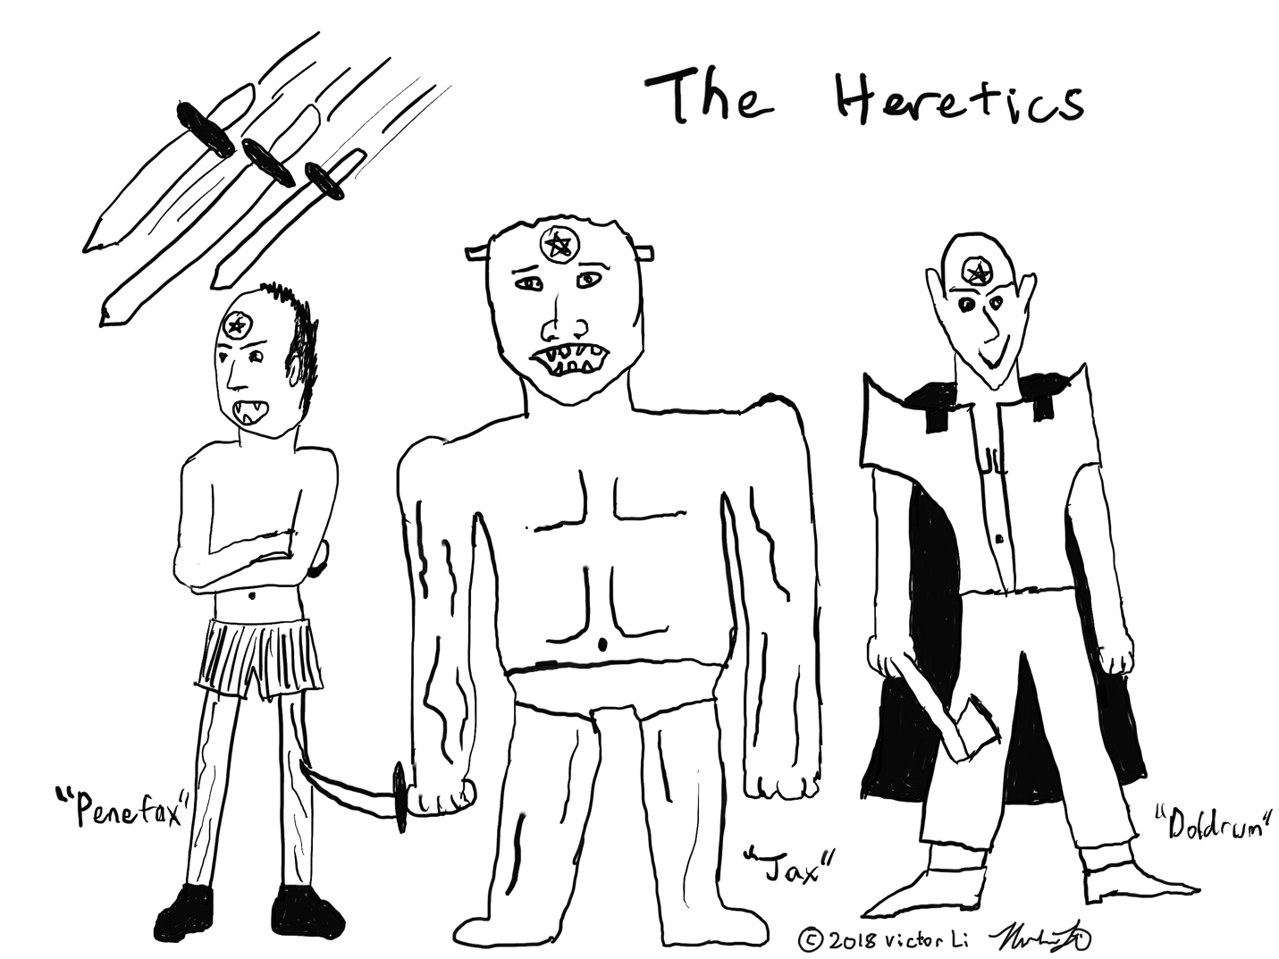

Three of the monster heretics, but they don’t really look like this; rather they’re just ugly looking Zombie guys

All the Heretics—not like this following “example” artwork, have leather armor, carry big weapons, look like classic AD&D monsters, but with makeup and all have patches of beard on the bottom of faces. ALL THE HERETICS should be made to look as realistic to their monsters, and as awesome and important as possible. Imagine them entering Cosplay contests! The best costumes/make-up wins.

Penefax the Insolent: Hallucinations of Mental Pain eyes are red. He is one of the most insolent and ignorant of them, not to mention stubborn. He looks fierce with his brown mane on his back, wears leather armor and has an ugly frown. He is proud, though, because his imaginary spears inside people’s dreams always hit. Weird smile. Imp-like-arched-back guy. Carries a spear-lance.

Jax the Bloody Mutilation Man: Giant Suicidal Dog a big, tall, tough guy (real or fake muscles), looking like a Frankenstein monster, who seems dangerous but is actually kind of lame. He wears red leather armor and weilds a sharp knife. He attempts to kill Henel several times, but always fails. Semblance of a Frankenstein because he has no human feelings.

Somnim: Sleep Loss A tough, evil-looking looking guy who seems like he can’t be beat. Looks like a real Zombie. Wearing chain mail, with broadsword.

Dorpf the Ugly Worm Man: Dumb looking guy with ridiculous wild words. Kevlar scalemail. Snake-scale-covered Man. Owns a big mace. His skin has metal scales up and down the body like a snake.

Tensar: The Genome Destroyer. The Designer of Evil. is only shown in the background, but he is the leader of them all. Behest looking at him or referring to him too long! He would like to disease everybody, so we dispose of him quickly. He looks like a demon-head, with terrible thoughts piercing through his menacing face. He wore tough, Kevlar scalemail armor (not knight mail). The only one with magic to attack (the magic to make more monsters). His voice is deep and grumbling.

Doldrum the Unsympathetic: Man of Depression is an intelligent-looking, long-haired guy with chain armor. Carries a broadsword. Loud, raucous cackle.

Lizard the Obsessive: Has little armor on and is just there for the show, battles a little with the Heroes and loses. A would-be Werewolf with some facial hair. Carries some kind of mace. Is supposedly powerful against the people but easily disposed of.

Earstuff the Stupid: Attention Deficit is responsible for almost nothing except ADHD. However, he sticks around. He might wear armor, but it’s probably backwards or something. Shorty with long, shaggy regular hair and youthful face. Easy to take care of, if done the right way. Has a pointy curved sword.

Wreck is a terribly ugly mean looking brute, looks like an ugly Wraith, stealing your internal energies. Would have a large club. (Not portrayed at all due to his dangerous nature on movie watchers)

When stabbed or otherwise wounded, there is either none or a little blood shown.

# **Re-Analyzing the Good Guys**

**Odin** **Allfather**: Looks old but not grey. Has thick black beard. Acts very wisely and cautiously. However he is a daring guy, wishing to destroy a bunch of evils. He has a snooty laugh. He understands everything – especially science matters. He has regular black hair. When he goes into human world for answers, he wears a long black coat and carries with him a normal staff (Vegtam the wanderer). After the beginning he is wearing invincible gold armor or a GOLD RIGHT- EYE-PATCH, depending on the scene. His weapon is Gungnir—a magic double-sided axe. Everywhere he steps magic is ready to be utilized. The big god who takes care of everything automatically.

**Odin’s brother** Odur, the headless horseman: A stalwart and super-brave mortal who joins in with the rest of the heroes, to fight to his death. After his head is lopped off, he’s not phased but he rides away, head grumbling some words (a short actor wearing a tall actor’s grim clothes and looking without a head).

**Henel**: “Hehnol” A proud, and resilient, but serious guy. He knows he must act out his immortal goal, and return to Asgard not too badly bent. He does not fear pain, nor suffering. He hates stupid mental problems like imaginary swords flying through the air in dreams and ADHD effect. He always carries on no matter the odds, because to lose he would face death and also the “loss” of humanity to overpowering sickness. While fighting Heretics, he weilds a white glowing-magic broadsword. Henel is either talking in 2018 with a casual outfit on, or fighting in 1021 with a blueish lines-dark colored armor and helmet and sometimes a magic sword Gram.

**Vlod**: A tricky, smart immortal hero who is a master negotiator. He keeps the witches at bay and makes sure, through either calmness or pacification or threats, to annul their diseasing power. When talking in 2018, Vlod wears a whitish coat and pants and big shoes, or fighting in dark grey armor in 1021. His weapon Holnir shines brightly, as if made of all chrome, and seems like a really formidable piece of weapon.

**Frigga**: Proud and tall and supportive, Frigga is the alpha-female character among these Valkyries and other female characters. Healer. Essential to the warriors. About 50 something, she in the myths is the most powerful female Asgard god. Sound-looking boobs. She wears a black long-full-skirt (shorter than a full dress, but covering most of her legs) no cloth strips with a symbol of a star during the ascent into Jotunheim.

**Charlene**: A cool natured and important looking girl with cool fashion and a friendly, helpful character. She will be sympathetic and move to restore any good guys who are killed. Wears a white shirt, blue midi skirt. Sister of Frigga

**Behemoth Giants** are only one per legion, but are the biggest (twice as tall as the Frost Giants) and toughest, very difficult to take down. They are extremely powerful, neutral and orderly (always aligned to Odin).

**Frost Giants** are tough and rugged, but not wicked like the witches or heretics. They have some kind of agreement with Odin—that is they don’t step out of their bounds, but do some kind of semi-evil work. They look blue in nature, and if possible fake ice on their bodies due to the northerliness of Jotunheim. They are harboring the evil Heretics due to an agreement made with them early in the movie (for the Heretics to have more protection after war is declared). They are 1.6X the height of a normal man, and have big muscles, which in 3D VFX they will clasp their hands together and hit down, from the top, onto heroes’ or legionmen’s heads. They are fairly easy for our Archers to hit them, though.

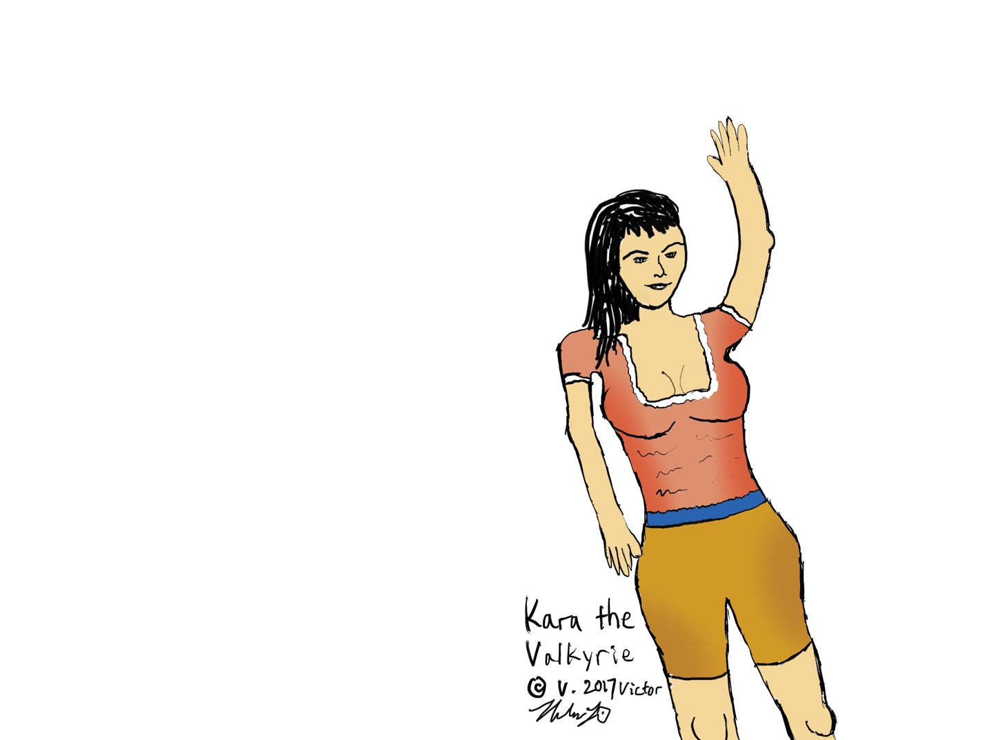

Kara waving goodbye to heroes, doesn’t have to be shown

**Kara:** “Kahra” A little bit unsure and fickle and playful, but definitely confident that Henel and Vlod will survive. She is undaunted. She is shy, but extremely cute and has some words to say. A brown haired Valkyrie, she rides on the back of a white horse together with Henel. Taking Henel to his teleporter, Kara wears a shirt and yellow midi skirt or tightshorts and *boob bags* with *cloth strips* of white coming from the top of that skirt. At the ending she wears a blue top, shimmery with a navy-blue short bottom hem at the knees with red cloth strips from the middle of that dress.

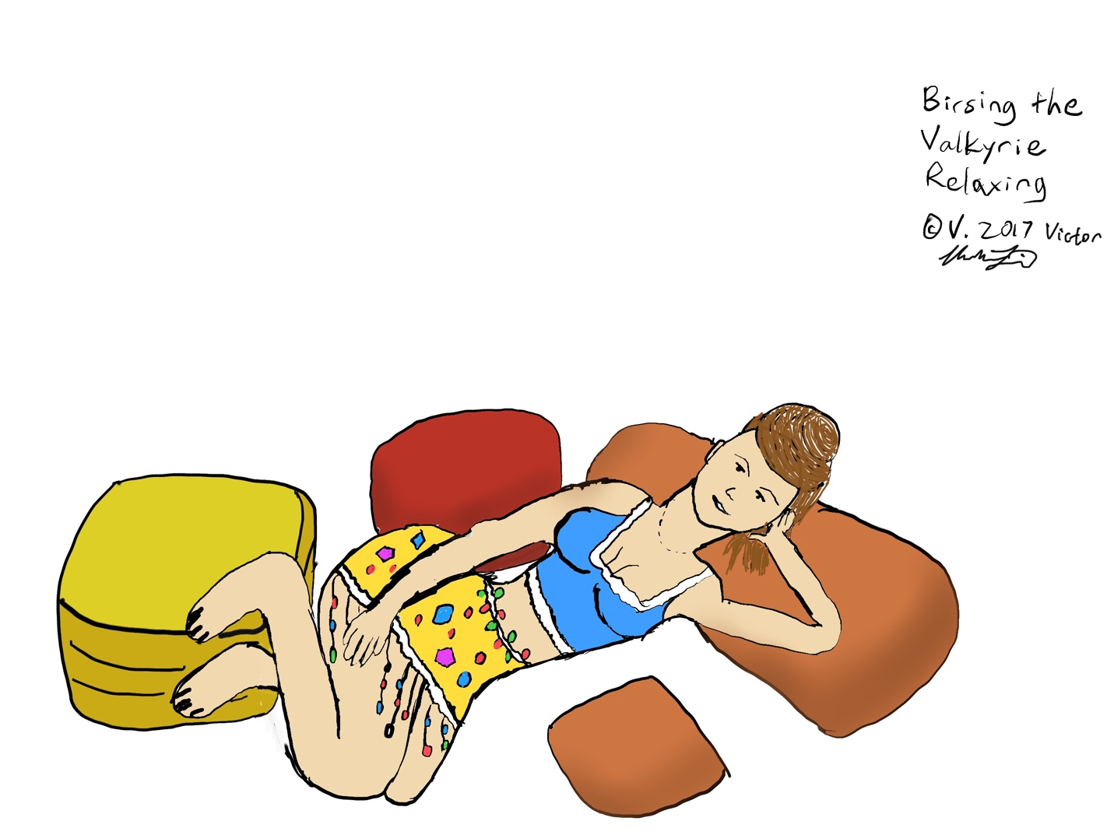

Birsing in a relaxing lounge, but does not have to be shown per script

**Birsing:** “Beersing” Having only a short time on screen, but very beautiful, the enchantress Birsing lures Vlod into her love cradle easily. They are a natural match. But after the fight, she was very strong-willed and protective and made sure that Vlod gets back all the strength that he needed. Then they met and made a baby at the end of the battle. Birsing wears yellow top over her *boob bags* with medium shimmery *cloth trails* with jewels red and yellow midi yellow dress during her wait for Vlod.

**Valkyrie Seeping:** In her wait before Drivloll’s return, she waits patiently in the courts of Immortal Valkyrie Haven in Asgard, together with the other Immortal Valkyries. She normally wears a tight-fitting midi skirt and boob bags.

**Valkyrie Beatrain:** She waits for Drivnor’s return, where she will hug and welcome him back to Asgard, him being a soon-to-be-famed Horseman. Glory awaits those who pommel terrible evils.

**The Valkyries’ and Frigga’s Gem Rings:** After Henel finds three sparkling, glowing hot gems at a brook near the fight scene, there are dwarves (unshown), who craft the rings: a blue sapphire for Kara, a green emerald for Birsing, and ruby red gem for Frigga. All three of them get married at the end. Their rings are magic love-attraction-maintaining, glowing color rings.

**Odur:** Unlucky brother of Odin who is not a god but a welcome member of them. He has a happy-go-lucky attitude and is usually not that doldrum. For some reason he kept seeing his own death in his dream. But that didn’t stop him from normal processions at Asgard. One day he joined the battlers on the battlefield, and his dream came true.

**Norma Windraiser:** A cheery, active blonde or brunette girl who guides everyone using powerful telekinesis, into high-up teleporters which look like O’s from the side, and some “entering energy” going clockwise. She wears tan and has her hair bunched up or just short, with a small-fringed hat and brown pants.

**Drivloll and Drivnor:** The two Horsemen (likeness to the name Horseman of the Apocalypse) wear brown chestplates and chainmail.

**Legionmen:** There are at least 50 or so legionmen, arranged into neat army order. They fire arrows straight at the Giants, through each other’s bodies, since they are CG, but all of them hit and take down the Giants’ hit points. Some are actually clobbered by the Giants, especially at the front lines. The fight is carefully scripted. There are no Giants on the walls of the Giantmantium castle, shooting arrows. The Giants try to “freeze” the Legionmen (wizards with freezeballs), or use their powerful arms to bash their bones in. But many of the Legionmen survive aiding Drivloll and Drivnor.

**Weapons of the Deep Piercing ™ kind:**

All piercing-type weapons will have retractable heads which collapse into the shaft of the weapon. So it looks like a sword which is deeply piercing someone’s stomach, where in fact it’s a cheap aluminum piece with a collapsing front edge. A new style of (un)violent filmmaking. CG director controls these weapons. After the stab the symptommakers “blobber” down, while Giants fall, but there’s no blood.

Some stabbings are filmed “sideways”.

Also, the sound of “clinking” armor as scales on scalemail, while riding horses and doing fighting is important.

We need to be all together! AirBnB? **Movie dorm?** How can we all live in the US temporarily?

**We have Norse specialized heroic and adventure-quest songs, or the example music leading to the full song,** with Dan Forrest providing some suspenseful parts and celebratory parts—continuing the provided music style with interesting measures, as well as “winning the princess” or “got the Valkyrie” song-pieces. “Flight of the Valkyries should play on the first ascent into the Teleporters. MUSIC doesn’t have to be an emphasis in this film, opposite to what I wrote here, but there should be one or two, at least, songs of short length that are the movie theme.

Music should be composed **by Dan Forrest,** some songs based on my pieces.

All of the credit for the Northern Poetry goes to Gardenia Wong.

We should globalize and send our troops to make **voice-over versions** of our movie in post-production. Especially China!

**Movie Publicizing Attempt:**

When publicizing the movie, call the scripts team led by **Mrs. Kruger** at Legendary and have some interesting talk with them about my story. Check the first part of “Notes for Lilan and Producers” below. They way to sale the movie is there. Ask them for their assessment. Depict some things (my pictures plus humming theme songs). Tell them how great it is, how classic it is, how memorable it will be, and also how much careful effort was put into writing the script. Tell them we expect to make over $700m and even $1b. Tell them how great the acting team is when together (be clear and obvious about how the actors will interact, e.g. Odin with Henel, or Vlod with Birsing Valkyrie).

Hidden Credit (Privacy and secrecy maintainable)

Original book (c) written by Haibei Li in Hong Kong

First draft finished 10-31-2018. Copying, and improper modifying strictly prohibited by law

Estimated Figures:

$113 million for production cost, $180,000,000 in-theater first-week, $984,000,000 in total worldwide sales inc. 2 years DVD

Public rates it 4.5/5.

Candid Overview of the writing and forming of the script:

Writing this was tough enough! The story presented here is a fantasy recount of things that may or may not exactly have happened in real life. We tried to make the important things as realistic as possible, such as the Henel suffering, people complaining, and many other parts. But the fights are kind of fake. They represent the quick and easy downing of the bad guys due to their inferiority. But we don’t know exactly how nasty they were. There are almost no completely fake main features in the story whatsoever—even the green dragon had some likeness to a real guy. Though fantasy deviations abound, all that mythological fiction specialness there is to make the movie as captivating to the audience as possible. The violence really should be taken smoothly and done well, so that it does not seem so much like a hyper-violent myth-movie. Good for anybody from 13 to old.

**Tips for the Battle Organizer role among the crew**

1. The fights are pretty central to the film. The three fights are what makes the film impactful and I hope to leave some memory of the *nature* of the fights to the audience.
2. The nature of the fights is simple
3. Odin is a humane god. He does not want to create too much gore or violence.
4. If possible, he would end everyone by Disappearance spell only, but it would not do justice, at least in the context of this film, that the bad guys get a “soft” ending. But you can be assured in life reality, the battle ended without any deaths. THAT is the true nature of Odin.
5. The battles, in the viewport of the camera should be *emotional*, with severe moments and harsh words spoken, and some garish wounds cut. You won’t see all of it, but there are all the important ups and downs for sake of effect.
6. An example: 1st fight – Henel slashes at a heretic. The guy is wearing chainmail, so he doesn’t cause a slice, but the guy is alarmed so he jumps back two steps, hobbling, picks up his mace, and tries in vain to hit Henel. Then, feeling in vain Henel musters a lot of energy to try to slash his foot only, and again it is dodged. The lucky heretic bashes again, and swears, cursing Henel’s very existence, and picks up his mace and does a tremendous swing which ends up hitting the ground, and Henel knew that he was immortal after all, because he dodged it without a scrape. Then as the guy still had his back turned, Henel slashes at his face – not covered with a helmet—and made a garish wound. “Ack, you impudent…” the Heretic whimpers, ask he morosely falls to the ground bleeding. (there are no fights in the film in which Evils are only knocked to the ground hurting (stalemate fights)
7. Odin himself minimizes his violence toward the Evils as much as possible though, preferring telekinesis to control the motion of the baddies, and prevent them from getting close to him. If they did, they’d have the sharpness of Gungnir the double-sided magic axe to confront. It’s there for appearance. But he will even use ESP to push the enemies away from a would-be nasty ending.
8. The words in the fight scenes of course don’t mean as much as the action, yet make sure every move in the scene is accounted for. The point is to get the final fight as close to a starkly real melee fight as possible, without showing *every* scene of violence.
9. Don’t forget now that there was a difficult-to-film melee fighting scene between Henel and Penefax, his one enemy. Henel carries a big enchanted broadsword while the other carries a sharp weapon for supposed damage. That scene is critical, gotta make the beheading at the end quite real.
10. Other fights are similar in that the evils lose, and with great effort they lose anyway. The fights are tense and vulgarly emotional, though dry and the evils are behest to do them. But they are aggressive showing their “fighting skill,” yet have the side of bad luck placed on them so they die, or get resurrected during the first fight.

**General Movie tasks list**

Possible ending:

Inform Legendary Pictures (Mrs. Kruger) that since I worked so hard, re-edited dozens of times, added all the notes and details, created 3 musical pieces, and basically started this Volsung Norse hero movie trend for Mr. Peter Jackson, I would be so grateful for $12m FLAT per movie and sequel.

Find a connection - any

Author’s name: Victor Haibei Li

Author’s email: [superlhb2@gmail.com](mailto:superlhb2@yahoo.com)

Author’s facebook: Vik Tor Lee (author pseudonym and facebook)

Author’s phone or Facetime: +852 5121 8507 (call before 9pm or after 5am LA time, 12 hrs difference NY time)

Apple Facetime preferred for live interaction!

**Items checklist to submit to Legendary:**

Sir Peter Jackson, when prompted to, should email to Legendary all the materials necessary (given a promise of director contract). Isn’t he the only one who can head this?

Recorded sample movie theme songs

2 Cheat sheets (bottom of this document)

Children of Odin official northern myth ebook (later)

**Notes for Movie Preparation**

After trying to interest and pique people’s attention in Fox 21 Century regarding my Final Battle (Battle Between Good and Evil) movie, you should give them real and digital versions of all my material, in first final version. They may edit and consult with me on how to do things whenever there are questions (Using Apple Facetime or facebook before LA time before 8am and after 8pm)

**Contact times: before 9pm and after 5am LA Time**

You can tell the Legendary people it is kind of like a mythological story based on a real 3-arena battle—the arenas being the main Final Battle against Symptoms, the Trojan War (a minor little scene in the script, and the fight against Giants, which is finished just before the Final Fight of the Final Battle.

If you need a boost trying to get Scarlett Johansson, a very special and essential personality in the “aftermovie” after the main movie, ask her persuasively. She can be a mythical superhero. She will be present in both The Final Battle and its Sequel, Planet Glenda. We **absolutely** must have her on our set. Please ask her **very gently.**

DVD and UltraHD Blu-Ray with script, signed pictures, musical files should be produced soon after Delivery Day final acceptance day.

Tell EVERYONE Haibei (Richard) is the most important staff on the team, so we must get him a “moviemaking visa” to go to SoCal and employ him as Assistant Director #1 under Peter Jackson of LOTR fame. Others, such as Elijah Wood and Garland Thetour the same, made available just as production starts.

Make digital “Children of Odin” (free myth ebook on Gutenberg.org) available to any who are interested.

Get movie featured in magazines.

Make at least ONE trailer for youtube!

Small type Subtitles in multiple languages including regular English.

We should obtain 9 times profit.

You must invite a kick-ass director who’s really enthusiastic and masterful of fantasy action epics to try to be Artistic Director of this movie.

Just get the meaning right for some spoken parts (e.g. the Trojan warriors/illegitimate Midgardians) and speak around it instead of directly from script. If little re-writings of spoken script are needed, go ahead.

Make link-ups with real content about how one part flows into the other, on spot while making movie.

Victor’s nickname for privacy sake is “H.B. Li”

Design a movie website.

Create something Norse and authentic.

Los Angeles folk can call me any time 9:00am or earlier or 5:00pm or later, LA time, that’s before 12am and after 8am. Any info you need me to make sure about or cleared up please video/audio call on Fb or Facetime (Facetime preferred—call by phone number) This is all before production.

The weapons look big and gory, but are actually light weight aluminum-alloy pieces made before filming day.

Gungnir, the gold, or IRL copper-colored double-sided heavy axe should take copyright so other films other than the owners can’t use it. Several things will be made copyright.

Make *boob bags* for the Valkyries and Frigga to wear, making them seem more Norse-like.

Have something to do during boring times (on set).

Find somewhere relatively cheap for all crew and cast to sleep.

Actors and actresses or editor of script can add in lines whenever the current one is imperfect.

Keep a “Making of” or “Actor commentary” videocamera ready all the time-battle (Good for special features!)

Drivloll and Drivnor get chosen by staff what type of weapons they bear. EVERYONE can have a say in their dress style, use American OR British English, and some can even provide some redefining or add-on lines of their own as they see appropriate. The spoken script here is not perfect, so actors or screenwriters may want to “edit” the script of their speech as necessary.

A possible outcome of this first movie would be that another follow-up sequel, The Planet Glenda will be made following a successful 1st year of The Final Battle.

As for the movie music, try to get a more pleasant full piece out of each of my pieces by composing songs to be played by a small orchestra (main part should be a flute), led by Dan Forest or someone, plus make some other background music.

Get the Copyright of the words “The Final Battle”

We must build hype! Just before launch date (post-Halloween 2020 or 2021), we must get a lot of excitement stirred up in the public about a big monster-bashing movie. Tons of trailers, billboards, Internet ads, and maybe even TV trailer.

Things will be going at top-speed for several months.

Lilan is a actress and a “coordinator” of sorts: many of her friends and family are employed for this film since it is a “noob” film for the writer. She’ll call everyone and get everyone interested in the film, and also may play the role of “Asgard Resurrector”

Lilan is a special assistant for Victor throughout the job in Los Angeles.

You can do “Making of” film—Special Features and Camaraderie Leader. You have your hands full.

What you must ask them for my sake is: pair me as Assistant Director #1 (high-level personnel) under Sir Peter Jackson. They need to get me a 6-month Entertainment visa for me to stay there. I will support the development of the story and visuals for production and post-production.

We need to ask Marvel whether we can use the names of Thor, Loki, and Odin

I can draw scenes in my iPad Pro whenever necessary. **The doing of the movie is necessary because this will be the only movie about the Final Battle Between Good and Evil there will be, and I’m the only one to bring it forth. It is intriguing, unique, and satisfying.** Peter Jackson was basically my mentor and executive director and has ensured the creative and commercial success of this film.

The Artistic Director’s role is to bring light to each scene, to imagine it visually and to bring this calculated scene of events to film life. His main job is to guide the camera director/camera operator to film this movie successfully.

Victor’s role is to bring light to each scene. Describe it artistically and provocatively. Another role is to make all the actors work together. A cast and crew coordinator.

# **MOVIE CASTING ATTEMPT**

Feed everyone correct food based on what they like. Go at lengths to find out what they would like to eat, and have extra rations and Snapple and Perrier drinks. (Have all different kinds of cheese)

DO make sure, obviously, that all the actors are VERY GOOD at remembering lines—especially Henel, Vlod, and Odin.

**Heretics lost at the end and which “monsters” they’re dressed up as:**

Red illnesses are shown at each Heretic’s introduction on the bottom third line

Penefax the Insolent of hallucinations: Jason Bowden brother of sister Lilan

Wreck the Beast of brain pain (not shown on film): no one

Dorpf the Insolent of Men’s Disease: ?

Jax the Bloody mutilation man: Paulo Blibro

Somnimsis the Drowsy of sleep loss: Frankie Ricardo

Lizard the Insipid of obsession: Beetings Lesthon

Earstuff the Stupid add man: ?

Heretics Lost Before the end:

Tensar the Fearsome genome king: Ralph Fiennes

--Black Minotaur with big side-horns

Doldrum the Unsympathetic badboy of depression: ?

--Make-up Vampire

Killwyn the Unmerciful queen of brain damage: ?

--Phoenix-like woman with crazy hair

Behemoths: CG Behemoths, perfectly magically controlled by Odin

2 Frost Giant Restorers: Peter Frakkers!, Judas Rabblerouser!

Other Frost Giant Battlers: CG Giants/Hunter Hurst Helmsley

Legionmen: Employed warriors

Wizard Frost Giants: CG Giants

Ghost Zombie Frost Giants: CG Giants

Catapult/Cannon operators: magically driven and fired

Fafnir the Pretender of Symptoms Dragon: CG of a dinosaur-looking dragon, which happens to stroll past the hole that Henel predicted it would walk across, to be stabbed and maimed by Henel

Trojan Evils

die by spearing from a horse, after getting noticed passing by and talking drivel - wondering where they are, being vagrants, get speared by Drivloll and Drivnor on horses.

1 Hector: Dudderly Mackeral (South Central LA)

2 Paris: Munden Packer (Ventura Co. Cali.)

3 Priam: Ronald Titymack (Pomona, Cali)

As soon as the victorious Commanders and Horsemen come home, they are provided their Valkyries the moment they cross the Teleporters.

2nd Rise Foes

Early Restorer

Arabic Evil Teleporter Halifat: Baron Cohen

Arabic Evil Restorer Vundel: Richard Steinberg (E. San Bernardino)

Witches lost at the end:

Angrboda “lady” of Heart Attacks: Mrs. E. Beach

Filveig “lady” Poisoner of infectious disease: Dominique Kallerman

Many Extras.

**Characters on the Winning Side:**

Odin Allfather:

Henel Volsung: Michael Skuhlbarg (N. Orange County) (and a child Henel, also to act in a few scenes)

Vlod Volsung: Garland Thetour

(need a child actor for a few scenes)

Thor: Tom Greenswood

Tyr: Paulo Blibro (Lilan’s frd)

Frigga Queenly Healer beside Odin: Freida Pinto

Asgard Resurrector Charlene: Francine Peterson

Kara Valkyrie for Henel: Scarlett Johansson

Birsing Valkyrie for Vlod: Lilan Bowden from Disney

Brother of Odin, Headless Horseman Odur: ?

Fallup the Valkyrie of Odur: ?

Luigi Warpeace: ?

Northern Poet Oracle (Skulda): Lilan’s friend Wilder Smith w/o voice

Horseman Drivnor: 2nd Legion Commander Sam Worthington

Valkyrie Beatrain for Drivnor: ?

Horseman Drivloll: 1st Legion Commander Joel Edgerton

Valkyrie Seeping for Drivloll: ?

Poem Reader: Wilder Smith’s voice

Austin Richman, Driver of Telekinetically Pulled First (and only driven-) catapult: Jason Wednerspring from New York

Austin Richman, Rounder of Ground-troops in Jotunheim: Jason Wednerspring

Michelle the Horse Trainer, especially Sleipnir the 8-legged horse: same as Norma

Austin Richman, Original voice of Fafnir the Dragon

Norma Windraiser telekinetic and remote control of fiery catapults: same as Michelle

Iduna the Apples of Youth Bearer: Ingrid Rysend (friend of Lilan)

“The Intelligent President” Imposter: Randolf Hilsurist in Ventura Co.

Horse Vocals: Sam Worthington and Joel Edgerton

“The Deletionist: Mike Fields in N. Orange County”

The Almighty: ?

Gymer the Frost Giant of Greed: CG Giant or Sam Worthington

Andvari the Dwarf: Simon Curtis (Contra Costa, Cali.)

Regin the Dwarf: Luis Galapagoes (lives in Hollywood, works for Dreamworks) Character owns a sharp pike!

Elena Vanderstring: Gerta Sinelli

Barfield Vanderchild of US Supreme Court Chief Justice: Randolf Hinserist in Ventura Co.

**CREW: (must be wholly re-found!)**

Post Production Effects Company: Method Studios

Project Head and Writer: Mr. Victor Li (not present)

Artistic Writer: Serafia Candorfield (not present)

Executive Director: Mr. Julian Terres

Main Director: Mr. Thomas Jacobson

Director’s Assistant #1-Set Designer: Mr. Jack Johnson

Team Management Supervisor: Mr. Jeremy Dascel.

Script Depictor - **Flow-Creative Director**: Janseng Wang

Camera Director:

Weapons and Battle Organizer: John Wilson

Funding Manager: Mr. Gellgann

Executive Producer: Will Giantia

Executive Director of Resources: Bill Gaileng

MPAA Ratings Consultant:

Financial Advisor: Ask top guys at Leg.

Assistant Producer: James D. Brubaker

Assistant Producer: Joel Edgerton

Storyboards: Kelly Injiun

Distribution Casting: John F. Manager of Business Division has line to [https://www.entertainmentone.com](https://www.entertainmentone.com/) and Peter J.

Executive Casting Agent:

Movie Preparation:

Script Reviewer: many

Multi-Language Subtitles: (Korean) (Mandarin Chinese) (Traditional Chinese) (Thai) (Malaysian) (Spanish) (French) (German)(Portugese)

Hidden Northern Poet of script: Invisible poet Gardenia Wong (Los Angeles – credits mention for providing inspiration for poems)

# **Outline of Story**

* Story begins at birth of Henel and Vlod, grandsons of Odin
* Some myth stuff happens, such as Odin losing his eye (precursor to Thor movies)
* Henel gets first nightmare from “Swords of Mental Pain” by Penefax, the antagonist
* Starts building a grudge against the Evils (or Heretics, or Diseasers or monsters)
* Society suffering crappy attacks
* Killwyn (queen) and Tensar (king) get killed
* Some suffering offset by romantic Odin and Frigga
* Decision by heroes to attack the Heretics at their home, Jotunheim
* First wave attack (of three)
* Setting off, conversation with Valkyries
* Attack and failure, because of Restorer Giants
* Second wave being planned, with lots of forces and Horsemen (whose role ends with Trojan fight after Giantmantium)
* Giantmantium, stronghold of Restorers and Giants is attacked
* Restorers are bashed
* The Trojan Fight just before the Final Fight
* The “Final Fight”, in which all of the Diseasers are decimated starts as warriors get off horses, fight in almost fully dark forest looking for Monster Heretics—they appear, then they fight with one of the Army Champions directly, and are all painfully killed
* Heroes fight all monsters, ending with Penefax on joust
* No more dragon fight!
* After all triumphs, the Heroes have their celebrations and even have little Volsung hero babies!
* Elena the Strong appears and shoots out of the sun to prove she is the Ultrapowerful Scorcher

# **SUPER CHEAT SHEET(S)**

**FOR CONDENSED SCREENPLAY MASTERY**

Henel is a mythological hero. Not a superhero, nor only a myth. Same for Vlod and Odin and Elena. The story presented is an adaptation of a real-world story, but let’s treat it as a normal fiction story. Most of the progress during the story is according to a true battle story—The Final Battle between Good and Evil—but it is highly condensed, made to fit the big screen.

Asgard is home of the Norse gods. Midgard is where the suffering happens-Earth. And Jotunheim (Yo-tun-heim) is where the Giants and Evils stay. There are 9 Norse Worlds total. Evils are new to the Norse myth spectrum, but common in everyday life. The mental Evils, the Heretics, are mostly guys, and very nasty. Whereas the physical-illness folk are Witches. For all the special suffering they have caused mankind, Henel takes it upon himself to destroy all the Heretics and hopefully the Trojans and the Witches too. We used to think it could be done in 8 years. But it has dragged on into the 9th year. H, V, and O are all backed up by special protective magic of Odin, whereas the nasties have their terrible illnesses as their protection.

We have a common area where we ride through the forests of cold Jotunheim in the moonlit dark, and a special Swedish tune plays through them. Then an ominous song plays, just before battling the Restorer Giants or Heretics. You know what? We don’t hurt the women witches that much! We just have them crumple to the ground in the end (a symbolic death). But also we should be reminded that some of these Heretics have killed more than has Adolf Hitler, to say the least.

Odin’s classic weapon is Gungnir, the double-sided short-axe. Henel is made a magic sword in the first part of the film. Vlod, Henel’s co-hero, carries a badass mace. Elena, the Aftermovie heroine, carries a sun-plasma-throwing boomerang. These are mainstay weapons of these characters.

Because we are traveling through time portals above Rainbow Bridge, a common Norse bridge, to 1021 ACE to fight the oldtime monsters (Evils), we have to don medieval armor and ride horses. There is a strong feeling of old time Norse lands and atmosphere over there (actually just the forests of New York, or a green screen?). The castle where the Restorers stay is a CG place called Giantmantium, and the heroes (Army Champions of a larger religion called Christianity) realize eventually that they needed to get rid of Giantmantium—after a failed destruction of the Heretics—and eliminate the Restorers there first. So they send their friends the non-immortal Horsemen (two guys on horses) to go and kill the restorers of Giantmantium. They succeed, with some help from a resurrector.

Forgetropolis is where the main Heretics stay—we ignore any Giants who may be there, but focus on Heretics, whom we slay one by one, the second time. To get to the second city (third fight) and try to kill the Monster Heretics, we ask a special levitator girl to help us “fly” into teleportation portals. So the story is quite simple put like this! It’s really getting it to the audience successfully and richly which is a big challenge. Several parts will require the CG team to finish it. For example the presentation of Giantmantium and Forgetropolis, both look like something complex but they are also neatly laid out like a game of conquest of empires.

Henel the Brave should “wake up” several times with dreams of spearing swords into his spirit, which are “nightmare” hallucinations and his antagonist is the sword throwing Penefax, who tries so hard to prevent his loss. But real weapons are heavier than hallucinations. We should show the public cheering as people recover from their witch-and-heretic-caused illnesses. For 5000 years, there have been transgressions made by Witches, and in the latest century, up to 2019, there have been innumerous attacks against the people by Heretics—and against the one warrior Henel. And they dared to break some of the strong rules. But Henel thinks that death is not an option in any case, especially since the Heretics would want to end somebody’s suffering. It’s improper! The suffering is almost always temporary. He feels that the Evils are simple degenerate.

To counter all the big violence we need some pleasantry, ie pleasure at the end of the movie to close nicely. In the process of lovemaking the two Volsung heroes (actual immortal heroes of Norse Asgard) will be having two more hero kids—one who is female.

# Complete Structural Analysis of Parts of Story

The story is made up of main 5 parts: The early beginning, with Odin “birthing” his two grandson Heroes the Volsungs.

The main suffering section, which depicts the horrifying damage that the Heretics and Witches impact the people, and the heroes, particularly Henel, is a large part of the story. So Henel vows to beat them back.

The first fight, in which Odin decides to do something about the accelerating suffering in the world, happens at a dark forest in Jotunheim, where the heroes land after shooting through a wormhole. They attack and kill everyone, but are hit once, and a Valkyrie brings the Headless Horseman back, but the heroes are at vain to totally destroy the bad guys due to a Giant restorer. Odin knew this would happen.

The second time two generals (legion leaders) are prepped to rain stones upon the Giants in a castle called Giantmantium in Jotunheim, classical years. They have two Giant restorers there, and with cunning preparation and the right formula of legionmen plus other types of fighters, and Catapults, tear the city down. The two restorers are found burned to death.

And the third, final time that the soon-to-be-victorious heroes enter the scene is when everyone assembles their weapons, but the Giants cut off access to Forgetropolis—the Giants’ Stronghold, and leave the Heretics and Witches for the Heroes to deal with. So they spar, but the weak ones are killed on Odin’s command easily. The tough ones like Penefax the heroes have significant difficulty taking down, but heroes prevail, even to the point of a gory ending for one of the Heretics, and all the heretic bodies and witches “blobber” down into blobs. This time there is no Restorer.

The heroes then celebrate by relaxing on “green pastures” as The Almighty had promised, and marry their respective Valkyries.